2022 Underfrequency Load Shedding Program Assessment
  - Underfrequency Load Shedding Work Group
  - October 24, 2022

Executive Summary
The Underfrequency Load Shedding Program Assessment Report summarizes the modeling and study methodology including assumptions, the study cases used, and the simulation results composing the 2022 assessment of the WECC Off-Nominal Frequency Load Shedding Plan (WECC Plan) in accordance with the applicable requirements in NERC Standard PRC-006-5 and WECC Criterion PRC-006-WECC-CRT-3.1. The modeling data validation and the study simulations composing the assessment were performed by WECC Technical Staff under the direction and guidance of the WECC Underfrequency Load Shedding Work Group (UFLSWG) with oversight provided by the Studies Subcommittee (StS) under the Reliability Assessment Committee (RAC). PowerWorld Simulator Version 22 software platform was used for all steady-state and dynamic simulations composing this assessment.
During this assessment, performance of the WECC Plan was assessed under heavy load conditions in the 2021 HS3 operating case and light load conditions in the 2024 LSP1 scenario case. For both operating conditions, frequency performance was evaluated in the WECC Island (entire Western Interconnection footprint), the North Island and the South Island at 10%, 20%, and 25% generation-to-load imbalance levels using the criteria in D.B.3.1 and D.B.3.2 in NERC Standard PRC-006-5. The arrest in frequency decline, the frequency nadir, and the frequency recovery performance was monitored at 48 representative buses spanning the Western Interconnection, equally divided between the studied North and South islands.
V/Hz performance was monitored in all 25% imbalance levels and violations of the criteria in D.B.3.3 in NERC Standard PRC-006-5 are identified in this report. These V/Hz violations will be monitored in future assessments to establish validity.
The difference between the armed load that was available to be shed and the load shed during the 25% imbalance underfrequency simulations was used to evaluate the implemented (i.e., modeled) WECC Plan’s adequacy and effectiveness. The amount of load that was armed to be shed but was not actually shed, was calculated. In this report, this value is called “available armed load margin” and indicates the adequacy of the WECC Plan’s implementation. As noted in the previous assessment, the North Island has significantly less armed load margin than the South Island. This level of margin should be verified and compared in future UFLS assessments.
Finally, the 25% WECC Island and North Island imbalance simulations, under 2021 HS3 heavy load conditions, failed to run successfully. In both cases, extreme low voltages in multiple areas of the interconnection, as well as formation of additional islands, was observed. As a result, this 2022 UFLS Assessment demonstrates that the WECC Off-Nominal Frequency Load Shedding Plan may not conform to all applicable requirements in NERC Standard PRC-006-5.
The recommendations in this report follow:
- Both the WECC and North Island simulations under 25% imbalance conditions in the 21 HS scenario failed to run the required amount of time and, therefore, did not produce meaningful results. The UFLSWG should investigate the cause and develop a Corrective Action Plan if the WECC Plan is insufficient.
- While running the WECC and North Island simulations under 25% imbalance conditions in the 21 HS scenario identified in Recommendation 1, extreme low voltages in many areas were observed. The UFLSWG should determine whether these instances of low voltage could be remedied by modeling reactive devices that could operate in the time frame of the simulations.
- V/Hz violations need to be addressed.
  - Each PC should evaluate the affected units with violations in their control area and validate the behavior of the model. If model updates are required, these should be communicated to the necessary people.
- The current UFLS Methodology Document, which outlines how the UFLS Assessment is performed, should be reviewed by the UFLSWG to address:
  - Methods of causing imbalance (e.g., tripping generation, setting unit PGen to zero but allowing it to stay online, dynamically opening tie lines, adding load)
  - Selection of generators to trip, including unit location, unit type (e.g., synchronous generator, IBR, must-runs)

Table of Contents
Purpose 6
Study Methods 7
Software Platform and Dynamic Models 7
UFLS Database Review 7
Island Formation in the Western Interconnection 8
Generation–Load Imbalance 9
Frequency Performance and Monitored Buses 10
V/Hz Performance Check 11
WECC Island Study 11
WECC 2021HS Case 11
WECC 2024LSP Case 12
North Island Study 13
North 2021HS Case 13
North 2024LSP Case 14
South Island Study 15
South 2021HS Case 15
South 2024LSP Case 15
V/Hz Performance Check 16
South Island 16
North Island 18
WECC Island 21
Armed Load Data Validation 24
Armed Load Adequacy Check 26
Findings and Conclusions 28
Recommendations 29
Appendix A—Frequency Performance—WECC Island 30
21HS—10% 30
21HS—20% 34
21HS—25% 38
24LSP—10% 42
24LSP—20% 46
24LSP—25% 50
Appendix B—Frequency Performance—North Island 54
21HS—10% 54
21HS—20% 56
21HS—25% 58
24LSP—10% 60
24LSP—20% 62
24LSP—25% 64
Appendix C—Frequency Performance—South Island 66
21HS—10% 66
21HS—20% 68
21HS—25% 70
24LSP—10% 72
24LSP—20% 74
24LSP—25% 76
Appendix D—WECC Powerflow Areas 78
Appendix E—WECC NE/SE Separation Scheme 81

Purpose
The WECC Off-Nominal Frequency Load Shedding Plan (WECC Plan) was formalized and first approved in 1997 by the Western Systems Coordinating Council (WSCC), WECC’s predecessor. A coordinated off-nominal frequency load shedding plan was originally developed by WSCC in the 1980s. This coordinated plan’s design was updated in response to three system-wide disturbances that occurred in 1996 before its initial approval and adoption. The current WECC Plan was revised and approved in 2011 after the NERC Standard PRC-006-1 was approved in 2010. The current version of the NERC Standard PRC-006-5 was approved in 2021 and includes a WECC variance in Section D.B.
WECC has two documents associated with its Underfrequency Load Shedding (UFLS) program. The primary document is the WECC Plan, effective May 24, 2011. It is the comprehensive description of WECC’s coordinated UFLS program and contains the background, design objectives, performance criteria, and the plan design details. The second document is WECC Criterion PRC-006-WECC-CRT-3.1, effective June 18, 2019, which was created to ensure consistent use of the WECC Plan among all applicable WECC entities and to coordinate the UFLS database maintenance and update requirements among these entities.
Planning Coordinators (PC) in the Western Interconnection have designated the Underfrequency Load Shedding Work Group (UFLSWG) to biennially assess the performance of the WECC Plan per the UFLSWG Charter and to help WECC Members meet their compliance with NERC Reliability Standard PRC-006-5. The activities and deliverables of the UFLSWG are overseen by the Studies Subcommittee (StS), which reports to the Reliability Assessment Committee (RAC). The biennial WECC Plan assessment is reviewed and approved by both the RAC and the Reliability Risk Committee (RRC).
Responsibilities of the UFLSWG, as identified in its charter, are to:
- Review UFLS data annually submitted by applicable WECC entities for consistency and accuracy of modeling (per requirements contained in PRC-006-WECC-CRT-3.1);
- Perform a biennial assessment of the WECC Plan to determine its effectiveness and adequacy in meeting the performance characteristics specified in PRC-006;
- Document the simulation results obtained from the biennial assessment in a report;
- Recommend improvements to the WECC Plan’s design and implementation to the RRC and StS, based on findings of the biennial assessment; and
- Perform other tasks as assigned by the StS or the RRC.
Within the Western Interconnection, the way electrical islands are formed results in two islands: the North Island and the South Island. As a result, the WECC Plan includes two sub-area plans—one for each island in addition to the Primary plan. The Primary (aka WECC) plan and both sub-area plans—the Northwest Power Pool (NWPP) plan and the South Island Load Tripping Sub-area Plan (SILTP)—are detailed in Section E, items 1a, 1b, and 1c of the WECC Off-Nominal Frequency Load Shedding Plan document. UFLS entities can adopt one plan or a combination of the three plans based on the location of their loads in the Western Interconnection. Most entities use one plan, but some UFLS entities’ loads are located in more than one sub-region, so, they use more than one plan.
This report summarizes the modeling and study methods including assumptions, the study cases used, and the simulation results comprised in the 2022 assessment of the WECC Off-Nominal Frequency Load Shedding Plan in accordance with the applicable requirements in NERC Standard PRC-006-5 and WECC Criterion PRC-006-WECC-CRT-3.1. The modeling data validation and the study simulations included in the assessment were performed by WECC Technical Staff under the direction and guidance of the WECC UFLS Work Group with oversight provided by the Studies Subcommittee (StS) under the Reliability Assessment Committee (RAC).

Study Methods
Performance of the WECC Plan was assessed under 2021 heavy summer (21HS) and 2024 light spring (24LSP) operating conditions by starting with the approved versions of the 21HS3A.sav and 24LSP1-SA.sav WECC base cases, respectively.

Software Platform and Dynamic Models
PowerWorld Simulator Version 22 was used for all steady-state and dynamic simulations in the studies performed for this assessment.
UFLS functionality was modeled in dynamic simulations by the lsdt9, lsdt1, and tlin1 models, which will automatically trip specified amounts of load at specific frequency levels. The WECC Plan also includes some automatic load restoration (reclosing) to arrest frequency overshoot, which, if actuated, would operate within the duration of the simulation run for the assessment.

UFLS Database Review
All data necessary to model the WECC Plan in dynamic simulations is contained in a UFLS database maintained by WECC staff. UFLS entities are asked to annually review this database and update it if necessary. The database is updated through a request from WECC to all UFLS entities to compile and submit their respective UFLS plan data and dynamic files using the data input form “Attachment A” of PRC-006-WECC-CRT-3.1. The “Attachment A” data input form is a spreadsheet that includes tabs where UFLS entities summarize their feeders and loads armed with UFLS relays, demonstrating that they provide automatic tripping of load in accordance with the UFLS program design. The database update occurs once each calendar year and is completed by June 1 for Generator Owners and July 1 for the other UFLS entities in accordance with PRC-006-WECC-CRT-3.1. The UFLSWG reviews and updates the Attachment A template before each data request to ensure that the UFLS database contains the data necessary to model the UFLS program once the Attachment A data input forms are completed by the UFLS entities.
The UFLS database submissions are reviewed by the UFLSWG to ensure the WECC Master Dynamics File (MDF) accurately reflects the submitted UFLS plan data. Inconsistencies are reported back to the UFLS entities with a request to correct the errors in the MDF through the company’s respective MOD-032 processes. The MDF contains data necessary to model the UFLS program for use in event analysis and assessments. Further, it is available to all PCs within the Western Interconnection.
The process for annual maintenance of the UFLS database described above, followed by the UFLSWG on behalf of all PCs within the Western Interconnection, is in accordance with PRC-006-WECC-CRT-3.1.

Island Formation in the Western Interconnection
PCs in the Western Interconnection have regularly participated in a joint regional review to identify the portions of the interconnection’s Bulk Electric System (BES) that may form islands. The criteria used to identify the formation of plausible islands in the Western Interconnection includes:
- Consideration of historical events,
- System studies, and
- Any portions of the BES designed to detach into islands because of Remedial Action Scheme (RAS) operation.
Based on these criteria, the consensus among PCs in the Western Interconnection is that the formation of two planned islands in the Western Interconnection—the North Island and the South Island—continues to be an adequate basis for the interconnection-wide coordinated UFLS program. Identification of both North and South islands is based on opening tie lines in the WECC Island—the entire Western Interconnection footprint—as further described below. The selection of islands in the Western Interconnection is therefore consistent with D.B.1 and D.B.2 in PRC-006-5.
As noted earlier, the WECC Plan was initially approved and adopted in 1997 in response to three system‐wide disturbances that occurred in 1996. Since then, it has been periodically updated or refined to include two sub‐area plans—the Northwest Power Pool (NWPP) plan and the South Island Load Tripping Sub-area Plan (SILTP)—that are fully coordinated with the primary (original) WECC area plan. After the 2011 disturbance event, the WECC UFLS Review Group (predecessor of the current WECC UFLS Work Group) evaluated the new island configurations that occurred during that disturbance (see 2013 UFLS Assessment). At the March 2014 meeting of the Planning Coordination Committee, the UFLS Review Group chair presented 14 potential BES island configurations based on the 2011 disturbance event, system studies, and RAS operation. The UFLSWG proposed, and the Planning Coordination Committee approved, that it is adequate to simulate the following planned islands in the 2015 UFLS Assessment:
- WECC Island;
- North Island; and
- South Island.
To date, the UFLSWG has not identified any other plausible island based on application of the island formation criteria. Therefore, like the 2015, 2017, and 2019 UFLS Assessments, the studies for this 2022 UFLS Assessment are also performed for the three planned islands noted above.
In the 2022 UFLS Assessment, dynamic simulations were run on all three specified islands in both WECC base cases identified earlier. The WECC Island is the entire Western Interconnection as represented in WECC base cases. The North and South islands are formed by starting with a WECC Island base case and splitting the Western Interconnection into two parts by opening the tie lines between the north and south halves. The WECC-1 RAS (aka NE/SE Separation Scheme) was designed to operationally perform this function. To form the North and South islands in the base case models, the following transmission elements were opened in accordance with the WECC-1 RAS (refer to Appendix E for details):
- Malin–Round Mountain #1 & #2 500 kV lines;
- Captain Jack–Olinda #1 500 kV line;
- Delta–Cascade #1 115 kV line;
- Pinto–Four Corners #1 345 kV line;
- Red Butte–Harry Allen #1 345 kV line;
- Walsenburg–Gladstone #1 230 kV line;
- Silver Peak–Control #1 & #2 55 kV lines;
- Summit/Drum–Cascade #1 60 kV and #1 & #2 115 kV lines;
- Robinson Summit–Harry Allen #1 500 kV line;
- Glen Canyon–Sigurd 230 kV line;
- Shiprock–Lost Canyon 230 kV line;
- Glade–Hesperus 115 kV line; and
- San Juan–Hesperus 345 kV line.

Generation–Load Imbalance
To simulate UFLS, a system event resulting in low frequency must be simulated; and to achieve a low frequency condition, it is necessary to simulate a case where generation in the interconnection is less than the load. In other words, there must be an imbalance between load and generation. In this assessment, the imbalance was calculated as described in D.B.3. in PRC-006-5 as:
$$\% Imbalance=\frac{(Load-Actual Generation Output)}{Load}$$
where Actual Generation Output = Total On-line Generation Output Prior to the Outage—Generation Tripped. Imbalance levels of 10%, 20%, and 25% were simulated for this assessment. These three imbalance levels were simulated in each of the three islands in both base cases for a total of 18 simulations.

Frequency Performance and Monitored Buses
The frequency performance was evaluated for each of the three islands (WECC, North, and South) in both the 2021 heavy summer (21HS3) and the 2024 light spring (24LSP1-S) by applying the criteria noted in D.B.3.1 and D.B.3.2 in PRC-006-5. Specifically, this was done by monitoring the arrest in frequency decline, the frequency nadir, and the frequency recovery. The frequency was monitored at 48 representative buses in the Western Interconnection; 24 each in the North and the South islands. Within each island, the 24 monitored buses were equally divided among four sub-regions of the island. The six buses in each sub-region were selected to achieve both geographic and voltage-level diversity throughout the sub-region. The 48 monitored buses, at which frequency performance of the WECC Plan was verified, are tabulated in Tables 1 and 2.
Table 1: North Island Monitored Buses
Canada | MT/ID/WY | WA/OR | CO/UT/NV
Williston 500 kV  Nicola 500 kV  Langdon 240 kV  Kelly Lake 230 kV  Clover Bar 240 kV  Muskeg River 72 kV | Garrison 500 kV  Midpoint 500 kV  Bridger 345 kV  Wyodak 230 kV  Crossover 230 kV  DRAM 138 kV | Coulee 500 kV  John Day 500 kV  Bethel 230 kV  Boundary 115 kV  Talbot Hill 115 kV  Port Angeles 69 kV | Valmy 345 kV  Terminal 345 kV  Daniels Park 230 kV  Sigurd 230 kV  Hayden 230 kV  North 115 kV

Table 2: South Island Monitored Buses
N. California | S. California/Mexico | S. California/NV | AZ/NM
Red Mountain 500 kV  Midway 500 kV  Gregg 230 kV  Folsom 230 kV  Newark 115 kV  Rector 66 kV | Vincent 500 kV  Imperial Valley 500 kV  Sylmar 230 kV  Rosita 230 kV  Mesa Rim 69 kV  San Onofre 12.47 kV | Harry Allen 500 kV  McCullough 500 kV  Victorville 500 kV  Decatur 230 kV  El Segundo 230 kV  Millers 57.5 kV | Moenkopi 500 kV  Rio Puerco 345 kV  Gladstone 230 kV  Phoenix 230 kV  Alomogordo 115 kV  Tucson 47.2 kV

Functionally, the dynamic simulations for evaluating the frequency performance of the modeled Western Interconnection are achieved by tripping generation to form the target generation–load imbalance (10%, 20%, and 25%). After the generation is tripped, the simulation must run for 60 seconds to make sure that (1) the simulation is stable, (2) the frequency recovers to the required level specified in PRC-006, and (3) additional data checks can be performed, such as V/Hz (see next section). Frequency response plots were produced for each simulation run—at 48 buses for the WECC Island, and at 24 buses each for the North Island and South Island.

V/Hz Performance Check
This verification was performed at each generator bus and generator step-up transformer high-side bus by applying the V/Hz criteria noted in D.B.3.3 in PRC-006-5. That is, for each simulated event, V/Hz could not exceed 1.18 per unit for more than two seconds cumulatively and could also not exceed 1.10 per unit for more than 45 seconds cumulatively.

WECC Island Study

WECC 2021HS Case
Load = 175,979 MW Generation Output = 182,007 MW

W21HS Imbalance
Imbalance | Generation Tripped, MW |  | Imbalance
Target | Target | Actual | Actual
10% | 23,626 | 24,284 | 10.4%
20% | 41,224 | 41,383 | 20.1%
25% | 50,023 | 50,076 | 25.0%

W21HS Frequency Performance
The frequency response plots are included in Appendix A. Frequency performance results from these plots for the 10% and 20% imbalance simulations meet requirements specified in D.B.3.1 and D.B.3.2 in PRC-006-5. However, the 25% imbalance simulation failed to run the required 60 seconds and failed at 47 seconds, shown in Figure 1. Additional results point to voltage collapse at lower voltage levels shown in Figure 2. Because of this, the WECC Plan does not meet the frequency performance requirements specified in D.B.3.1 and D.B.3.2 in PRC-006-5 for the 25% imbalance.
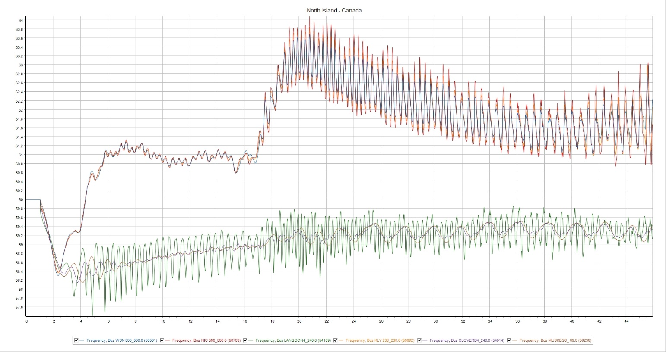
Figure 1: Unstable System
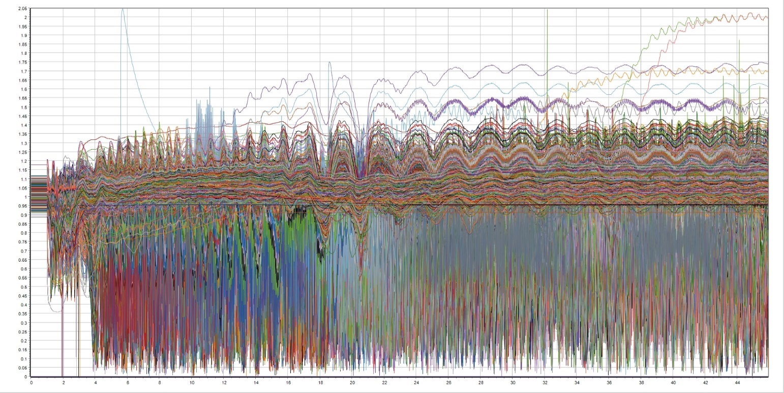
Figure 2: Sub-100kV Voltage

WECC 2024LSP Case
Load = 92,054 MW Generation Output = 94,604 MW

W24LSP Imbalance
Imbalance | Generation Tripped, MW |  | Imbalance
Target | Target | Actual | Actual
10% | 11,756 | 12,761 | 11.1%
20% | 20,961 | 21,208 | 20.3%
25% | 25,564 | 24,790 | 24.2%

W24LSP Frequency Performance
The frequency response plots are included in Appendix A. Frequency performance results from these plots for the 10%, 20%, and 25% imbalance simulations meet requirements specified in D.B.3.1 and D.B.3.2 in PRC-006-5.

North Island Study

North 2021HS Case
Load = 79,272 MW Generation Output = 84,455 MW

N21HS Imbalance
Imbalance | Generation Tripped, MW |  | Imbalance
Target | Target | Actual | Actual
10% | 13,110 | 13,162 | 10.1%
20% | 21,037 | 23,659 | 23.3%
25% | 25,001 | 26,487 | 26.9%

N21HS Frequency Performance
The frequency response plots are included in Appendix A. Frequency performance results from these plots for the 10% and 20% imbalance simulations meet requirements specified in D.B.3.1 and D.B.3.2 in PRC-006-5. However, the 25% imbalance simulation failed to run the required amount of time and failed at 35 seconds, shown in Figure 3. Additional results point to voltage collapse at lower voltage levels, shown in Figure 4. Because of this, the WECC Plan does not meet the frequency performance requirements specified in D.B.3.1 and D.B.3.2 in PRC-006-5 for the 25% imbalance.
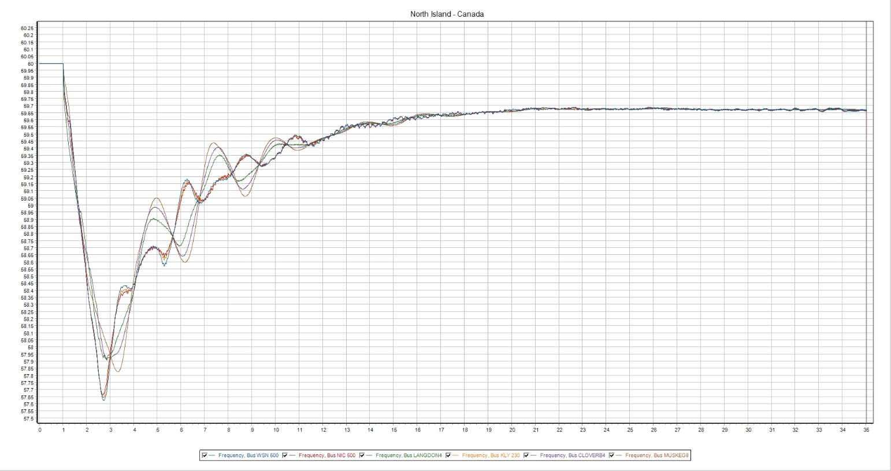
Figure 3: Simulation aborts at 35 seconds
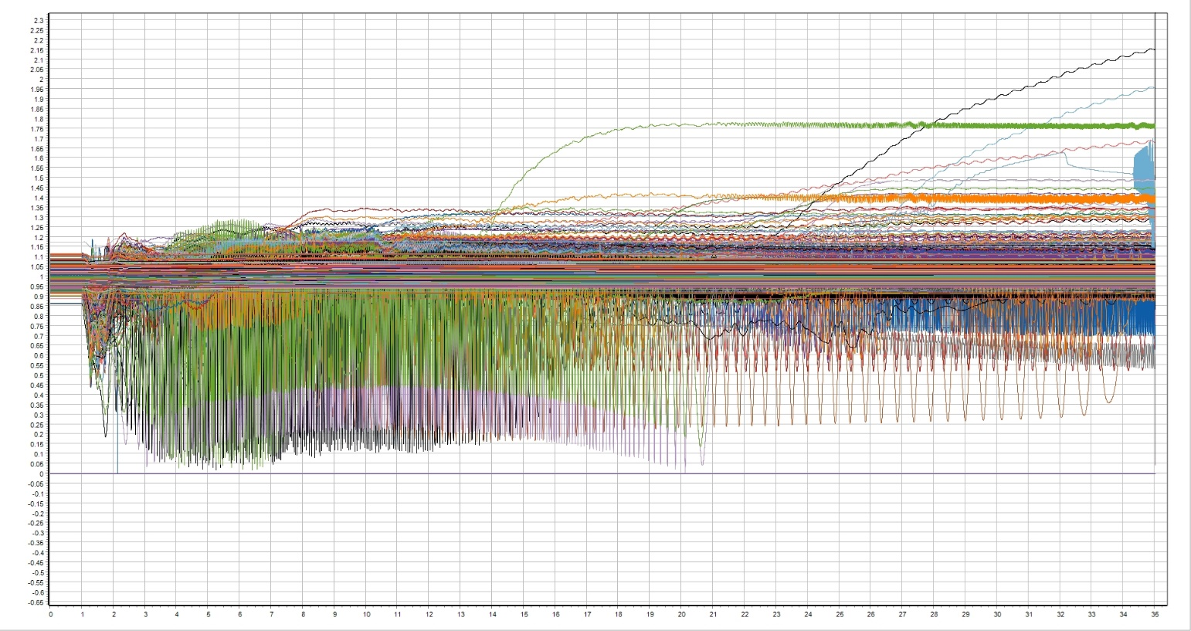
Figure 4: Sub-100kV Voltage

North 2024LSP Case
Load = 48,438 MW Generation Output = 49,499 MW

N24LSP Imbalance
Imbalance | Generation Tripped, MW |  | Imbalance
Target | Target | Actual | Actual
10% | 5,905 | 6,053 | 10.3%
20% | 10,749 | 11,321 | 21.2%
25% | 13,171 | 13,319 | 25.3%

N24LSP Frequency Performance
The frequency response plots are included in Appendix A. Frequency performance results from these plots for the 10%, 20%, and 25% imbalance simulations meet requirements specified in D.B.3.1 and D.B.3.2 in PRC-006-5.

South Island Study

South 2021HS Case
Load = 91,529 MW Generation Output = 91,685 MW

S21HS Imbalance
Imbalance | Generation Tripped, MW |  | Imbalance
Target | Target | Actual | Actual
10% | 9,308 | 9,346 | 10.0%
20% | 18,461 | 18,654 | 20.2%
25% | 23,038 | 23,274 | 25.3%

S21HS Frequency Performance
The frequency response plots are included in Appendix A. Frequency performance results from these plots for the 10%, 20%, and 25% imbalance simulations meet requirements specified in D.B.3.1 and D.B.3.2 in PRC-006-5.

South 2024LSP Case
Load = 43,313 MW Generation Output = 44,826 MW

S24LSP Imbalance
Imbalance | Generation Tripped, MW |  | Imbalance
Target | Target | Actual | Actual
10% | 5,844 | 5,768 | 9.8%
20% | 10,175 | 10,127 | 19.9%
25% | 12,341 | 12,239 | 24.8%

S24LSP Frequency Performance
The frequency response plots are included in Appendix A. Frequency performance results from these plots for the 10%, 20%, and 25% imbalance simulations meet requirements specified in D.B.3.1 and D.B.3.2 in PRC-006-5.

V/Hz Performance Check
A V/Hz performance check was done for the WECC, North, and South island simulations. This check is performed on synchronous generators and the high side terminals of generator step-up transformers because of the potential for high V/Hz levels to damage this equipment through elevated magnetic saturation. V/Hz is the voltage of the element (generator terminals or transformer high-side terminals), in per-unit, divided by the frequency at the same location, also in per-unit. This value is then evaluated relative to PRC-006-5, D.B.3.3:
V/Hz Threshold | Time Limit
1.18 per-unit | 2.0 sec
1.1 per-unit | 45.0 sec (Cumulative)

South Island
2021HS case: 25 criteria exceedances were flagged in the 2021 HS3 South Island 25% imbalance simulation. See Appendix E for WECC Power Flow Areas.
Area | Generator Bus | Violation
10 | 10261 Unit 1 | 1.18 pu 2 seconds
 | 10262 Unit 1 | 1.18 pu 2 seconds
16 | 160425 Unit PV | Both
 | 160435 Unit Q1 | 1.1 pu 45 seconds
 | 160902 Unit 1 | Both
 | 160926 Unit 1 | Both
 | 160930 Unit 1 | Both
21 | 21458 Unit 1 | Both
24 | 24026 Unit D1 | 1.1 pu 45 seconds
 | 24248 Unit EQ | 1.1 pu 45 seconds
 | 24457 Unit 1 | 1.1 pu 45 seconds
 | 24491 Unit 1 | 1.1 pu 45 seconds
 | 24695 Unit EQ | Both
 | 24695 Unit EQ | Both
 | 29591 Unit 7 | 1.1 pu 45 seconds
 | 29592 Unit 1 | 1.1 pu 45 seconds
 | 29659 Unit EQ | 1.1 pu 45 seconds
26 | 26026 Unit 1 | 1.18 pu 2 seconds

2024LSP case: Zero criteria exceedances were flagged in the 2024 LSP South Island 25% imbalance simulation.

North Island
2021HS case: 39 criteria exceedances were flagged in the 2021 HS North Island 20% imbalance simulation. The 25% imbalance simulation results are not reported below because of failure to run the entire 60 seconds. See Appendix E for WECC Power flow Areas.
Area | Generator Bus | Violation
40 | 44980 Unit 1 | 1.18 pu 2 seconds
 | 47688 Unit L | Both
 | 47924 Unit Z1 | Both
 | 47974 Unit Z1 | 1.18 pu 2 seconds
50 | 50306 Unit 1 | 1.18 pu 2 seconds
 | 50637 Unit 1 | 1.1 pu 45 seconds
 | 50640 Unit 4 | 1.1 pu 45 seconds
 | 51140 Unit 1 | 1.1 pu 45 seconds
54 | 56401 Unit G2 | 1.1 pu 45 seconds
 | 58030 Unit ST | 1.1 pu 45 seconds
 | 59835 Unit G1 | 1.1 pu 45 seconds
 | 59935 Unit G2 | 1.1 pu 45 seconds
 | 560026 Unit G1 | 1.1 pu 45 seconds
 | 560894 Unit G1 | 1.1 pu 45 seconds
 | 561026 Unit G2 | 1.1 pu 45 seconds
 | 562026 Unit G3 | 1.1 pu 45 seconds
60 | 60188 Unit 1 | Both
 | 60121 Unit 1 | 1.1 pu 45 seconds
 | 60345 Unit NT | 1.1 pu 45 seconds
62 | 623581 Unit 1 | 1.18 pu 2 seconds
65 | 65583 Unit 1 | Both
 | 65680 Unit 1 | Both
 | 69517 Unit 1 | 1.1 pu 45 seconds
 | 69527 Unit 1 | 1.1 pu 45 seconds
73 | 79150 Unit 1 | Both
 | 79151 Unit 3 | Both
 | 79151 Unit 4 | Both
 | 79153 Unit 7 | Both
 | 79153 Unit 8 | Both

2024LSP case: 17 criteria exceedances were flagged in the 2024 LSP North Island 25% imbalance simulation. See Appendix E for WECC Power flow Areas.
Area | Generator Bus | Violation
40 | 42997 Unit Z1 | 1.1 pu 45 seconds
 | 44980 Unit 1 | 1.1 pu 45 seconds
50 | 50295 Unit 2 | 1.1 pu 45 seconds
 | 50296 Unit 3 | 1.18 pu 2 seconds
 | 50297 Unit 4 | 1.18 pu 2 seconds
54 | 570008 | 1.1 pu 45 seconds
60 | 60314 Unit 1 | Both
65 | 65391 Unit 1 | Both
 | 65583 Unit 1 | Both
 | 65778 Unit 1 | 1.1 pu 45 seconds
 | 67908 Unit 2 | Both
 | 69020 Unit 1 | 1.1 pu 45 seconds
 | 69523 Unit 1 | 1.1 pu 45 seconds

WECC Island
2021HS case: Five criteria exceedances were flagged in the 2021 HS WECC Island 20% imbalance simulation. The 25% imbalance simulation results are not reported because of failure to run the entire 60 seconds. See Appendix E for WECC Power flow Areas.
Area | Generator Bus | Violation
26 | 26004 Unit 1 | 1.1 pu 45 seconds
 | 26005 Unit 2 | 1.1 pu 45 seconds
 | 26006 Unit 3 | 1.1 pu 45 seconds
 | 26026 Unit 1 | 1.18 pu 2 seconds
40 | 46188 Unit 9 | 1.1 pu 45 seconds

2024LSP case: 35 criteria exceedances were flagged in the 2024 LSP WECC Island 25% imbalance simulation. See Appendix E for WECC Power flow Areas.
Area | Generator Bus | Violation
24 | 24560 Unit 1 | 1.1 pu 45 seconds
 | 29418 Unit 2 | 1.1 pu 45 seconds
 | 29421 Unit 3 | 1.1 pu 45 seconds
 | 29425 Unit 4 | 1.1 pu 45 seconds
 | 29428 Unit 5 | 1.1 pu 45 seconds
 | 29434 Unit 8 | Both
 | 29437 Unit 9 | Both
 | 29591 Unit 7 | 1.1 pu 45 seconds
40 | 42997 Unit Z1 | 1.1 pu 45 seconds
 | 44980 Unit 1 | 1.1 pu 45 seconds
 | 47866 Unit Z1 | 1.1 pu 45 seconds
50 | 50172 Unit 1 | 1.1 pu 45 seconds
 | 50173 Unit 2 | 1.1 pu 45 seconds
 | 50174 Unit 3 | 1.1 pu 45 seconds
 | 50295 Unit 2 | 1.18 pu 2 seconds
 | 50296 Unit 3 | 1.18 pu 2 seconds
 | 50297 Unit 4 | 1.18 pu 2 seconds
 | 50500 Unit 6 | 1.1 pu 45 seconds
 | 50959 Unit 1 | 1.1 pu 45 seconds
 | 50960 Unit 2 | 1.1 pu 45 seconds
 | 50966 Unit 8 | 1.1 pu 45 seconds
54 | 560003 Unit G1 | 1.1 pu 45 seconds
 | 570008 Unit G1 | 1.1 pu 45 seconds
60 | 60314 Unit 1 | Both
65 | 65391 Unit 1 | Both
 | 65583 Unit 1 | Both
 | 67908 Unit 2 | Both
 | 69020 Unit 1 | 1.1 pu 45 seconds
 | 69523 Unit 1 | 1.1 pu 45 seconds

Armed Load Data Validation
As part of the validation check of UFLS data submittals received from the UFLS entities, the amount of load armed for each Load Shed Block of the WECC Plan was tabulated for both the 2021 Heavy Summer and the 2024 Light Spring cases. This benchmarks the consistency between actual implementation of the WECC Plan by UFLS entities compared to its design. The values in the Plan Design columns reflect the Primary WECC plan, NWPP sub-plan, and SILTP sub-plan descriptions in the WECC Plan and are tabulated here for easy comparison. The percentages in these columns are minimum requirements. The values in the “Modeled” columns of Table 3 and Table 4 represent the amount of load armed for underfrequency shedding within the North and South islands—these percentages are the ratio of armed load shed data submitted by UFLS entities to the connected bus load in the case, computed for each Load Shed Block.
Table 3: Armed Load Shed Data Validation for the 2021 Heavy Summer Case
 | Modeled Armed Load Validation 2021 Heavy Summer Case
Load Shed Block BlockBlock | North Island (NWPP & WECC plans) |  |  | South Island (SILTP plan)
 | Plan Design NWPP | Plan Design WECC | Modeled | Plan Design SILTP | Modeled
 | n/a | n/a | n/a | ~4.0% (DLT) | ~0%
1 | 5.6%  (59.3 Hz) | 5.3%  (59.1 Hz) | 8.9%  (≥ 59.1 Hz) | 5.3%  (59.1 Hz) | 6.1%  (59.1 Hz)
2 | 5.6%  (59.2 Hz) | 5.9%  (58.9 Hz) | 4.5%  (≥ 58.9, < 59.1 Hz) | 5.9%  (58.9 Hz) | 5.9%  (58.9 Hz)
3 | 5.6%  (59.0 Hz) | 6.5%  (58.7 Hz) | 5.0%  (≥ 58.7, <58.9 Hz) | 6.5%  (58.7 Hz) | 6.7%  (58.7 Hz)
4 | 5.6%  (58.8 Hz) | 6.7%  (58.5 Hz) | 5.5%  (≥ 58.5, < 58.7 Hz) | 6.7%  (58.5 Hz) | 6.5%  (58.5 Hz)
5 | 5.6%  (58.6 Hz) | 6.7%  (58.3 Hz) | 3.4%  (≥58.3, < 58.5 Hz) | 6.7%  (58.3 Hz) | 6.4%  (58.3 Hz)
< 58.3 Hz |  |  | 1.6% |  | 18.7%
TOTAL | 28.0% | 31.1% | 28.9% | 35.1% | 50.3%
UF Stalling | 6.0% | 6.0% | 4.0% | 6.0% | 6.2%

Table 4: Armed Load Shed Data Validation for the 2024 Light Spring Case
 | Modeled Armed Load Validation 2024 Light Spring Case
Load Shed Block | North Island (NWPP & WECC plans) |  |  | South Island (SILTP plan)
 | Plan Design NWPP | Plan Design WECC | Modeled | Plan Design SILTP | Modeled
 | n/a | n/a | n/a | ~4.0% (DLT) | ~0%
1 | 5.6%  (59.3 Hz) | 5.3%  (59.1 Hz) | 8.6%  (≥ 59.1 Hz) | 5.3%  (59.1 Hz) | 5.5%  (59.1 Hz)
2 | 5.6%  (59.2 Hz) | 5.9%  (58.9 Hz) | 4.3%  (≥ 58.9, < 59.1 Hz) | 5.9%  (58.9 Hz) | 5.5%  (58.9 Hz)
3 | 5.6%  (59.0 Hz) | 6.5%  (58.7 Hz) | 4.4%  (≥ 58.7, <58.9 Hz) | 6.5%  (58.7 Hz) | 6.2%  (58.7 Hz)
4 | 5.6%  (58.8 Hz) | 6.7%  (58.5 Hz) | 4.6%  (≥ 58.5, < 58.7 Hz) | 6.7%  (58.5 Hz) | 5.7%  (58.5 Hz)
5 | 5.6%  (58.6 Hz) | 6.7%  (58.3 Hz) | 2.6%  (≥58.3, < 58.5 Hz) | 6.7%  (58.3 Hz) | 5.1%  (58.3 Hz)
< 58.3 Hz |  |  | 1.2% |  | 13.8%
TOTAL | 28.0% | 31.1% | 23.7% | 35.1% | 41.8%
UF Stalling | 6.0% | 6.0% | 3.7% | 6.0% | 4.1%

North Island—Note that, in Table 3 and Table 4, the Total Armed Load modeled in the North Island falls short of what is required by plan design for both the 2021 Heavy Summer and 2024 Light Spring cases. Assuming the connected load in the North Island is almost equally distributed between the NWPP plan and WECC plan, the Total Armed Load, per plan design, would be 29.55% (average of 28.0% and 31.1%). In the 2021 Heavy Summer, the modeled Total Armed Load percentage is 28.9% and, in the 2024 Light Spring, it is 23.7%. This results in armed load deficits of 0.7% and 5.9%, respectively.
South Island—Similarly, the Total Armed Load modeled in the South Island is much higher than what is required by plan design for both the 2021 Heavy Summer and the 2024 Light Spring cases—a surplus of 15.2% in the 2021 Heavy Summer and 6.7% in the 2024 Light Spring.
The Armed Load Data Validation also serves as the prerequisite step for performing the Armed Load Adequacy Check for the WECC Plan (see next section).

Armed Load Adequacy Check
This check provides another metric for evaluating the adequacy and effectiveness of the implemented (i.e., modeled) WECC Plan. Comparing the amount of actual load shed during the underfrequency event simulation with the amount of total armed load (i.e., maximum available load for shedding) in the model allows computing the remaining or unused armed load—available armed load margin—as an indicator of the adequacy of the WECC Plan’s implementation. The difference between this section and the previous section is that this section shows how much load is armed and is still available to be shed in the specified simulations (unused armed load), while the previous section shows how much load is armed compared to what is required in the WECC Plan.
As shown in Table 5 and Table 6 below, the total armed load in the North Island has significantly lower margin compared to the others. Tables 7 and 8 are taken from the previous assessment report and are included only for the purpose of comparison. As in the current assessment, the North Island has lower margin compared to the others. This should be monitored and verified in future UFLS assessments since validated low margin would be a reasonable basis for making appropriate design adjustments to the WECC primary plan and NWPP sub-area plan to provide additional armed load in the North Island. Note that results for the WECC and North Island 25% simulations are not included in Table 5. These two dynamic simulations didn’t finish but load was shed and the amount that was shed up to the point where the simulations stopped is provided in Footnote 4.
Table 5: Armed Load Adequacy for the 2021HS Case
Island |  |  |  | 25% Imbalance
 | Total (MW) | Armed (MW) | Armed (% of Total) | Shed (MW) | Shed (% of Armed) | Plan Margin %
WECC | 175,979 | 80,605 | 44.8% | Simulations Incomplete |  | 20.2%
North | 78,283 | 25,625 | 32.7% |  |  | 7.9%
South | 97,696 | 54,980 | 56.3% | 26,106 | 47.5% | 52.5%

Table 6: Armed Load Adequacy for the 2024LSP Case
Island |  |  |  | 25% Imbalance
 | Total (MW) | Armed (MW) | Armed (% of Total) | Shed (MW) | Shed (% of Armed) | Plan Margin %
WECC | 92,054 | 34,253 | 37.2% | 18,230 | 53.2% | 46.8%
North | 48,696 | 14,355 | 29.5% | 10,529 | 73.3% | 26.7%
South | 43,358 | 19,898 | 45.9% | 10,335 | 51.9% | 48.1%

Table 7: Armed Load Adequacy for 2019HS Case
Island |  |  |  | 25% Imbalance
 | Total (MW) | Armed (MW) | Armed (% of Total) | Shed (MW) | Shed (% of Armed) | Plan Margin %
WECC | 172,836 | 73,044 | 42.3% | 49,925 | 68.35% | 31.65%
North | 75,712 | 22,863 | 30.2% | 21,604 | 94.5% | 5.5%
South | 97,124 | 50,181 | 51.7% | 30,353 | 60.5% | 39.5%

Table 8: Armed Load Adequacy for 2019LSP Case
Island |  |  |  | 25% Imbalance
 | Total (MW) | Armed (MW) | Armed (% of Total) | Shed (MW) | Shed (% of Armed) | Plan Margin %
WECC | 9,5071 | 36,765 | 38.7% | 29,014 | 78.9% | 21.1%
North | 50,442 | 14,743 | 29.2% | 13,147 | 89.2% | 10.8%
South | 44,629 | 22,021 | 49.3% | 30,353 | 68.0% | 32.0%

Findings and Conclusions
This assessment of the WECC UFLS Plan was unable to demonstrate that it meets some of the performance characteristics defined in PRC-006-5. Specifically, PRC-006-5, D.B.3. requires it to maintain a steady-state frequency condition between 59.3 and 60.7 Hz under generation-to-load imbalance conditions of up to 25% within identified islands for 60 seconds or until steady-state conditions are achieved. In both the WECC and North Island 25% heavy summer imbalance scenarios, the software that was used for this assessment was either unable to complete the simulation to 60 seconds or provide meaningful results. The underlying cause has not been fully determined, but some of the symptoms are extreme low voltages, voltage collapse in multiple low voltage pockets (Figure 2), and formation of islands (Figure 1), in addition to the North and South islands in the WECC and North Island 25% heavy summer imbalance scenarios.
As shown in the Armed Load Adequacy Check section of this report, the North Island has a much lower armed load margin than the South Island in the 25% imbalance simulations, particularly under heavy load conditions. None of the imbalance simulations resulted in 100% of the armed load being shed, but as this level of load shed is approached, the addition of more armed load or WECC Plan design adjustments should be considered.
V/Hz results were tabulated for the 25% imbalance simulations for all but the 21HS WECC and North Islands. For these two scenarios, which stopped prematurely, V/Hz results would have been meaningless, so results were taken from the 20% imbalance simulations.

Recommendations
Due to findings and results in this assessment of the WECC Plan, the following recommendations are made:
- Both the WECC and North Island simulations under 25% imbalance conditions in the 21 HS scenario failed to run the required amount of time and therefore didn’t produce meaningful results. The UFLSWG should investigate the cause and develop a Corrective Action Plan if the WECC Plan is determined to be insufficient.
- While running the WECC and North Island simulations under 25% imbalance conditions in the 21 HS scenario identified in Recommendation 1, extreme low voltages in many areas were observed. The UFLSWG should determine whether these instances of low voltage could be remedied by modeling reactive devices that could operate in the time frame of the simulations.
- V/Hz violations need to be addressed.
  - Each PC should evaluate the affected units with violations in their control area and validate the behavior of the model. If model updates are required, these should be communicated to the necessary people.
- The current UFLS Methodology Document, which outlines how the UFLS Assessment is performed, should be reviewed by the UFLSWG to address:
  - Methods of causing imbalance (e.g., tripping generation, setting unit PGen to zero but allowing it to stay online, dynamically opening tie lines, adding load); and
  - Selection of generators to trip, including unit location, unit type (e.g., synchronous generator, IBR, must-runs).

Appendix A—Frequency Performance—WECC Island

21HS—10%
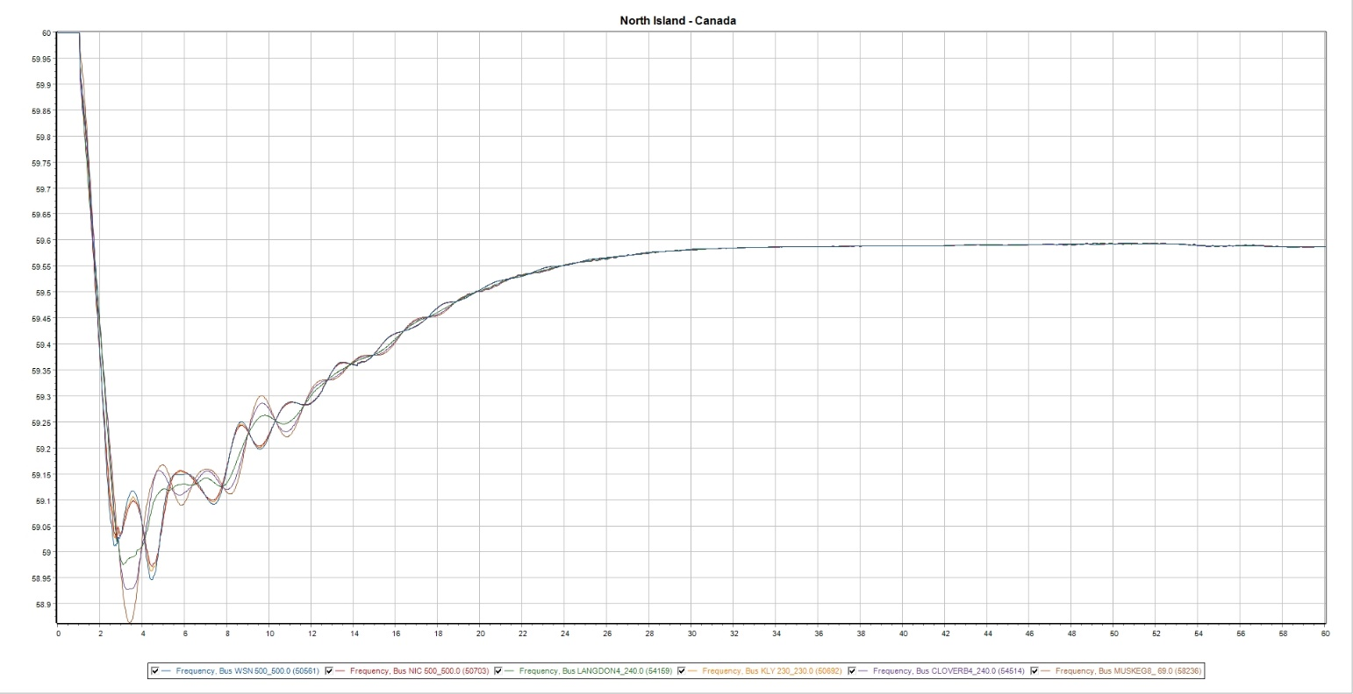

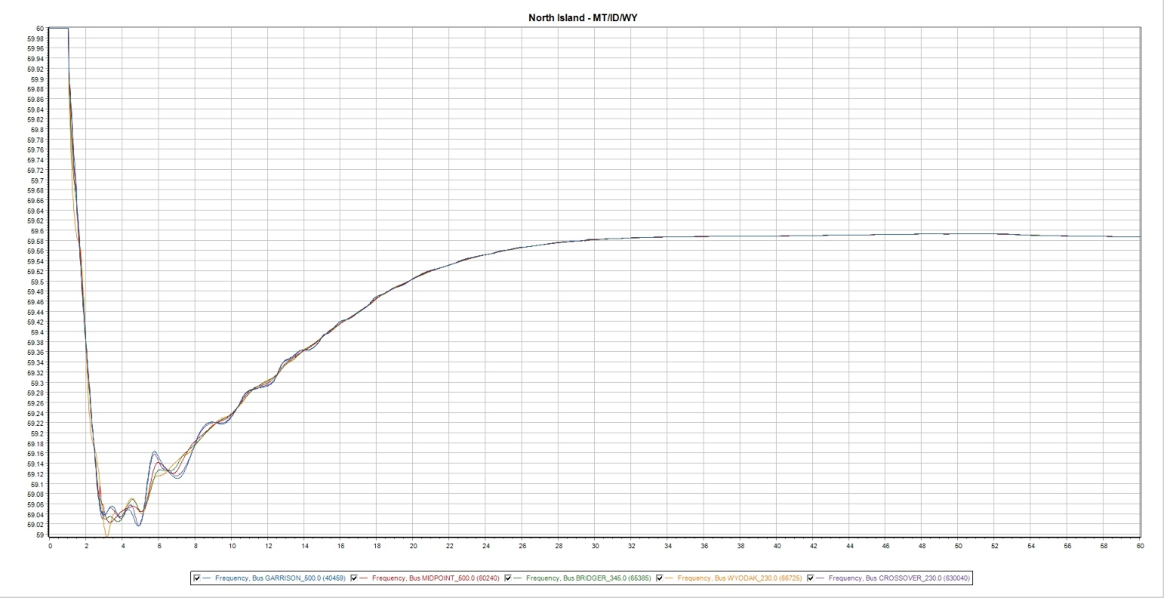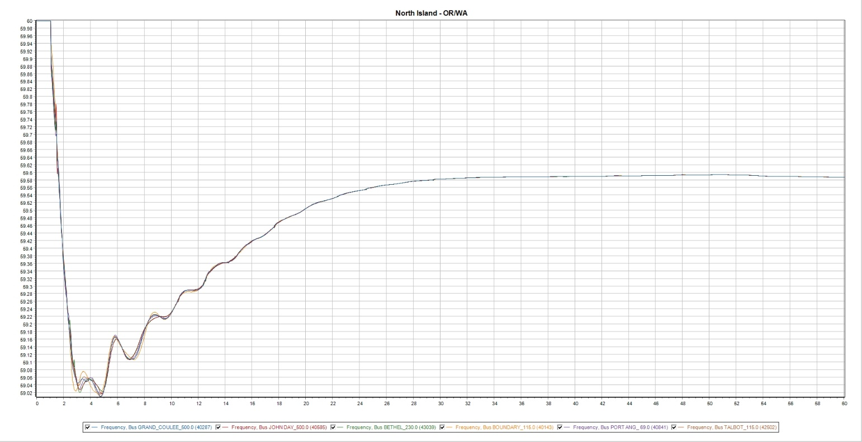

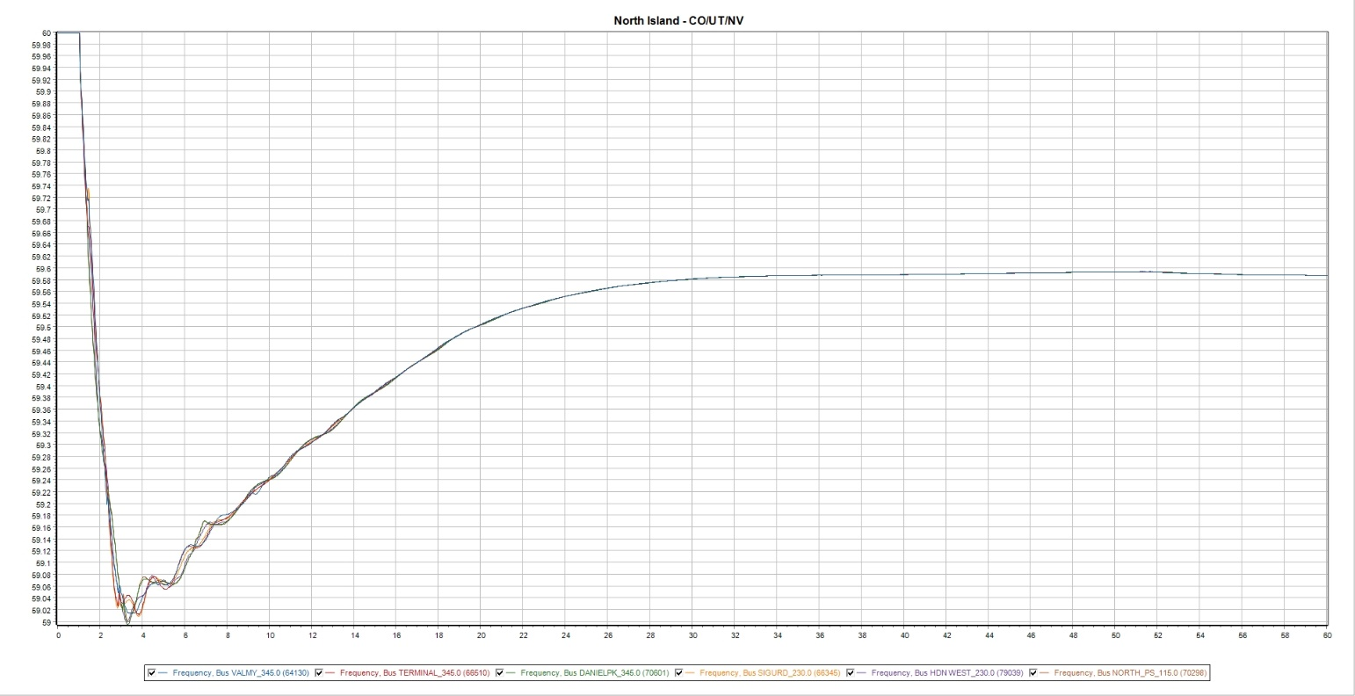

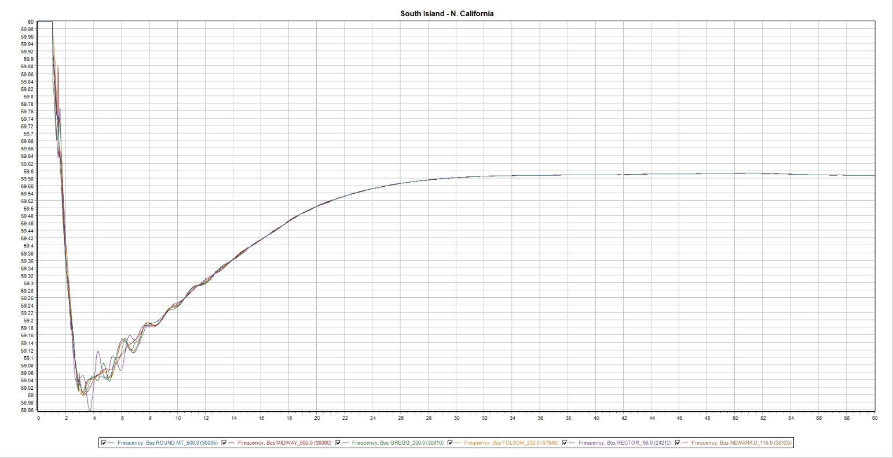

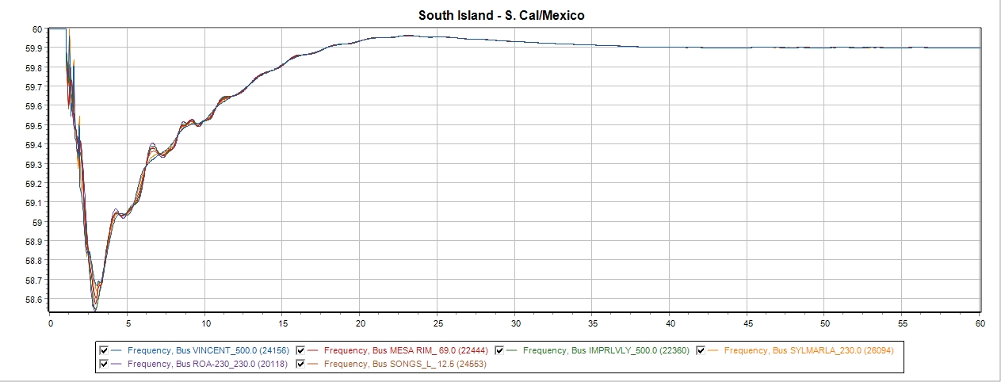

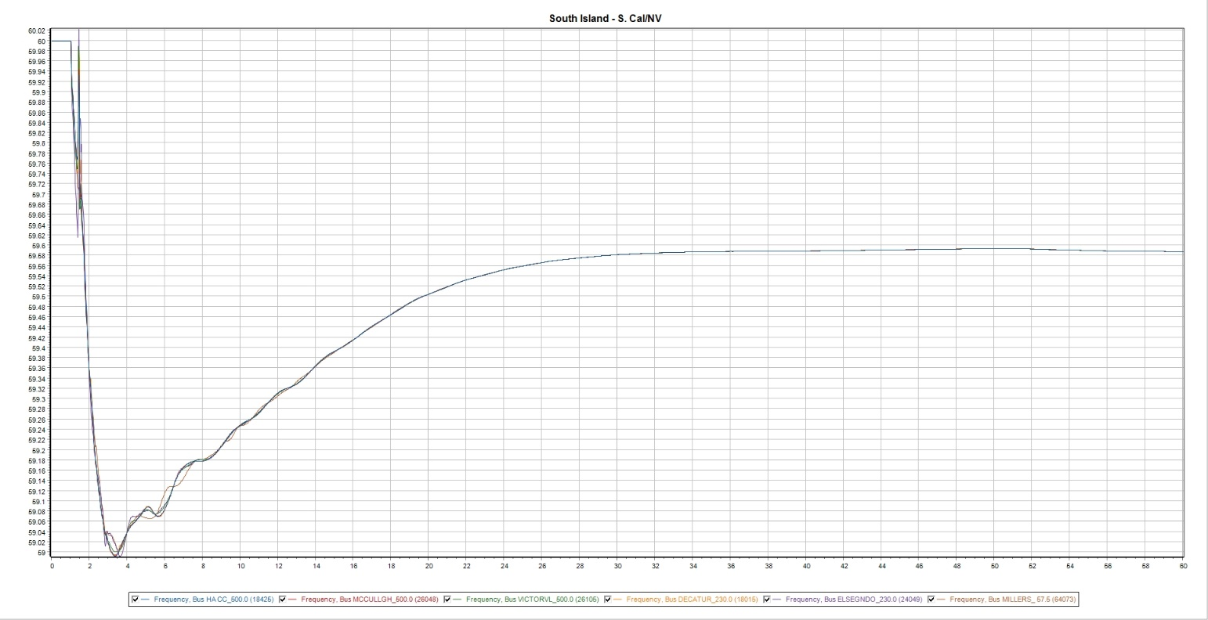

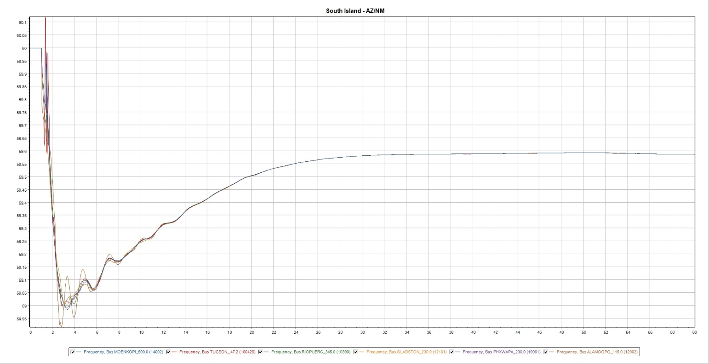

21HS—20%
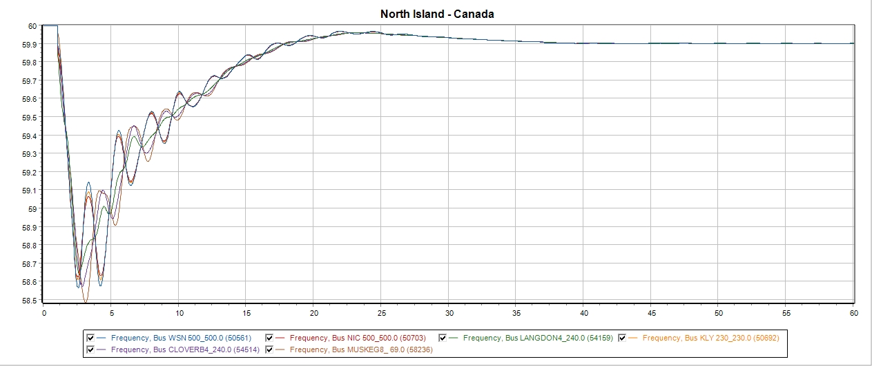

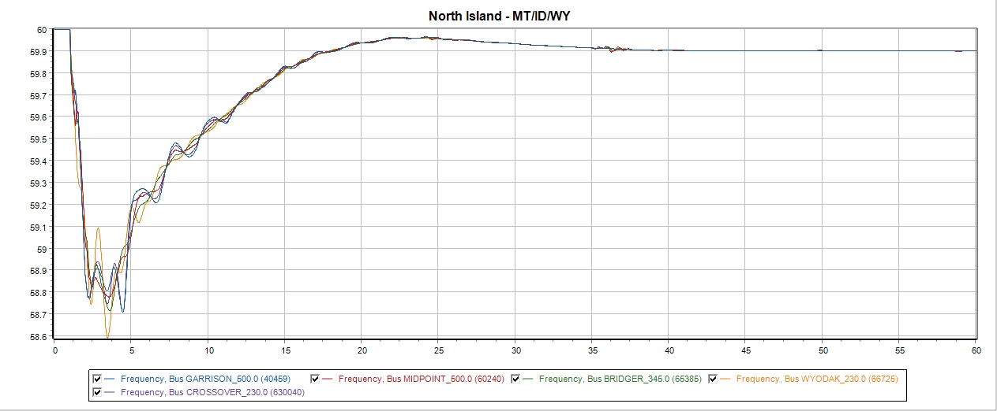
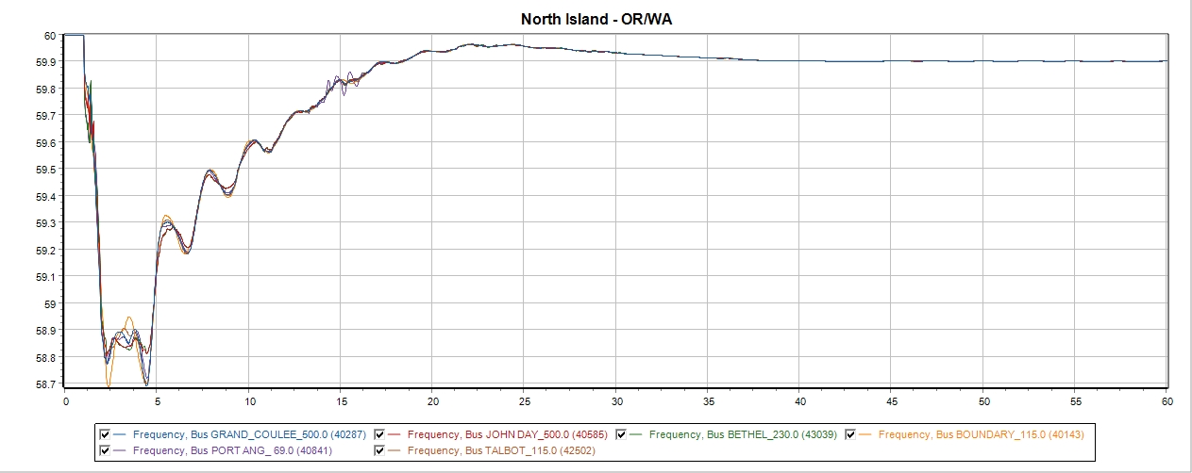

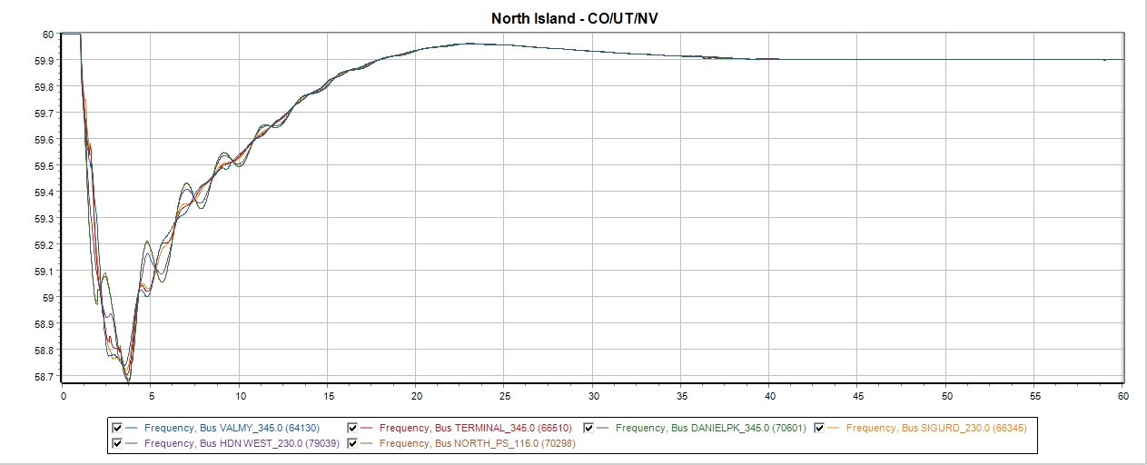
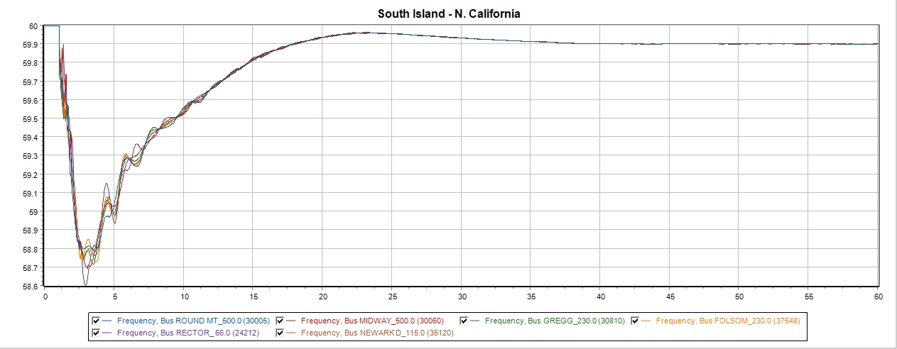

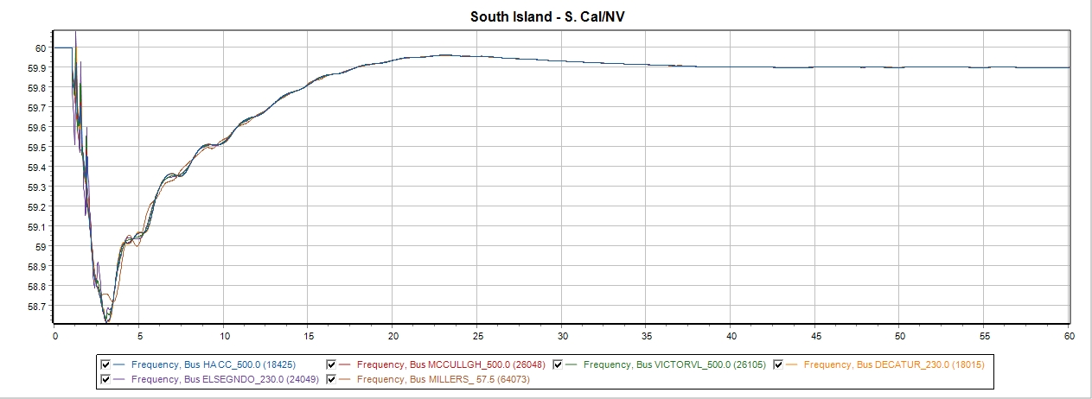

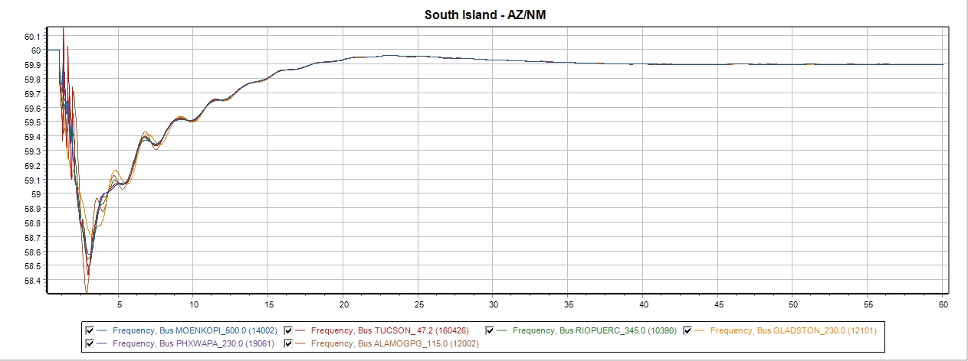

21HS—25%
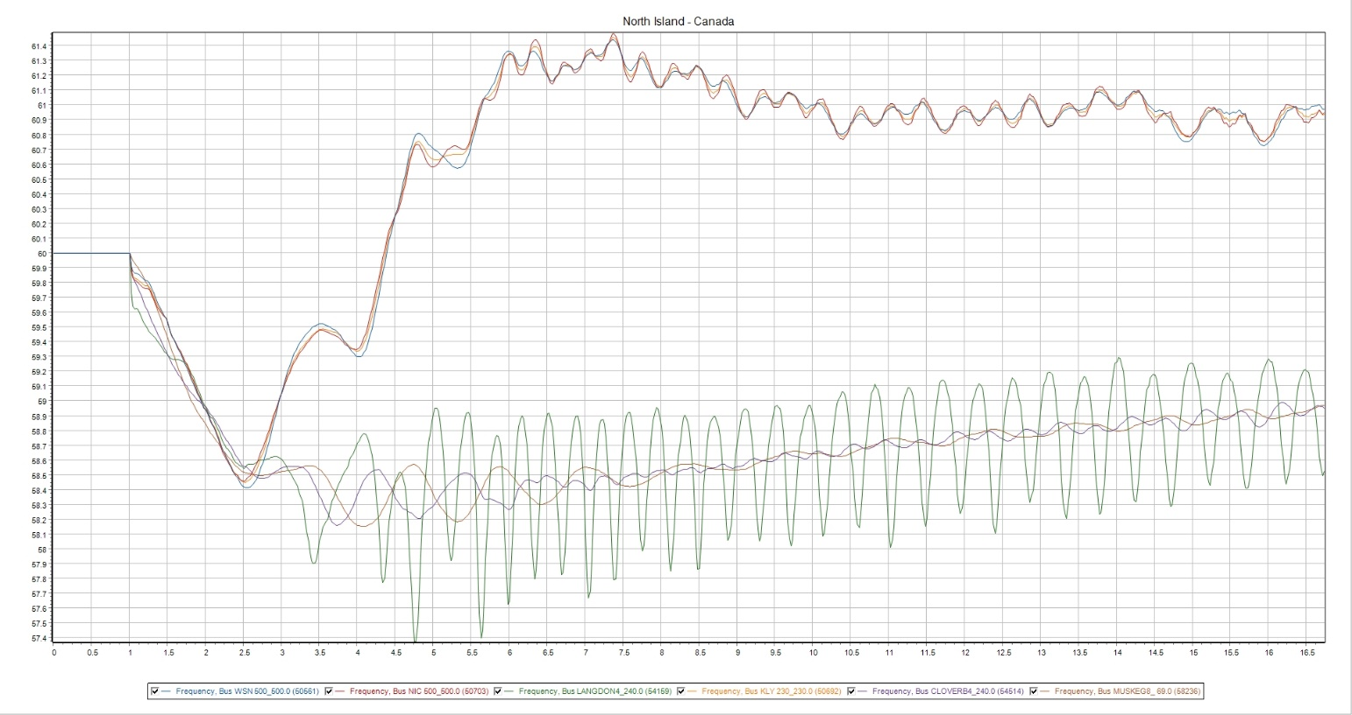

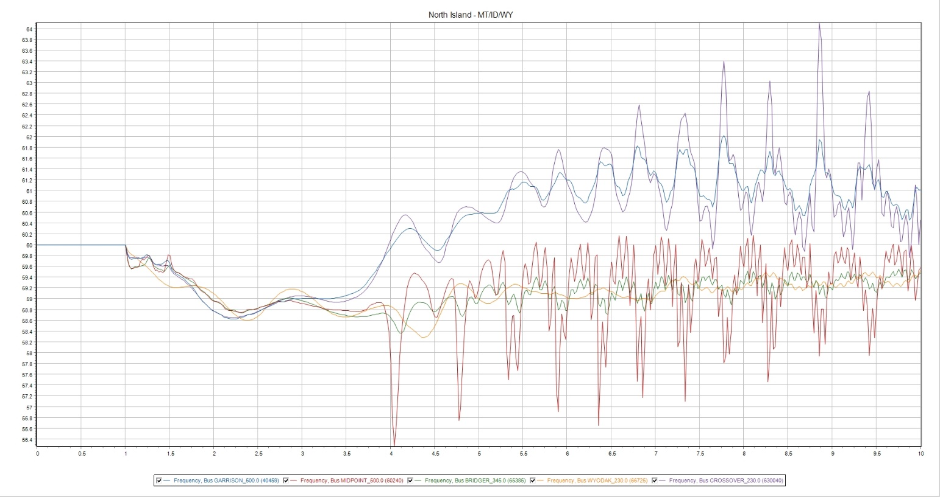

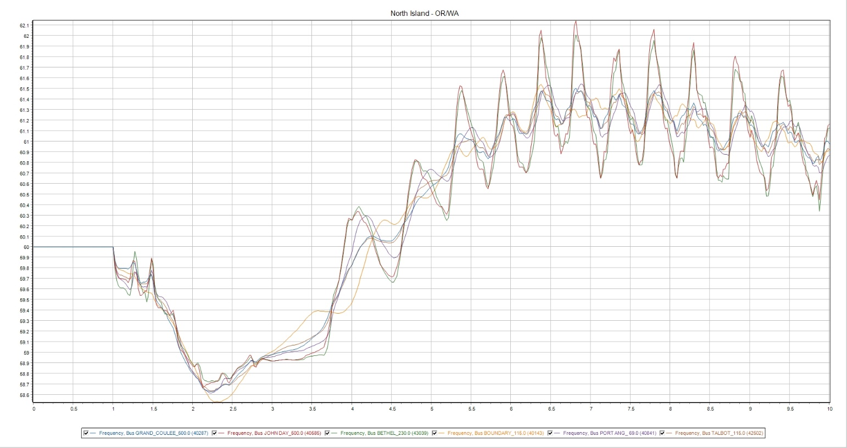

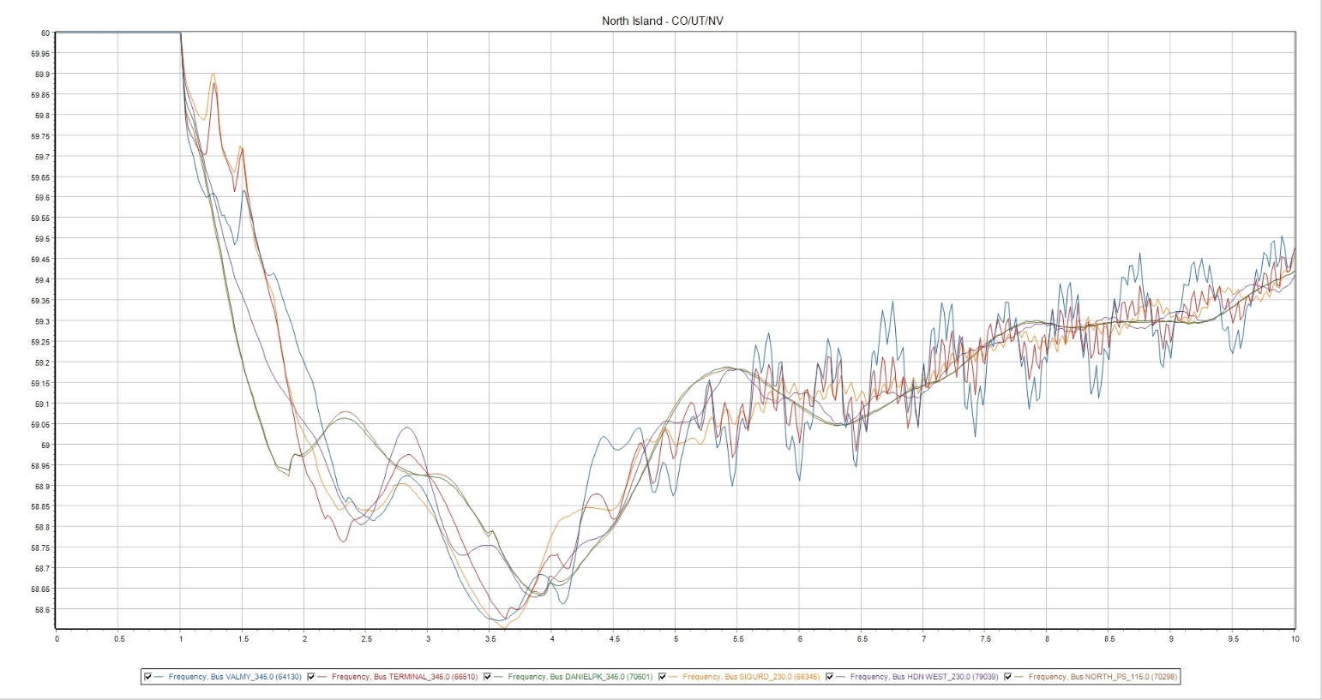

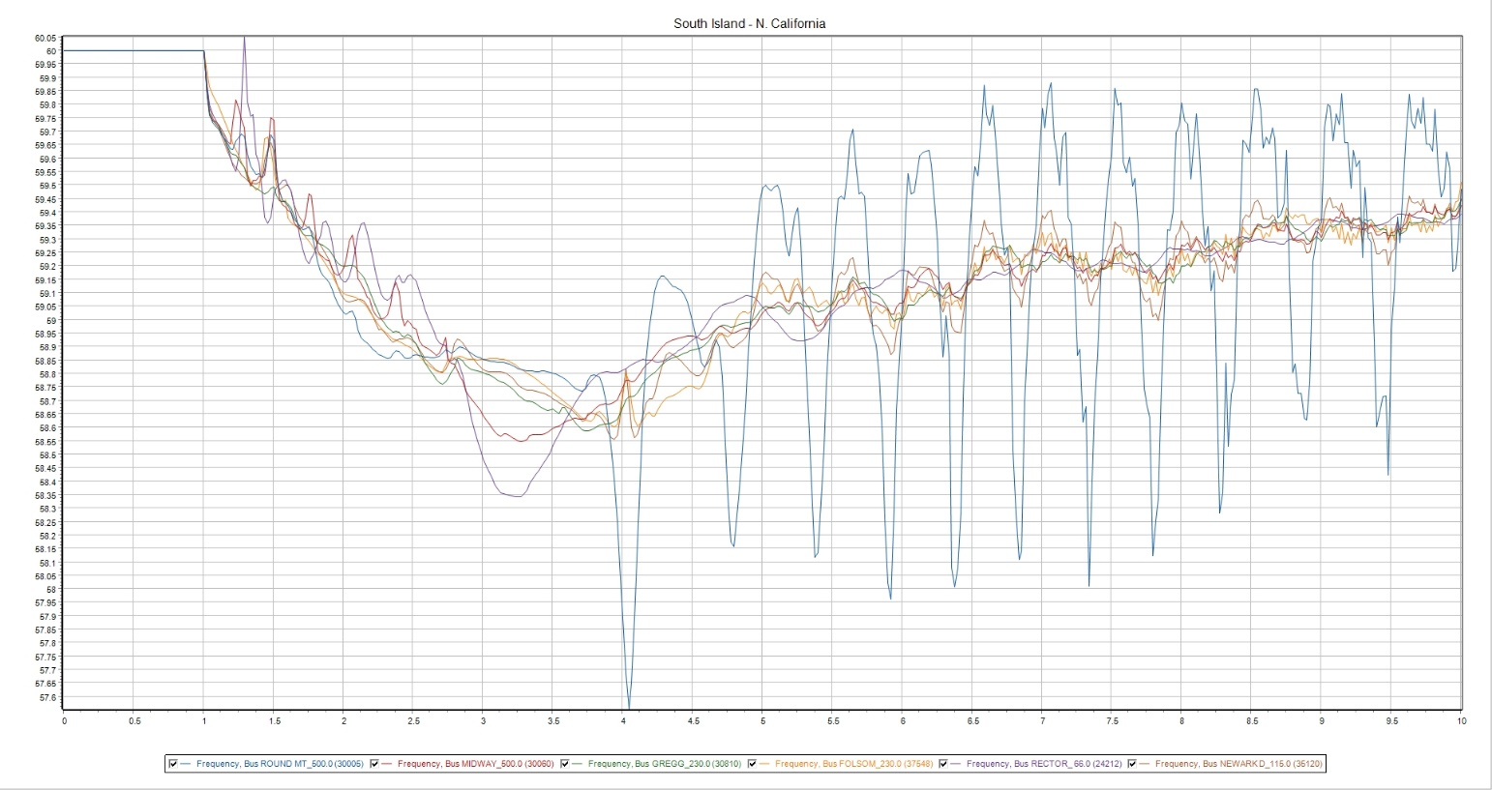

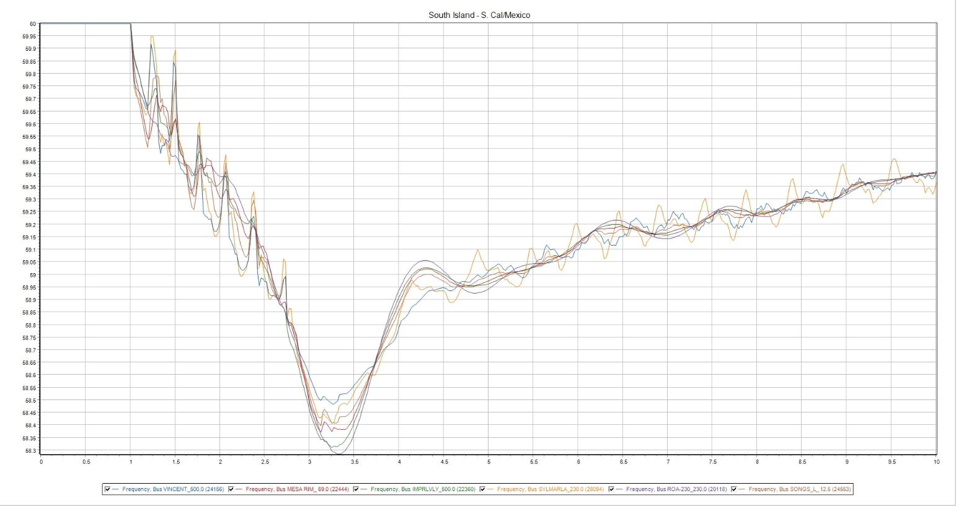

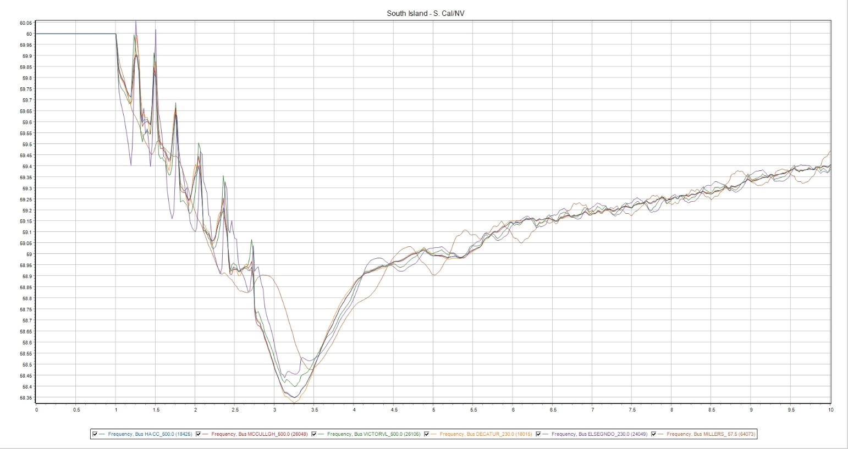

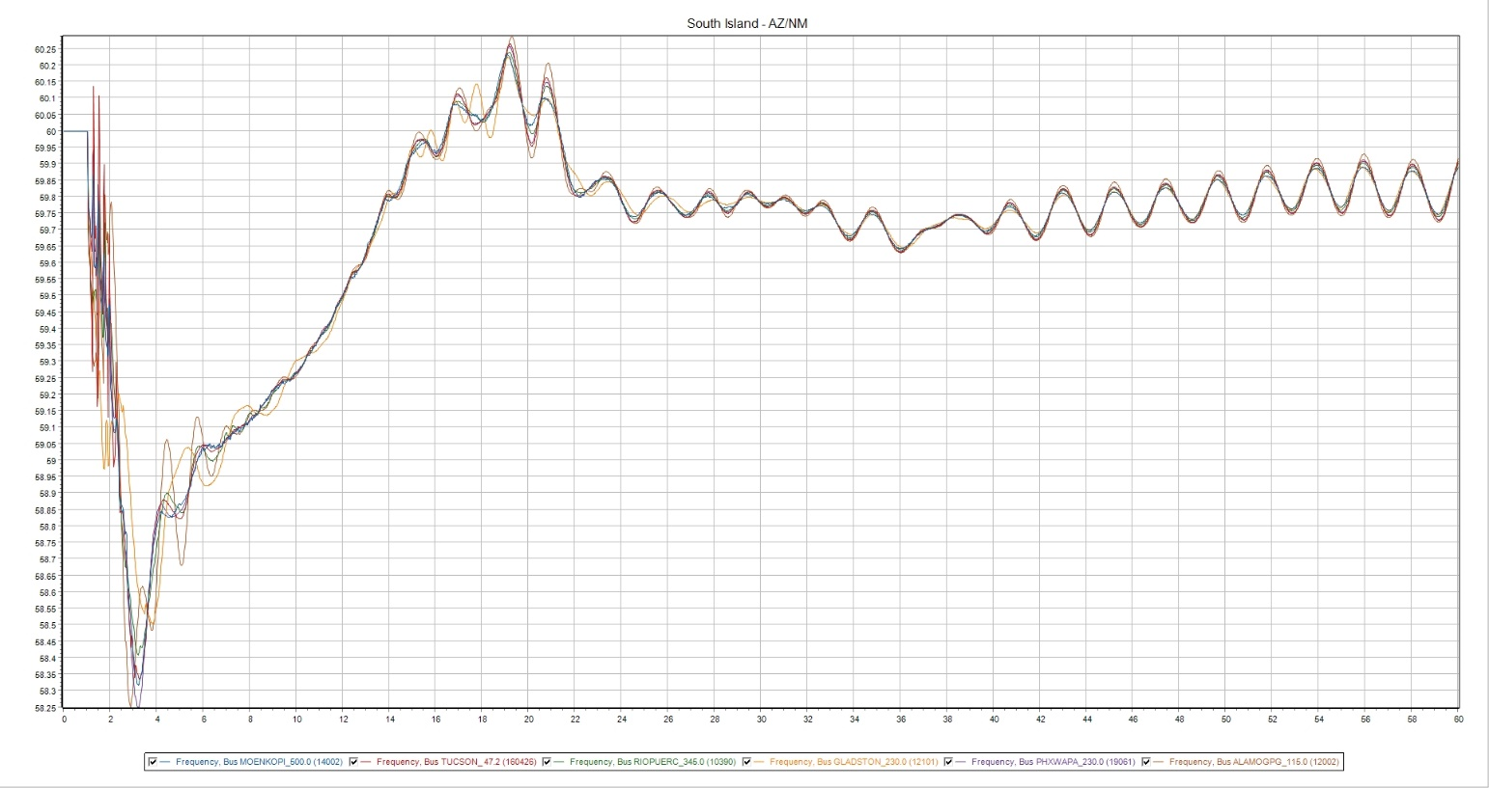

24LSP—10%
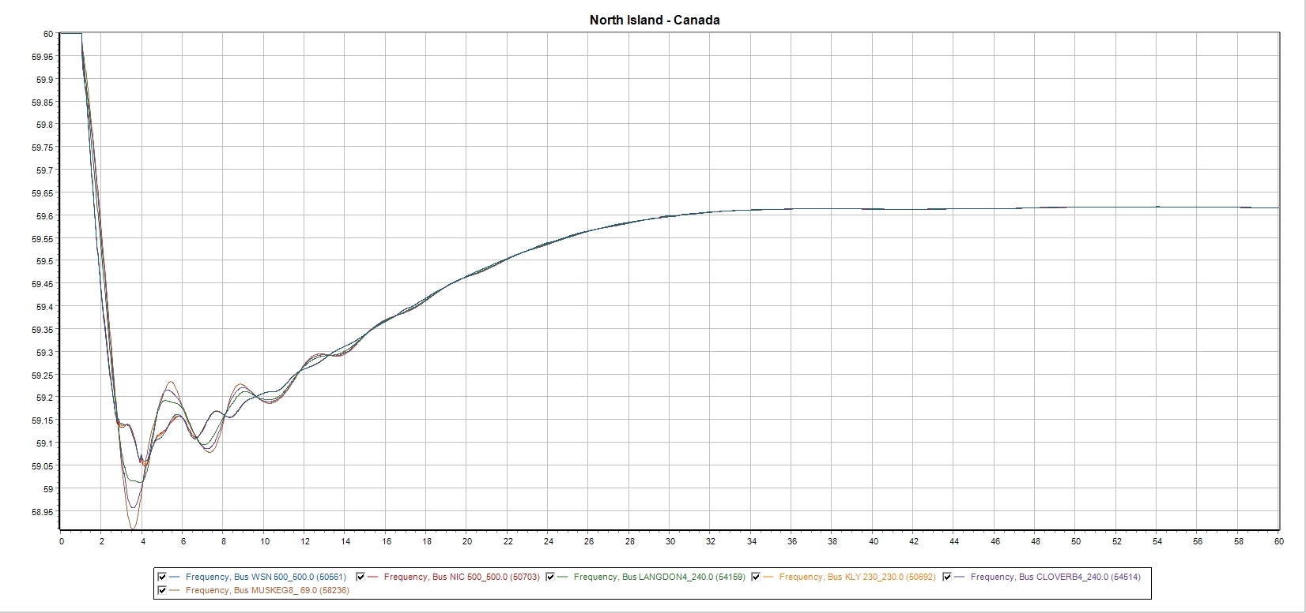

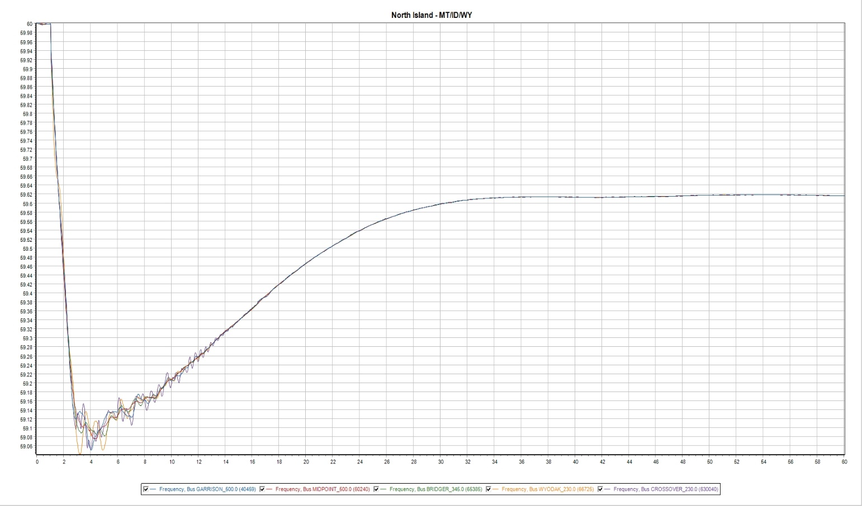
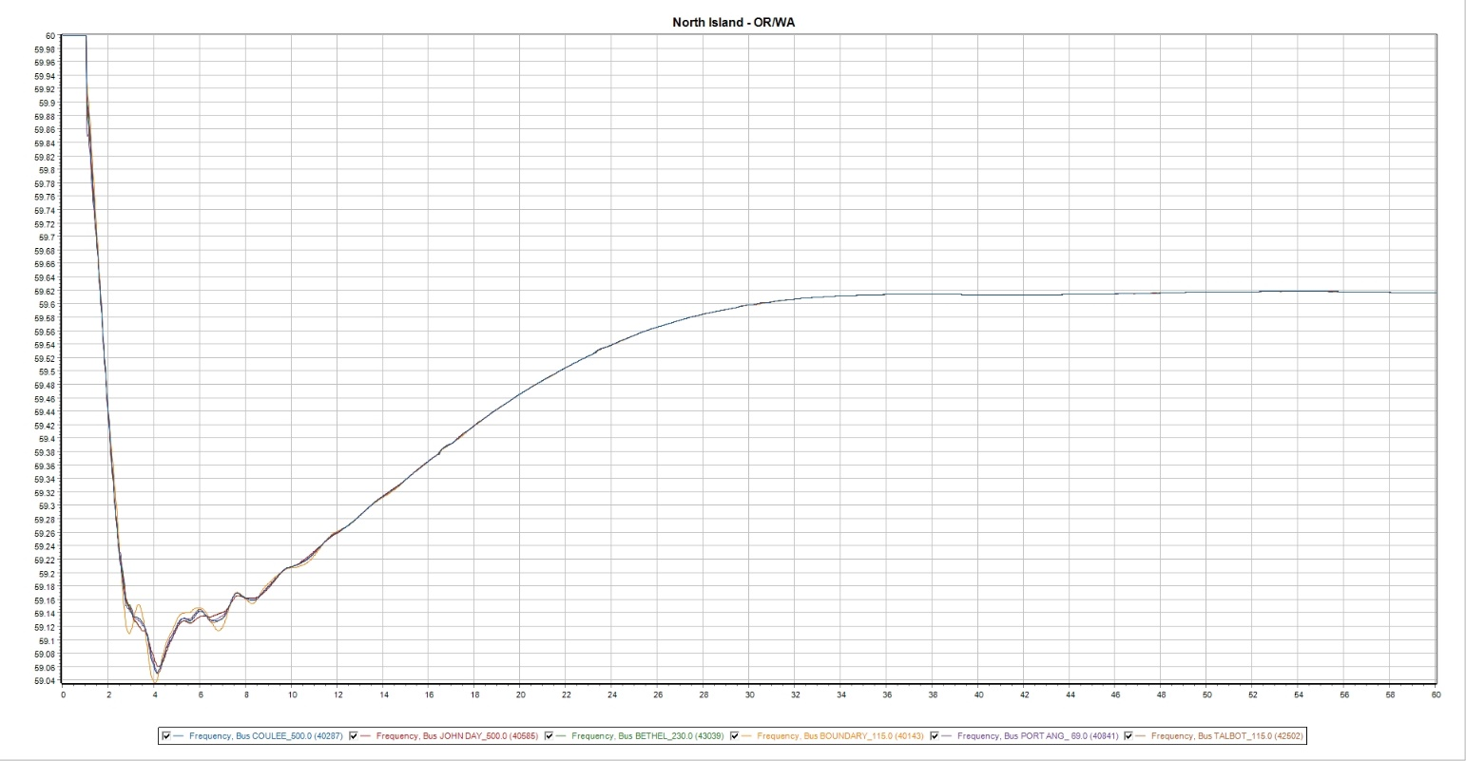

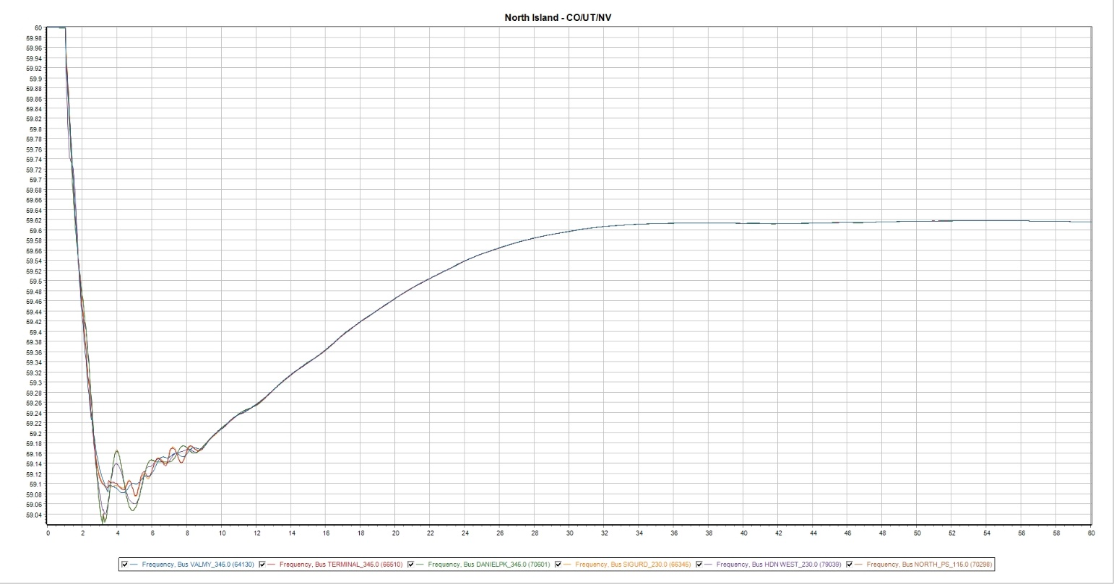

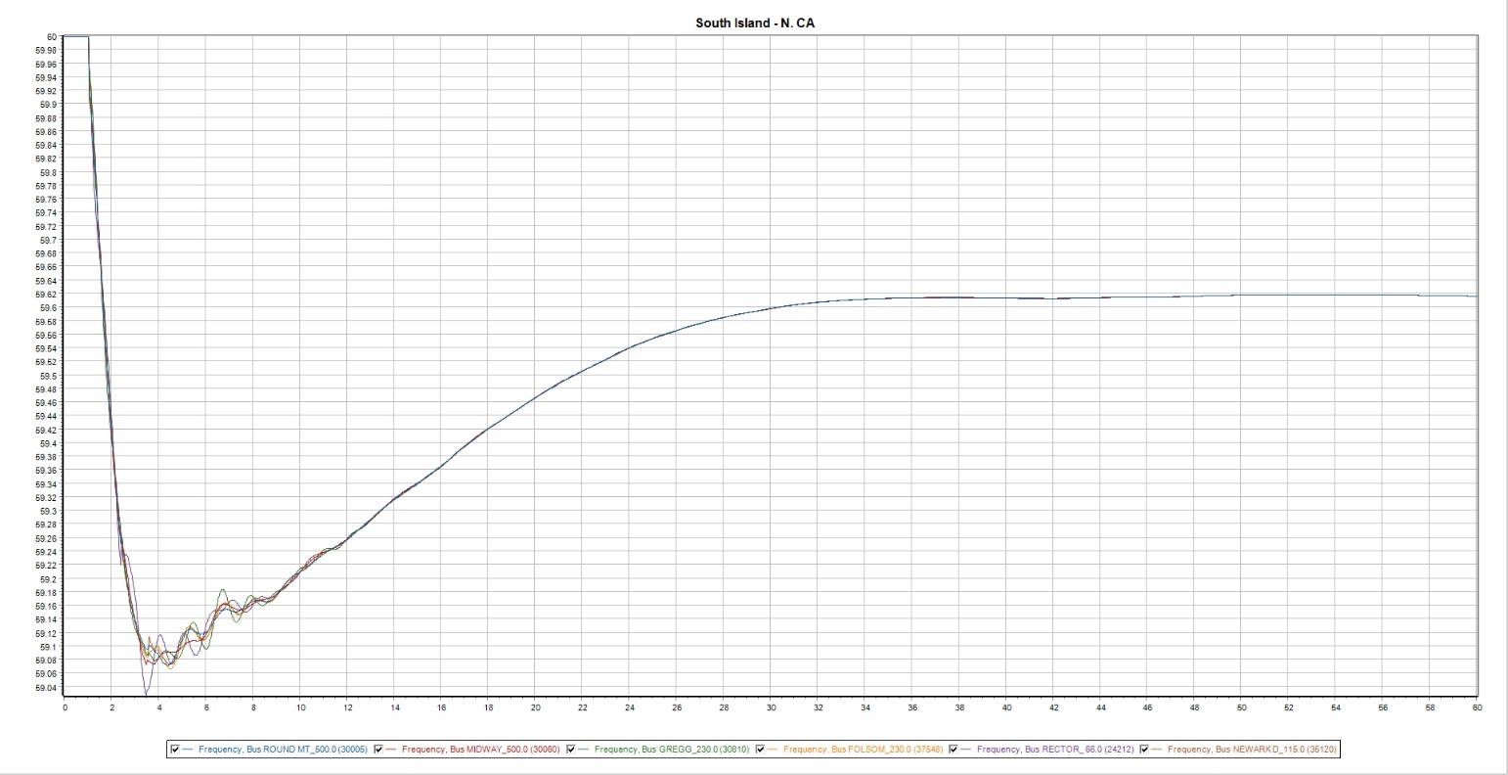

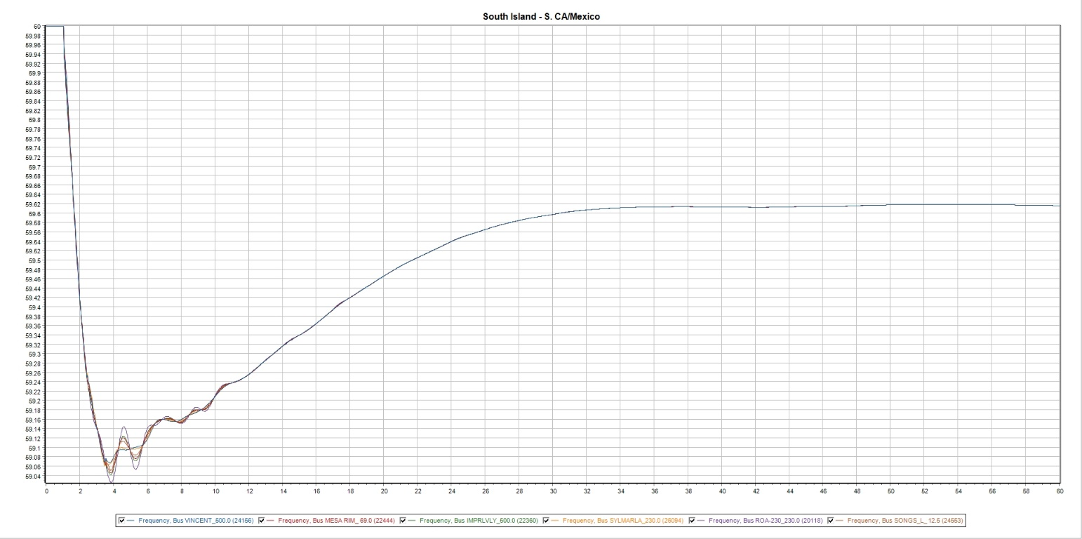

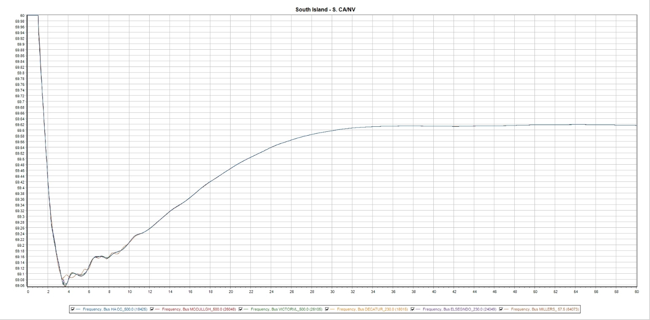

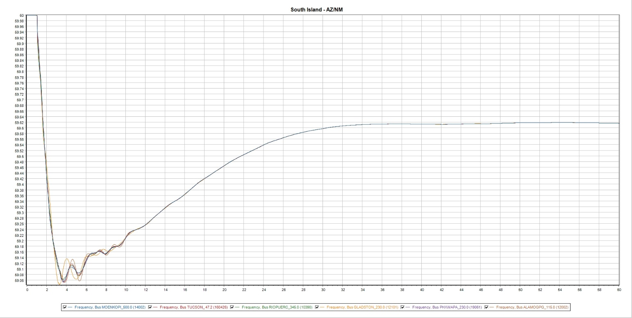

24LSP—20%
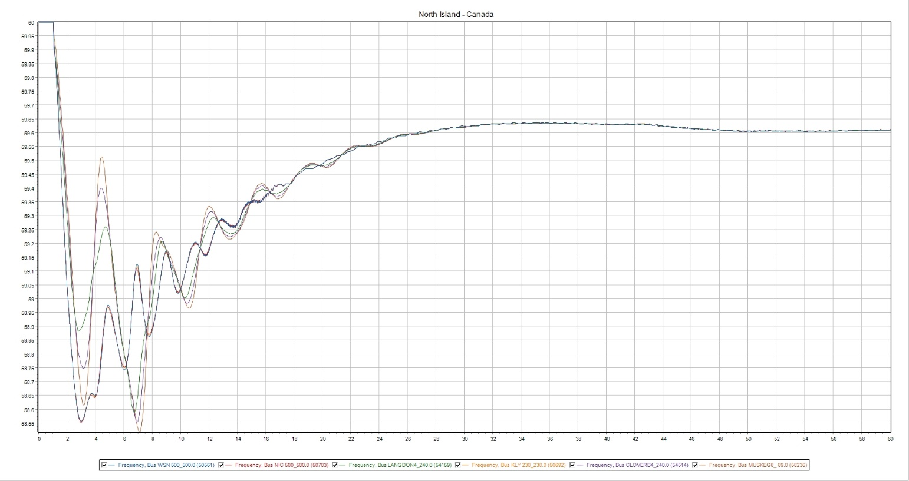

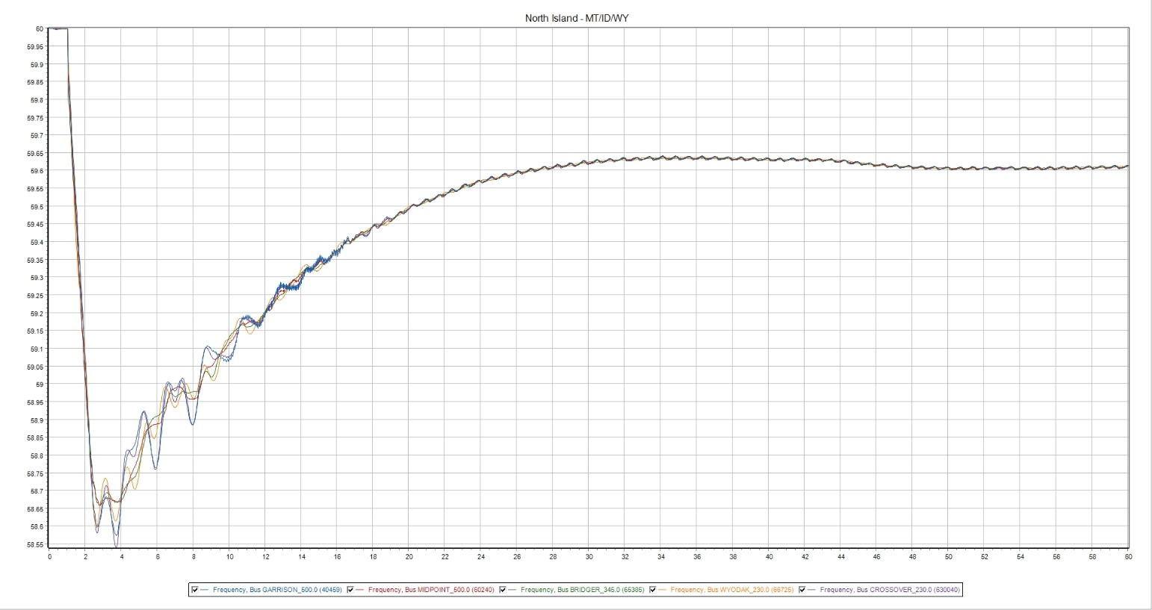

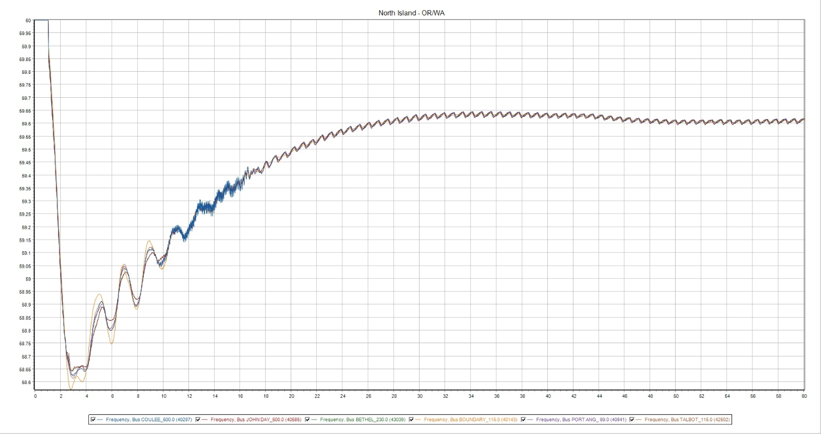

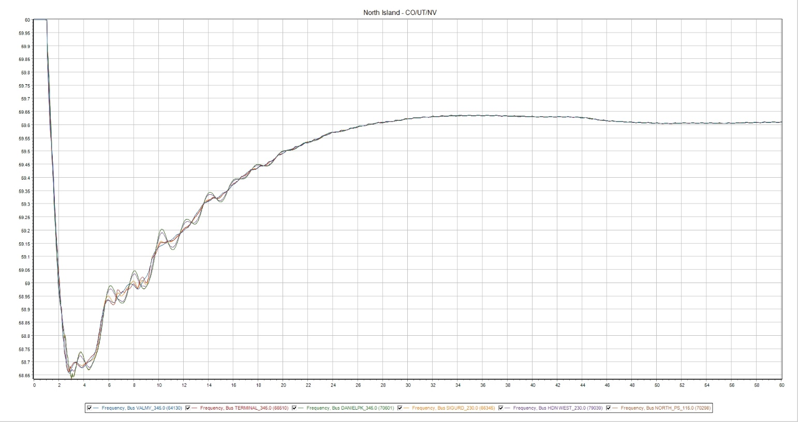

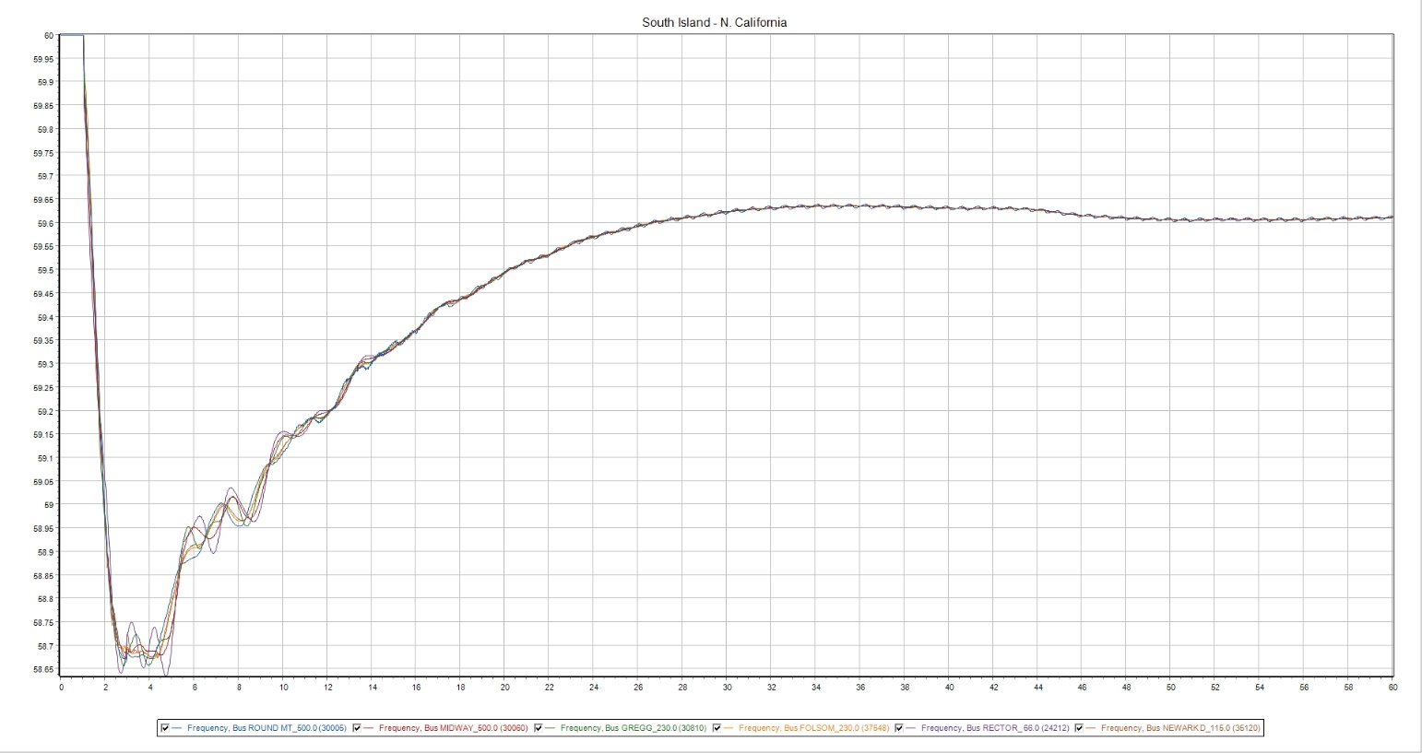

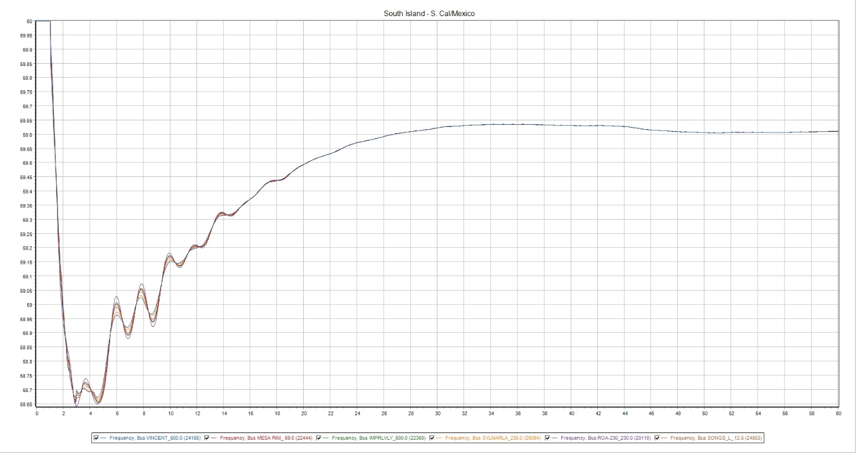

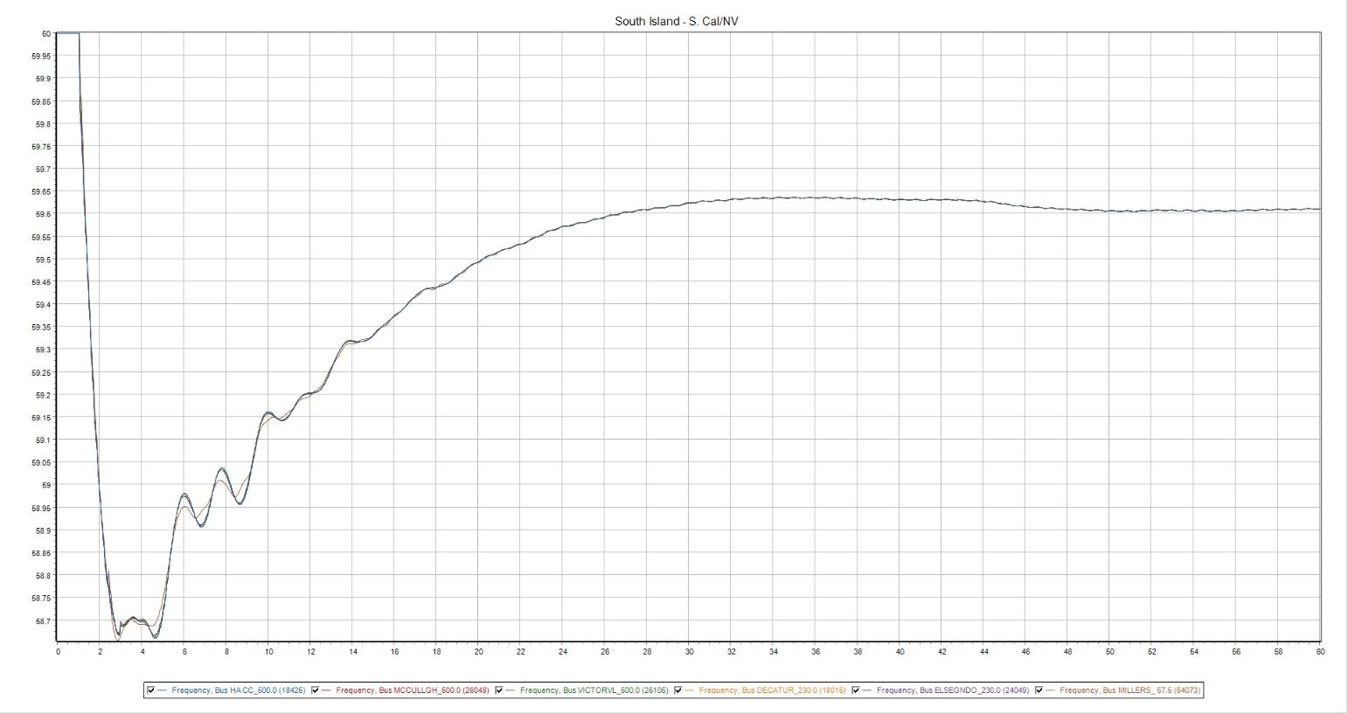

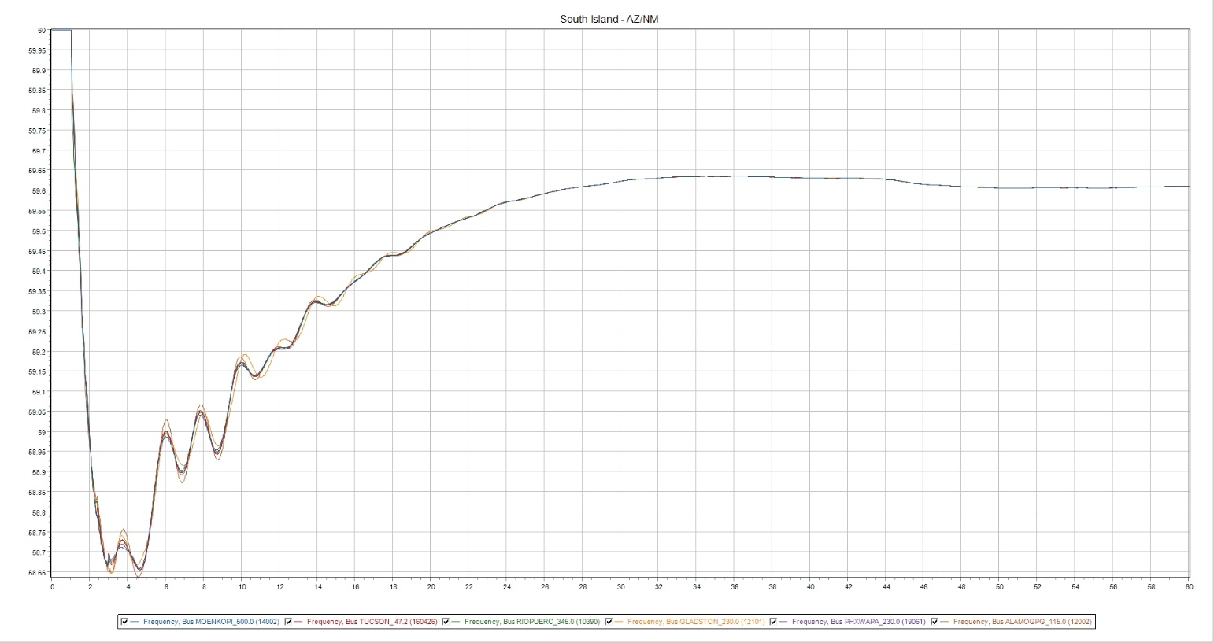

24LSP—25%
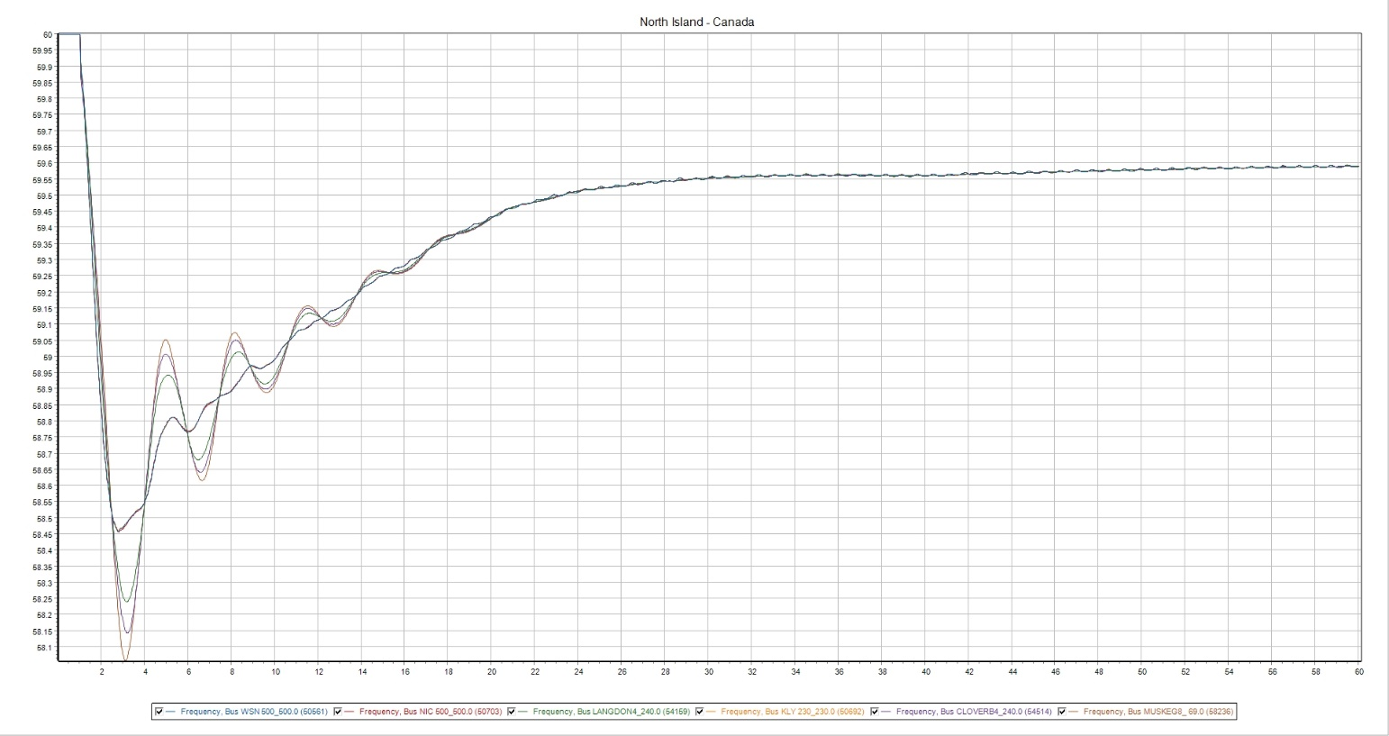

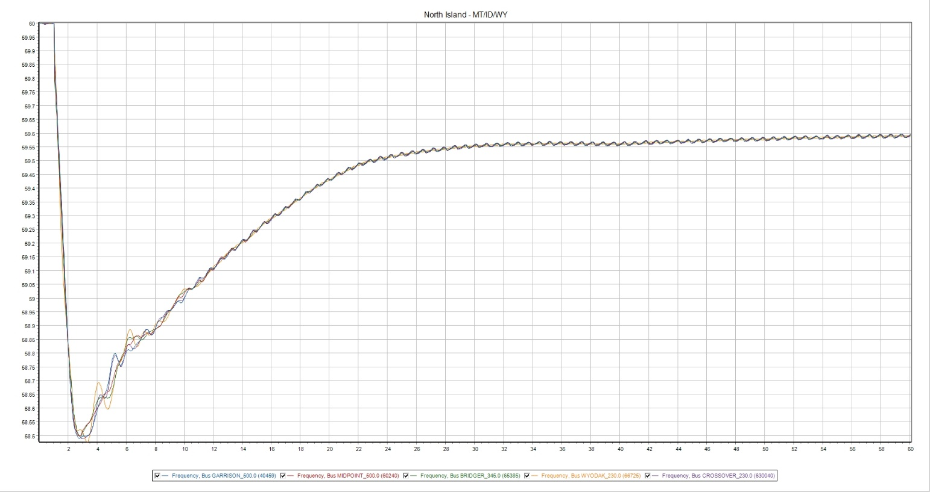

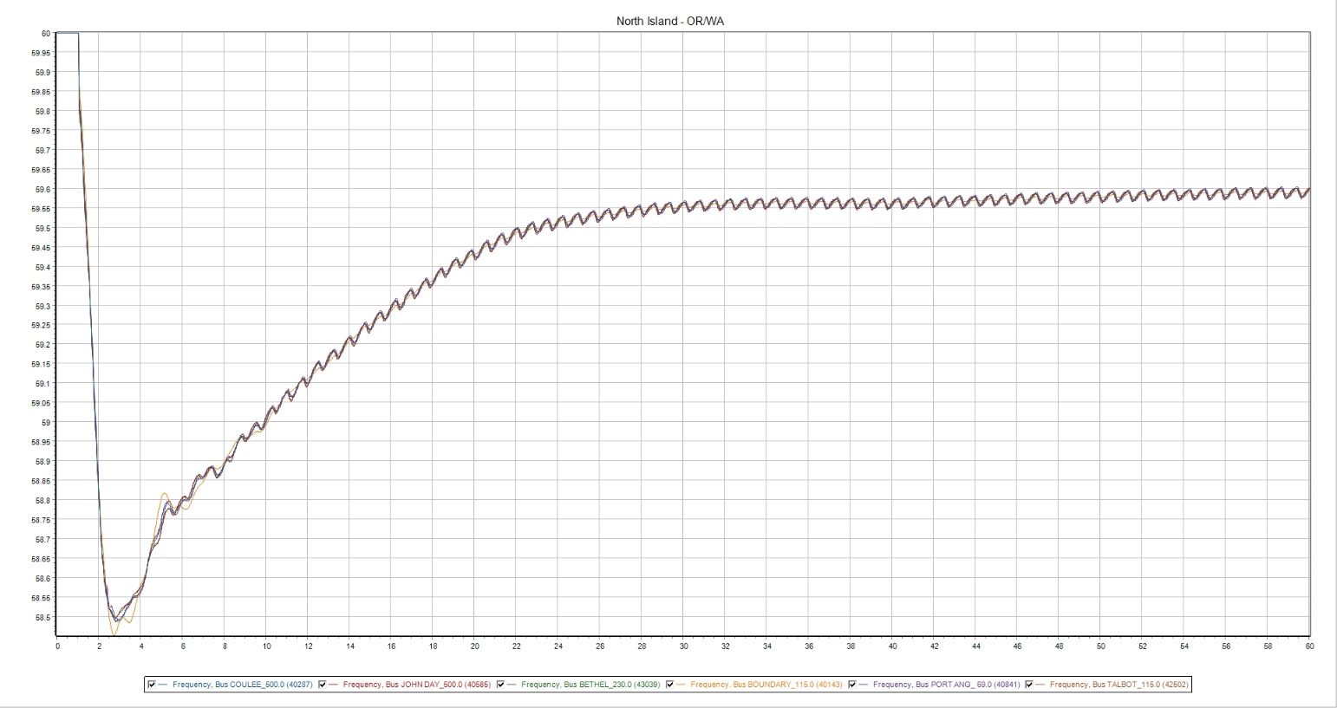

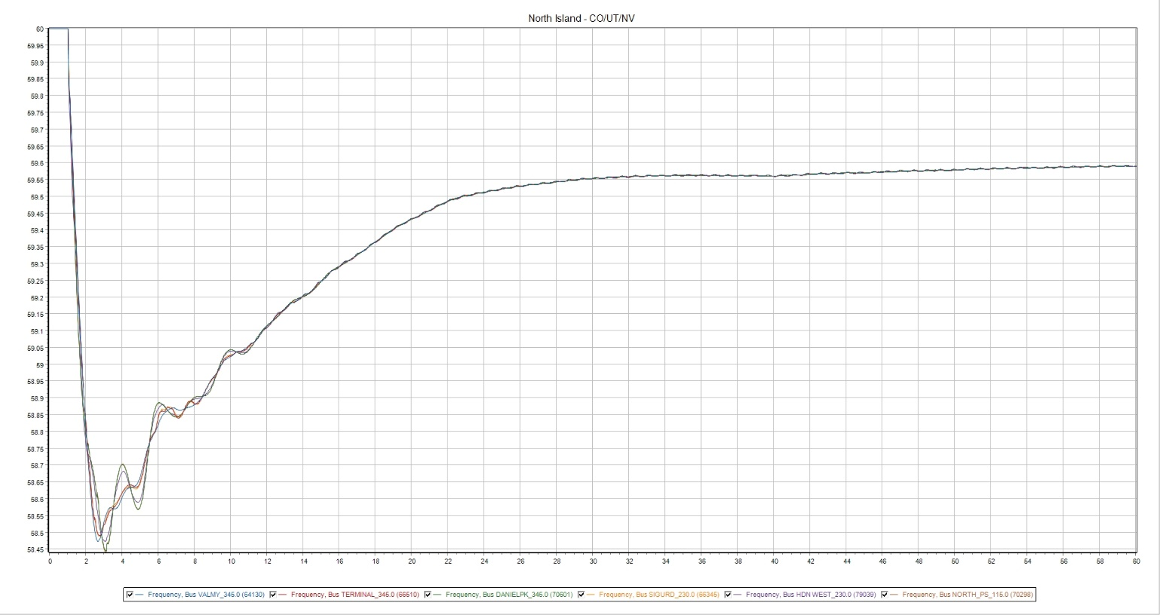

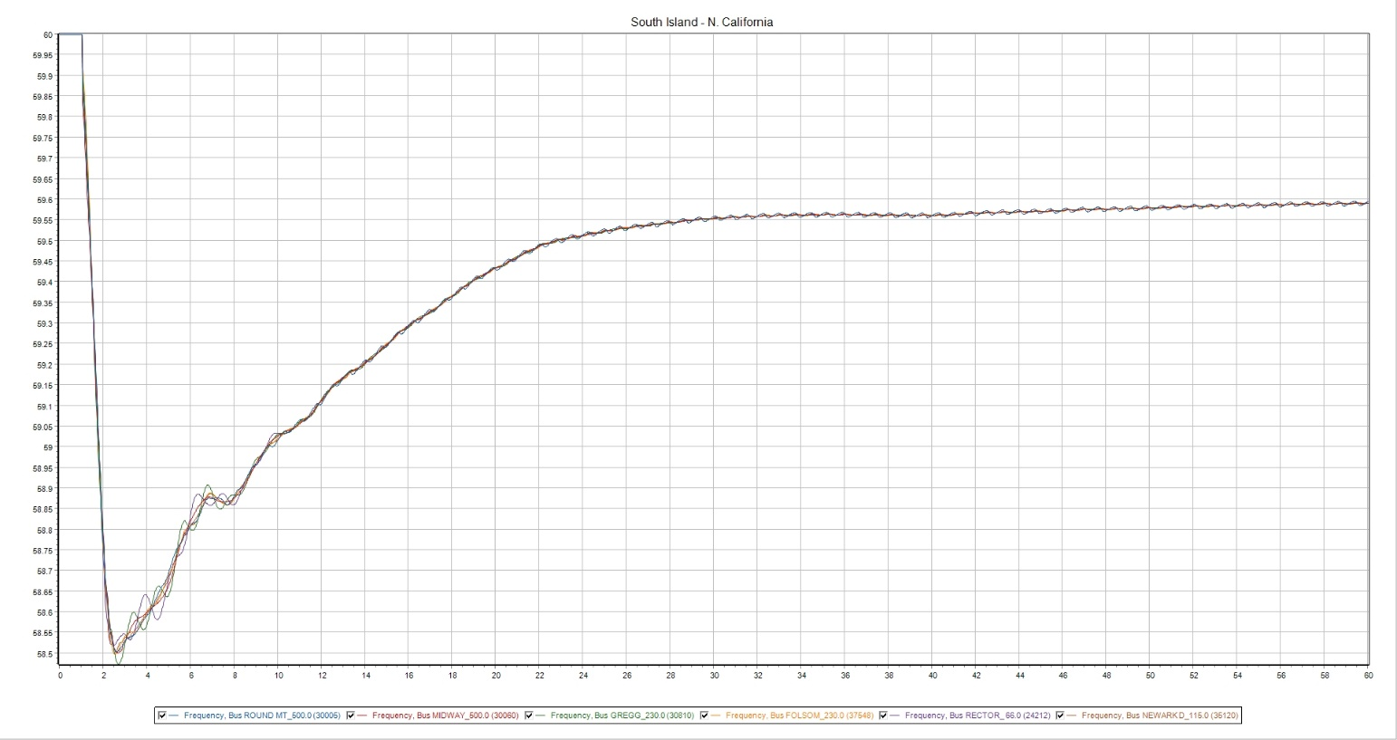

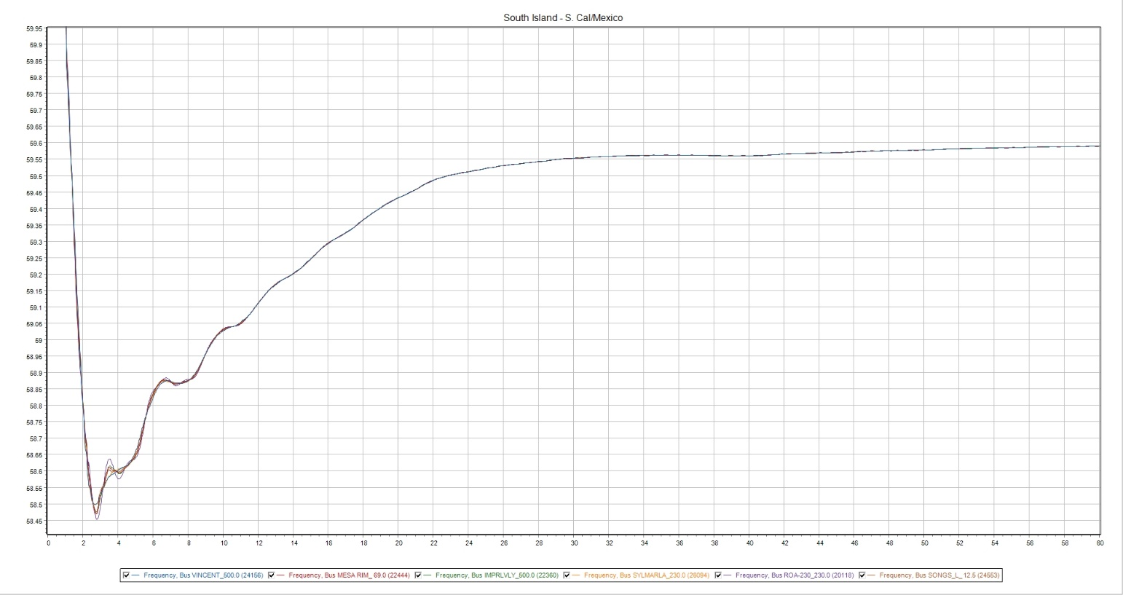

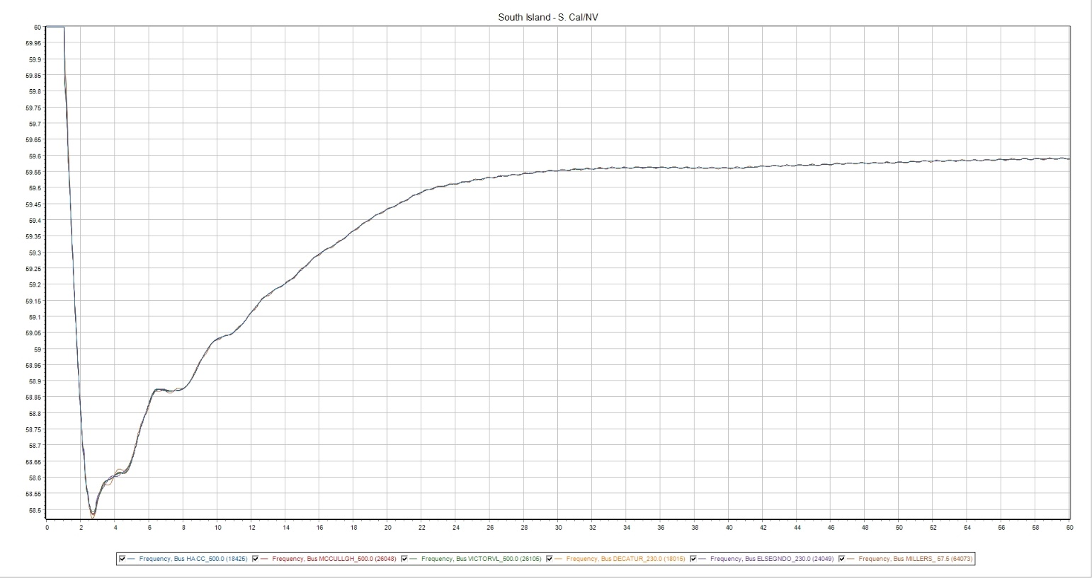

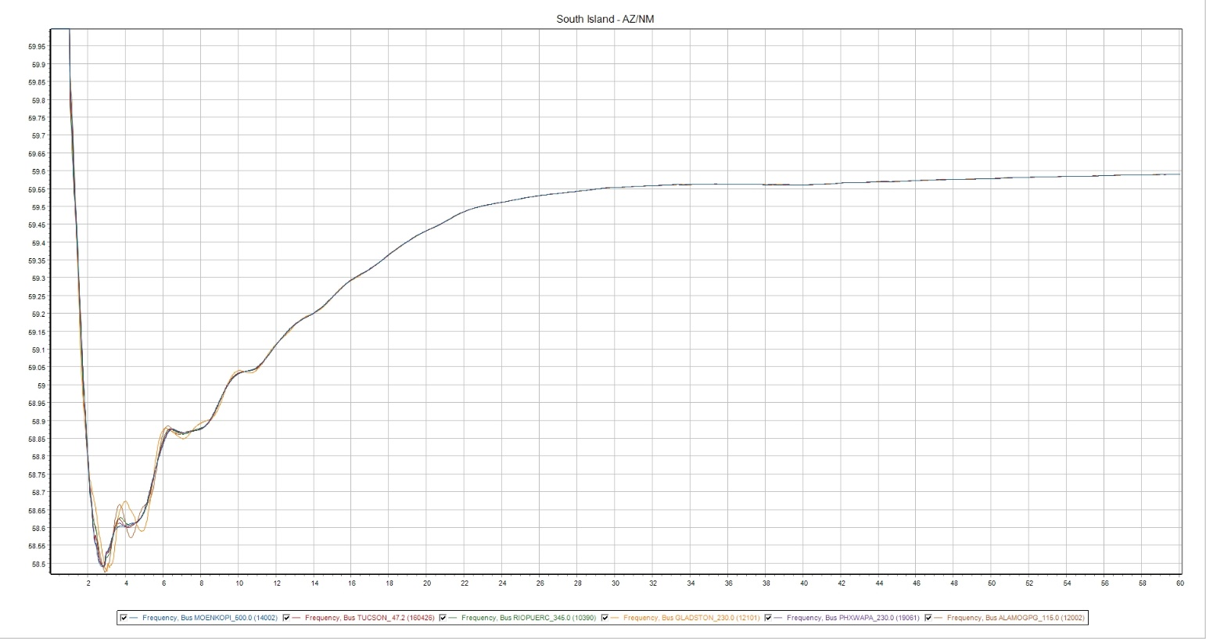

Appendix B—Frequency Performance—North Island

21HS—10%
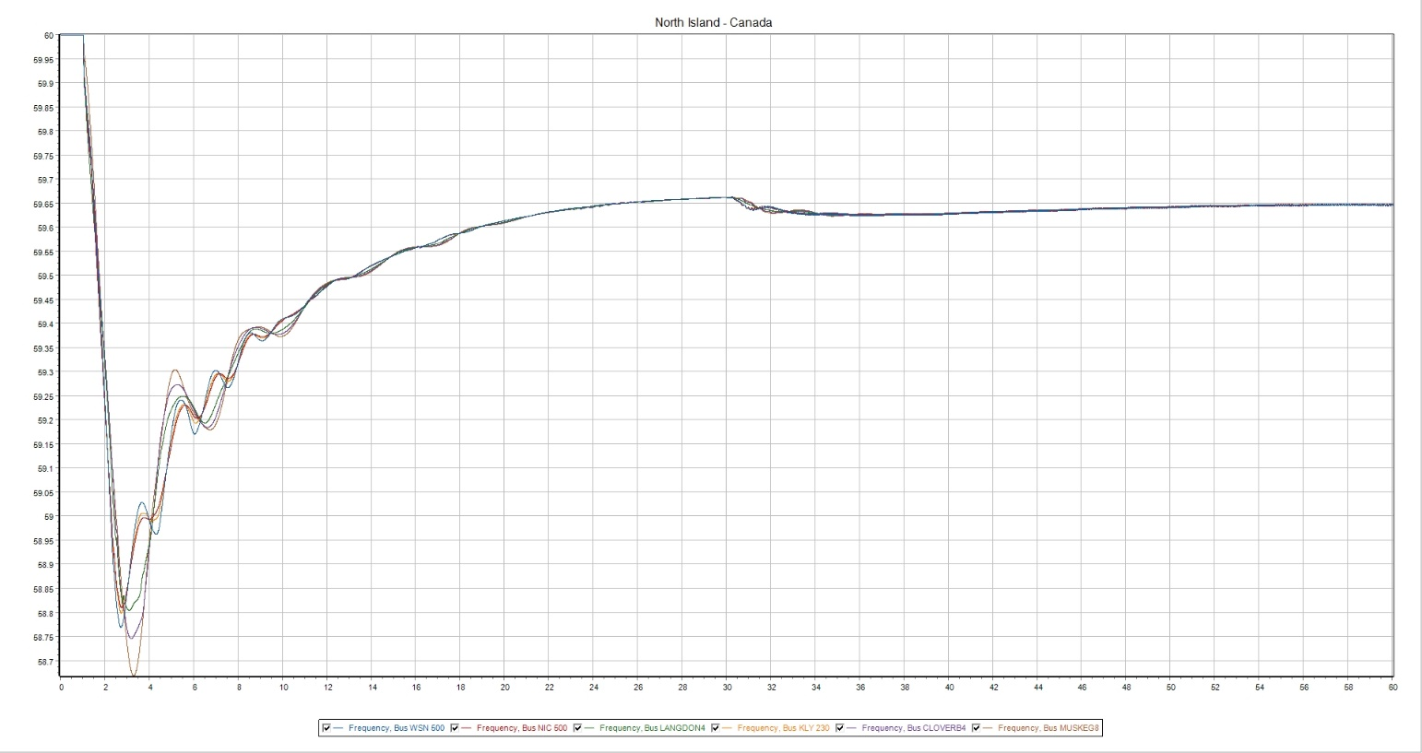

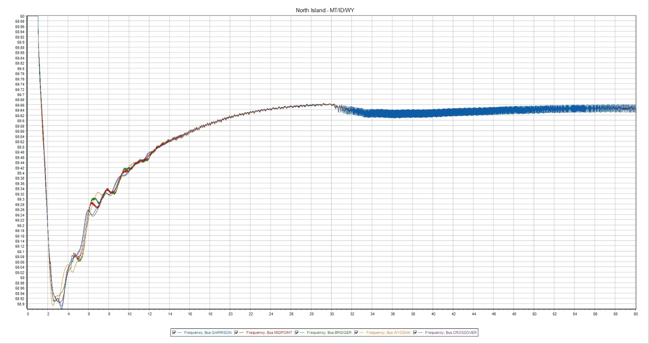
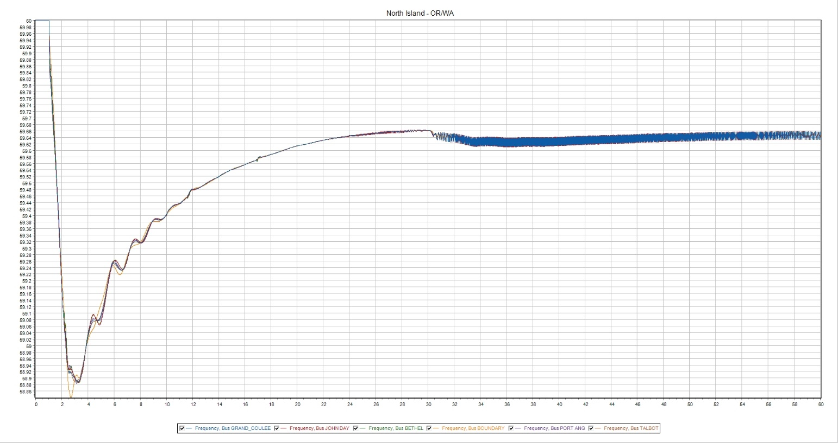

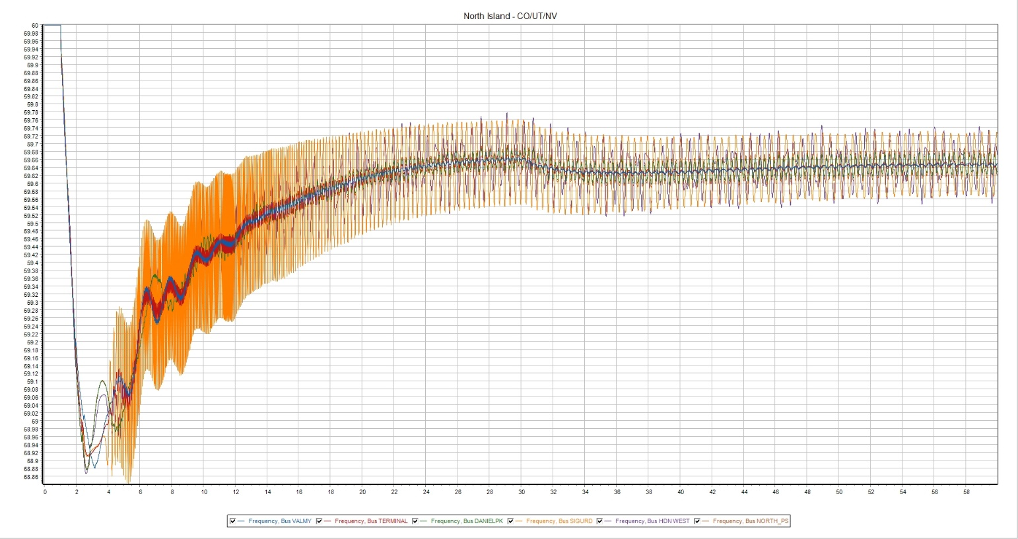

21HS—20%
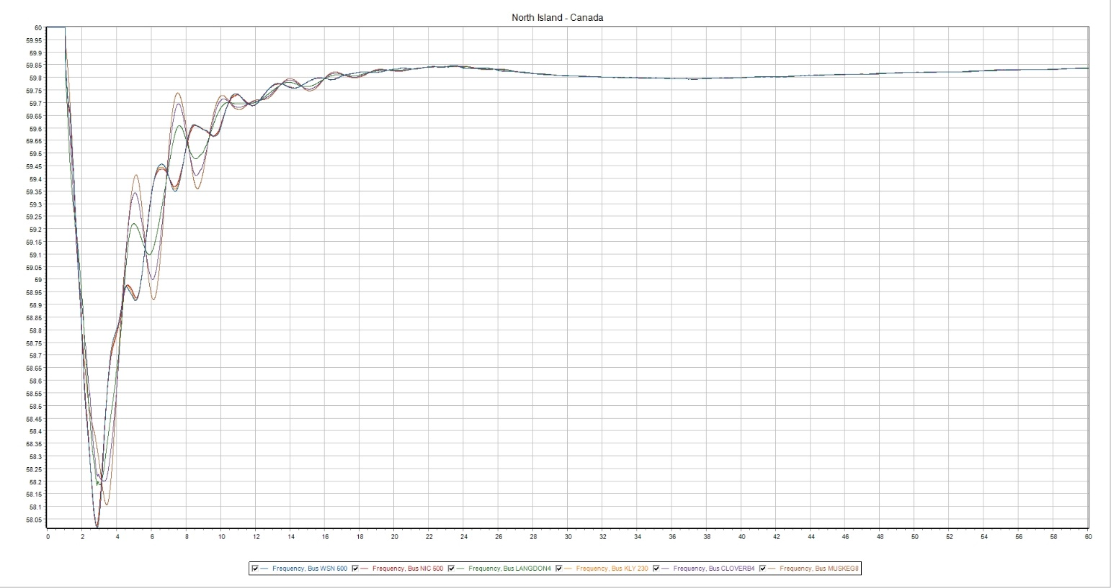

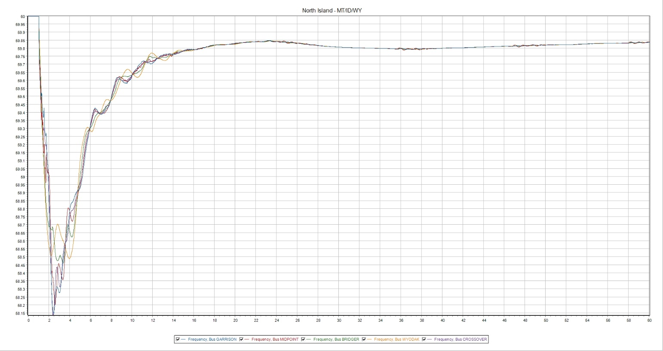

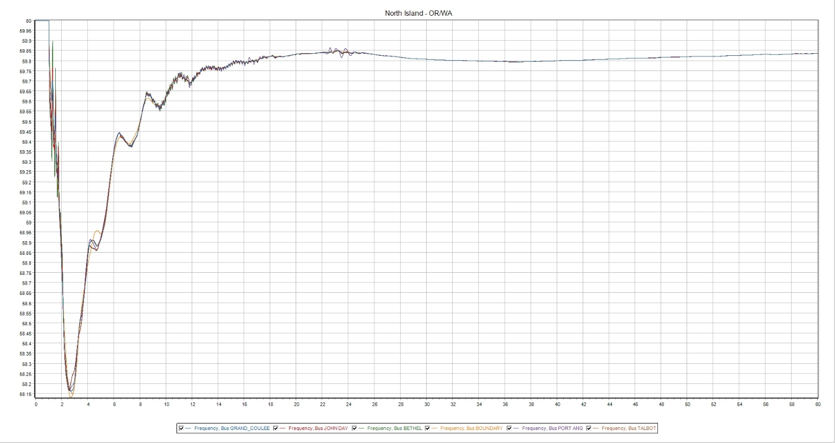

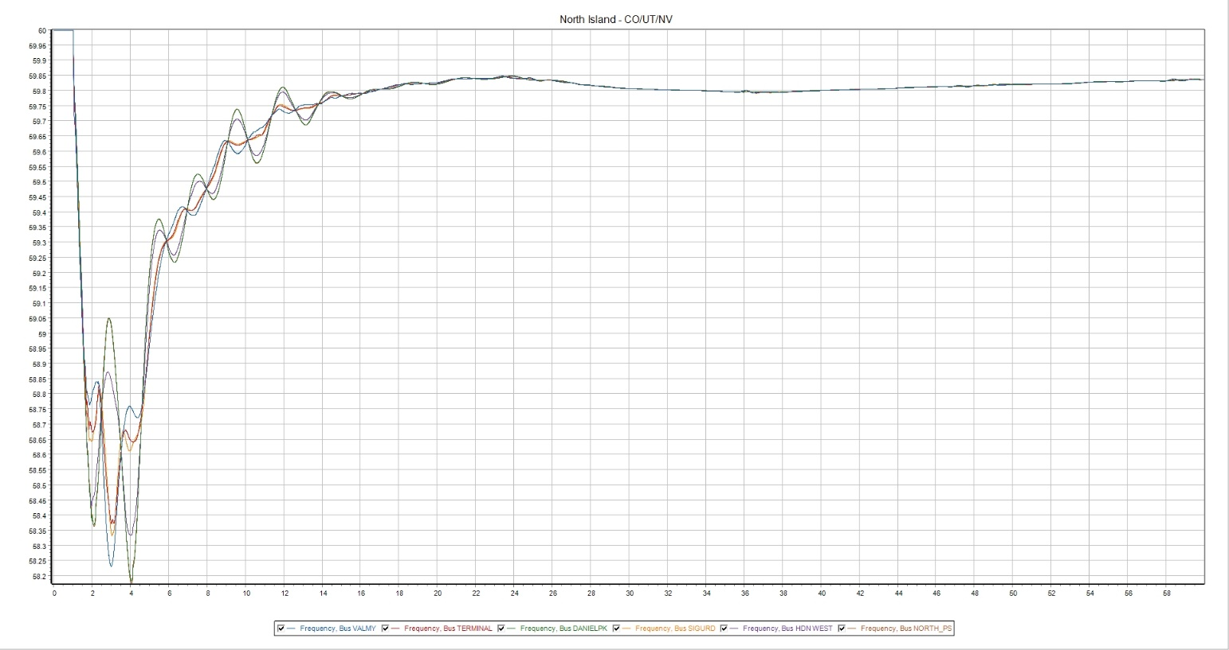

21HS—25%

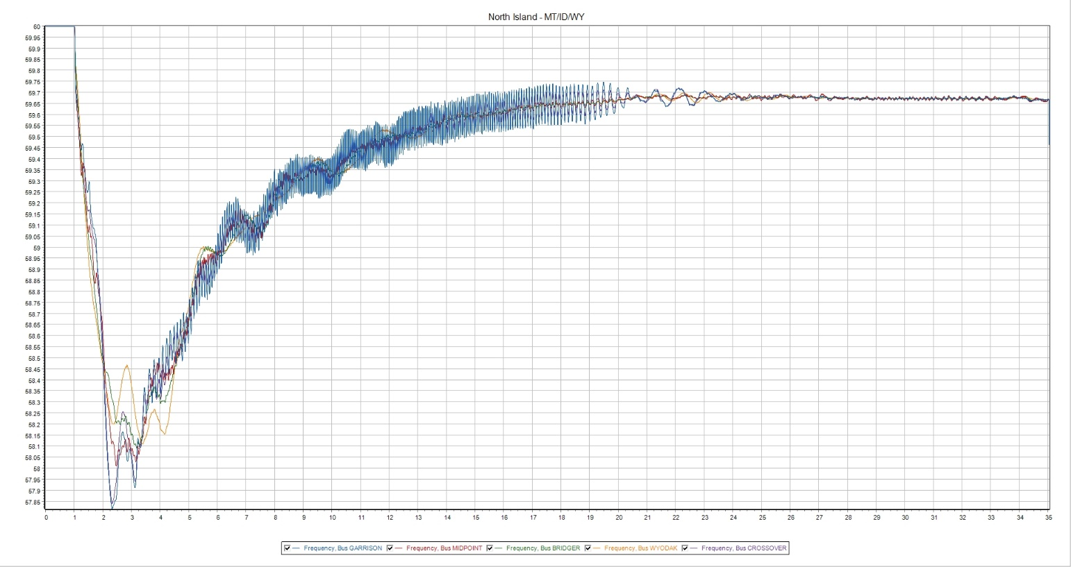

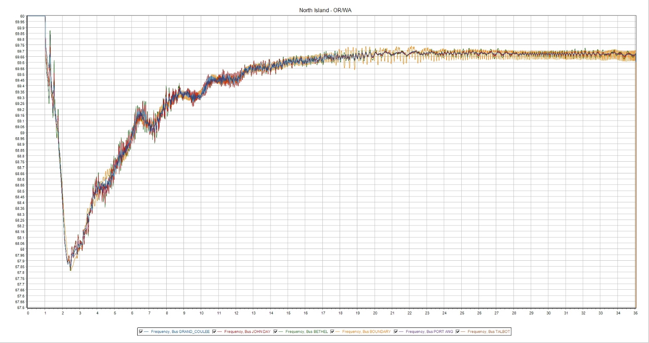

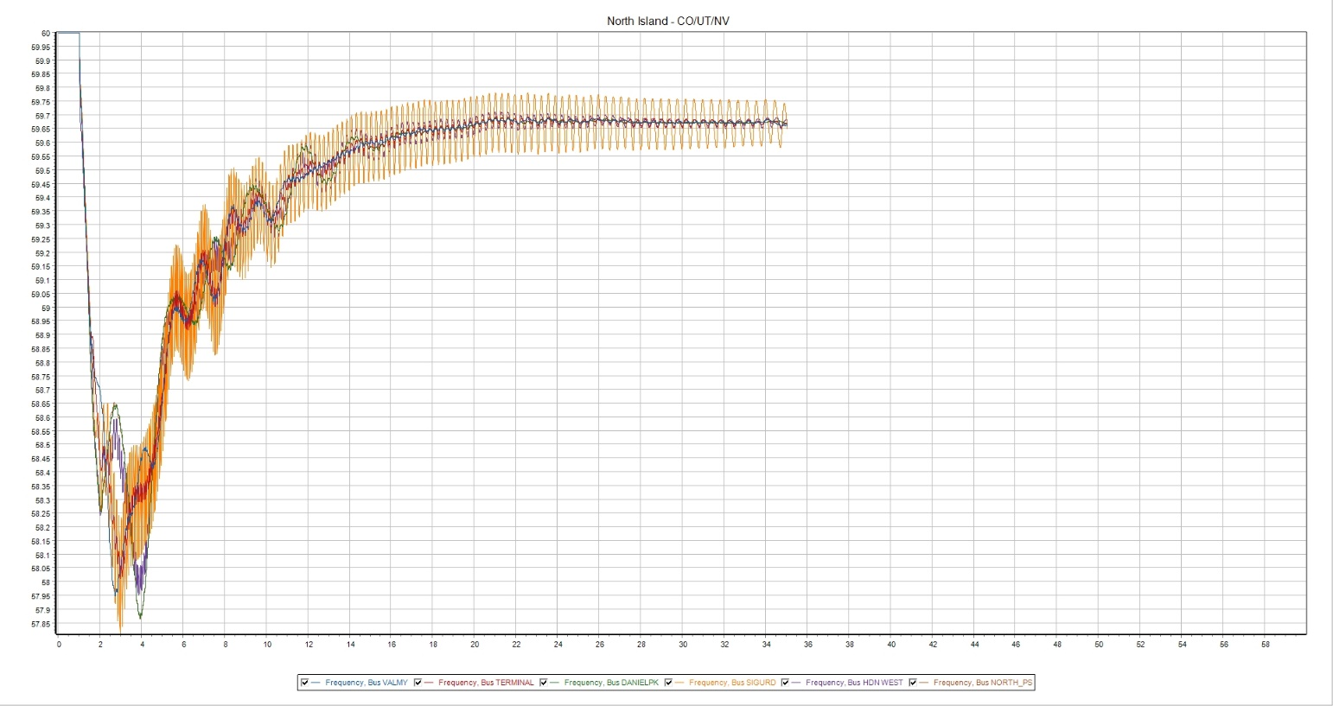

24LSP—10%
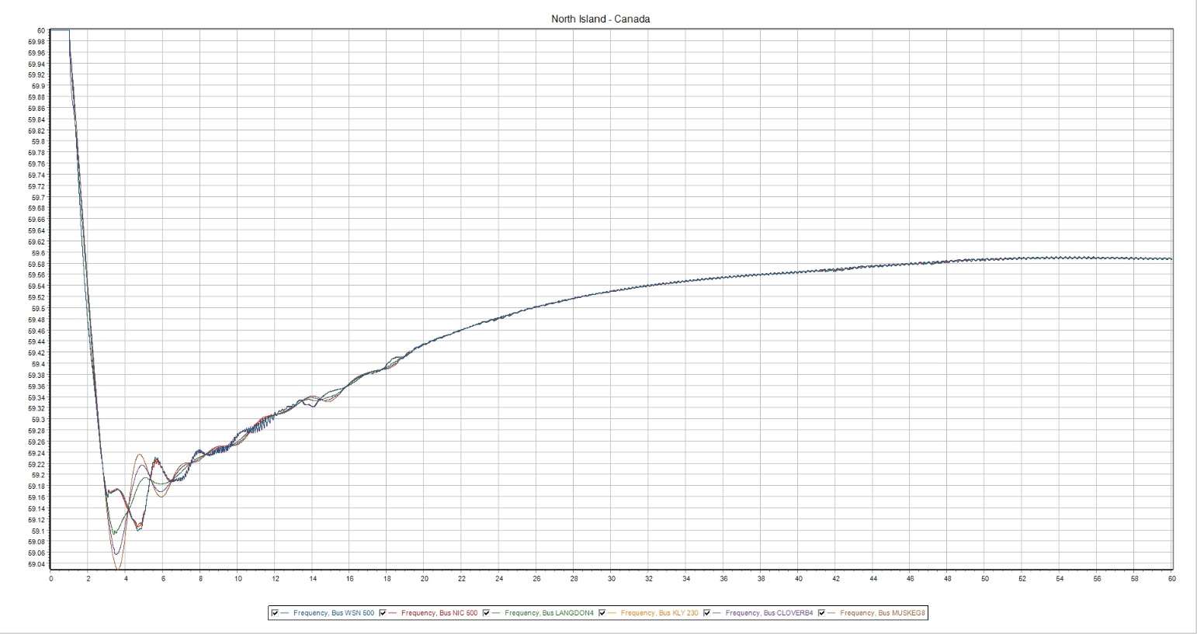

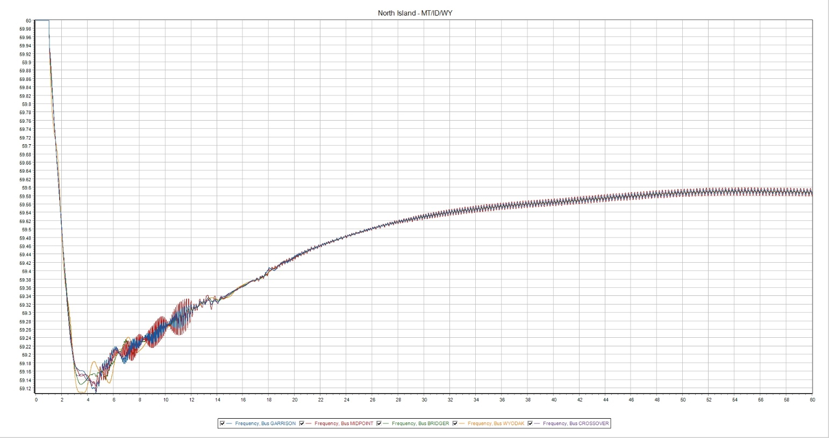

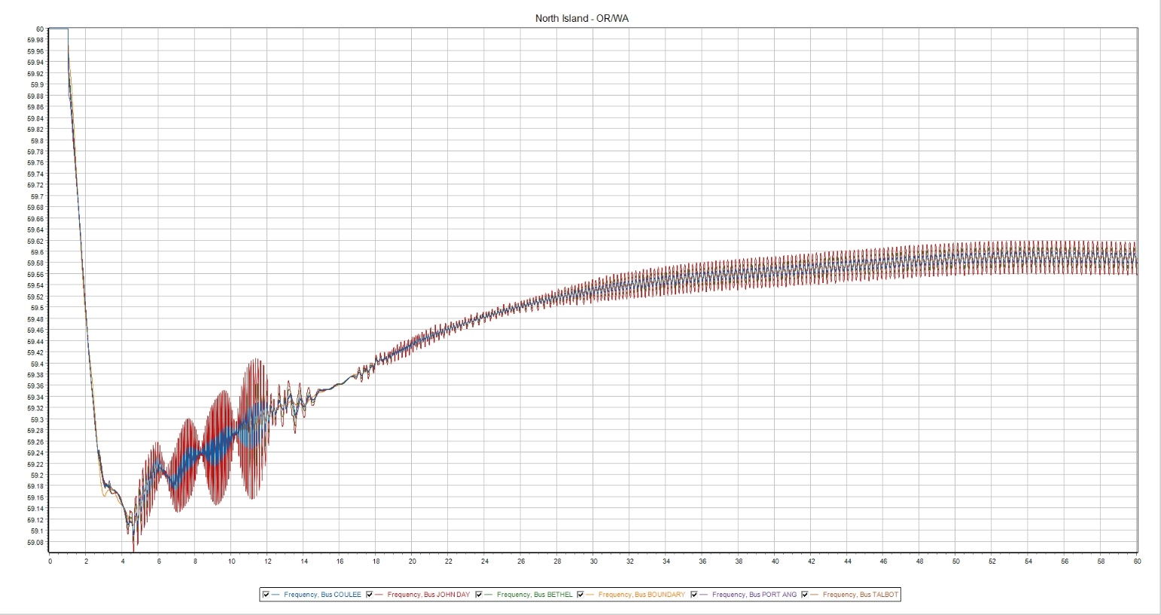

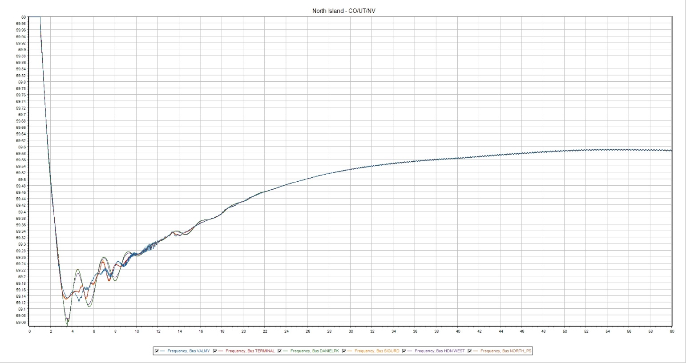

24LSP—20%
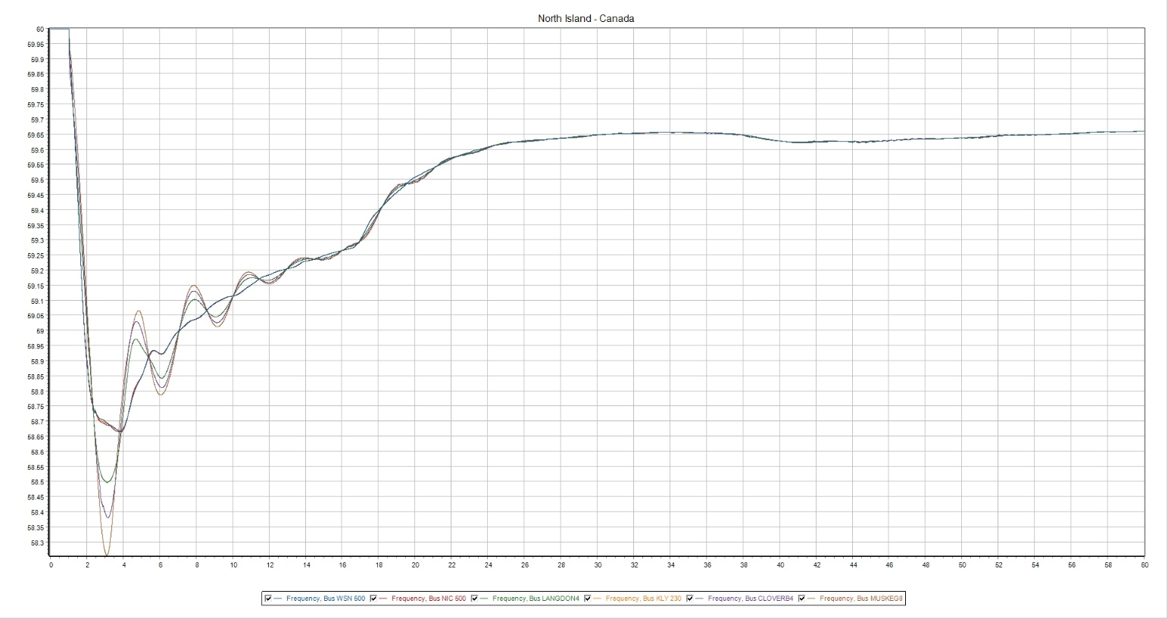

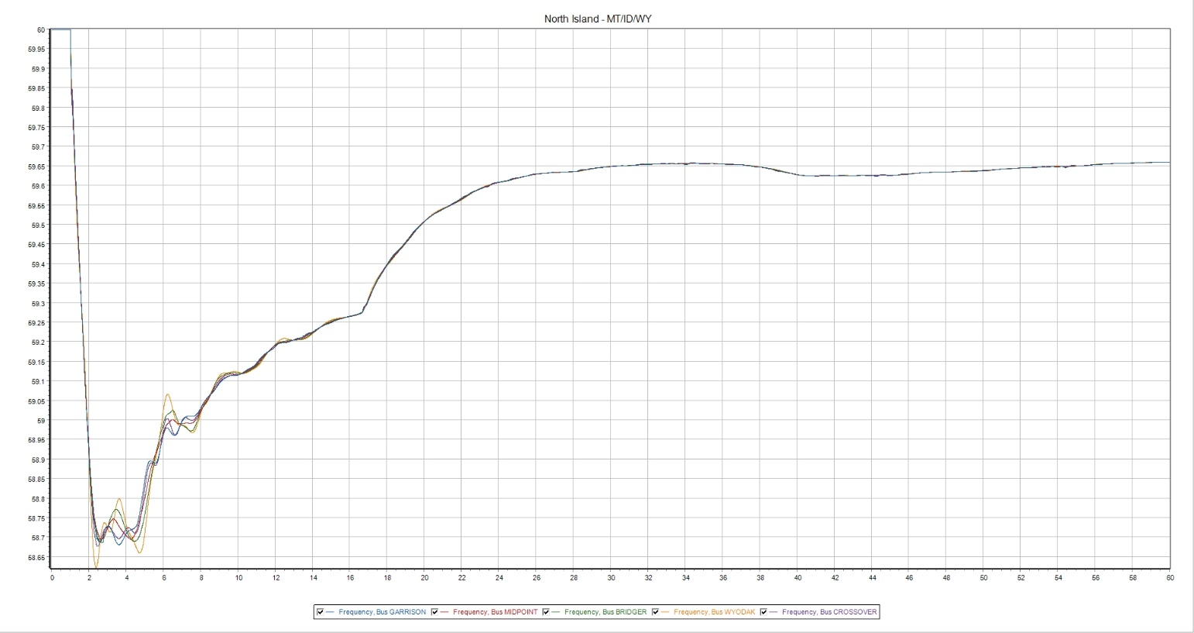

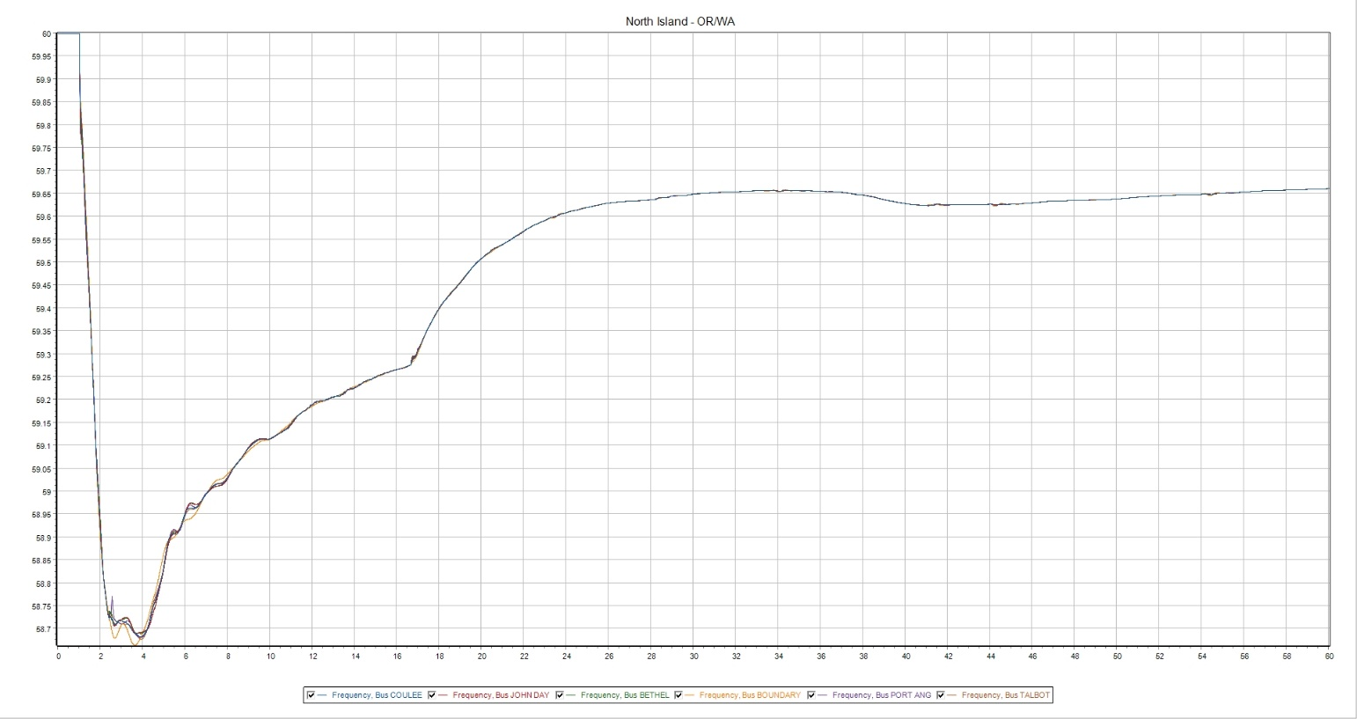

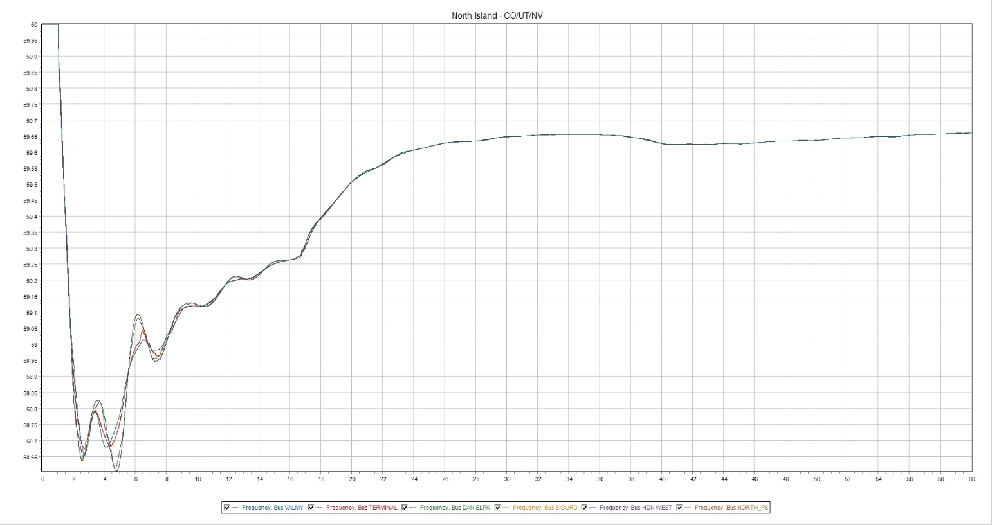

24LSP—25%
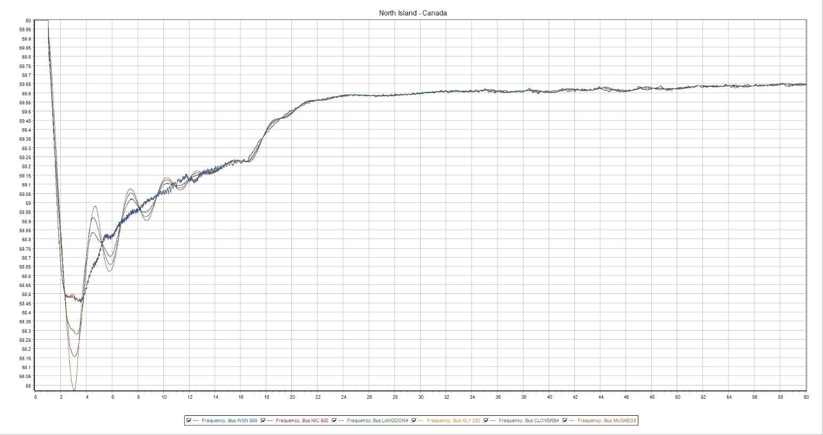

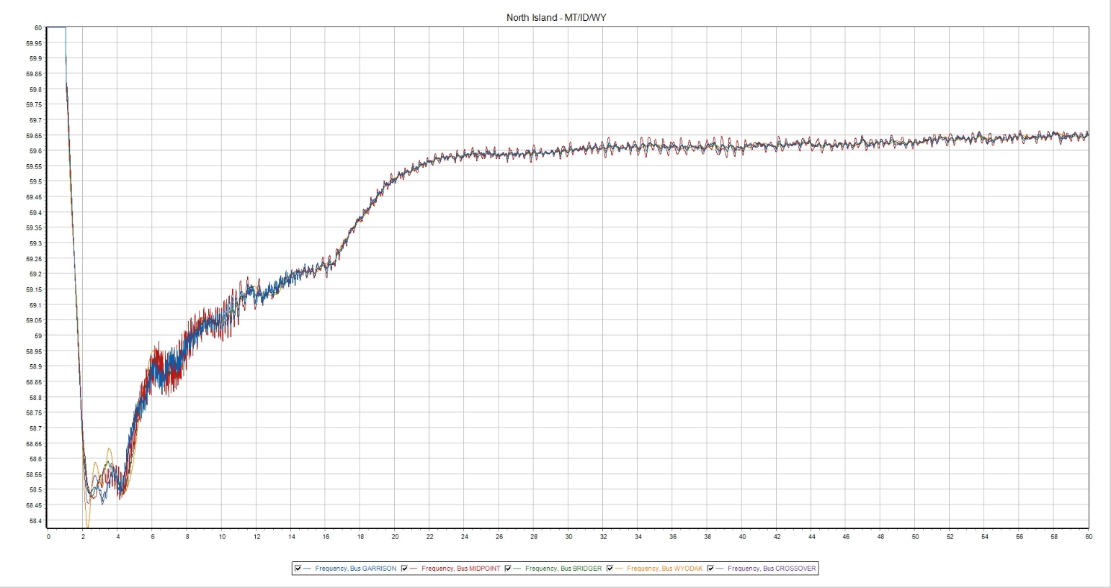

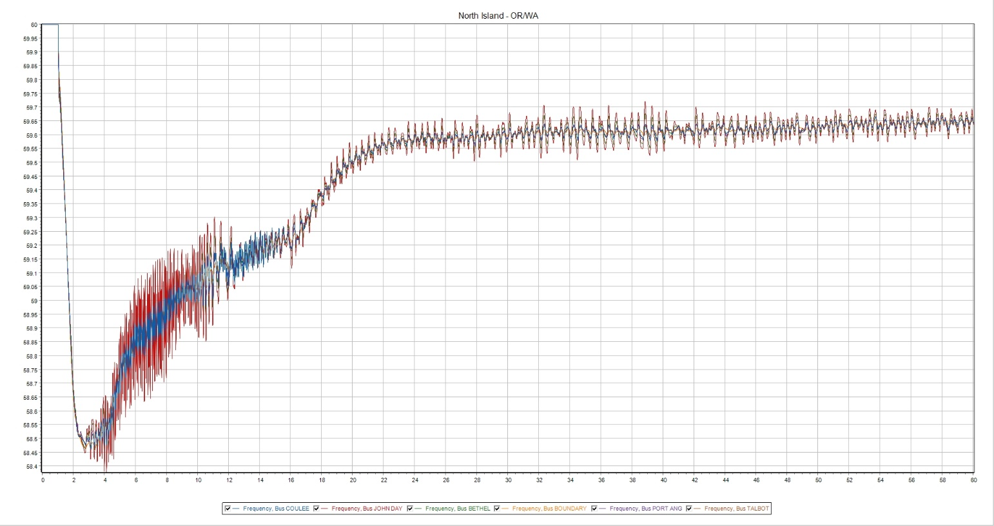

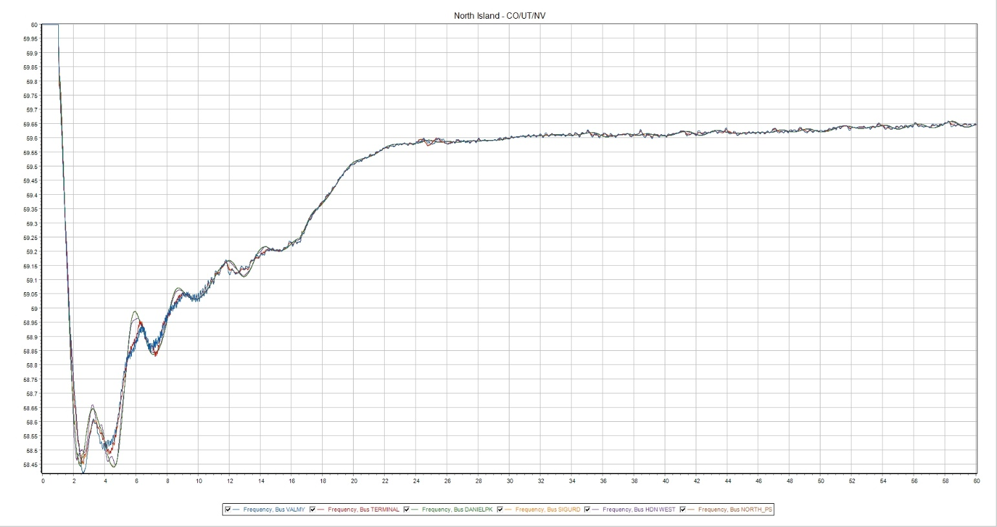

Appendix C—Frequency Performance—South Island

21HS—10%
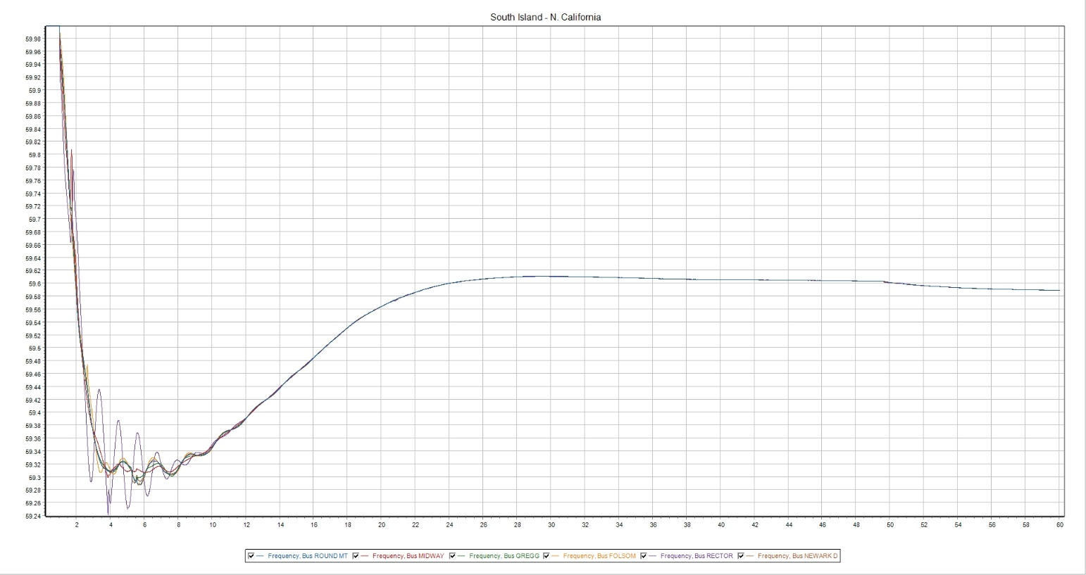

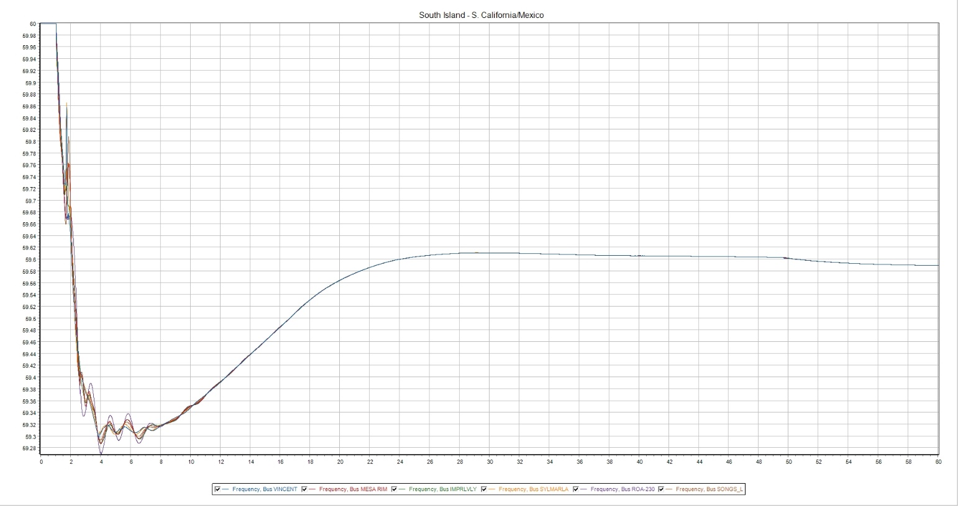

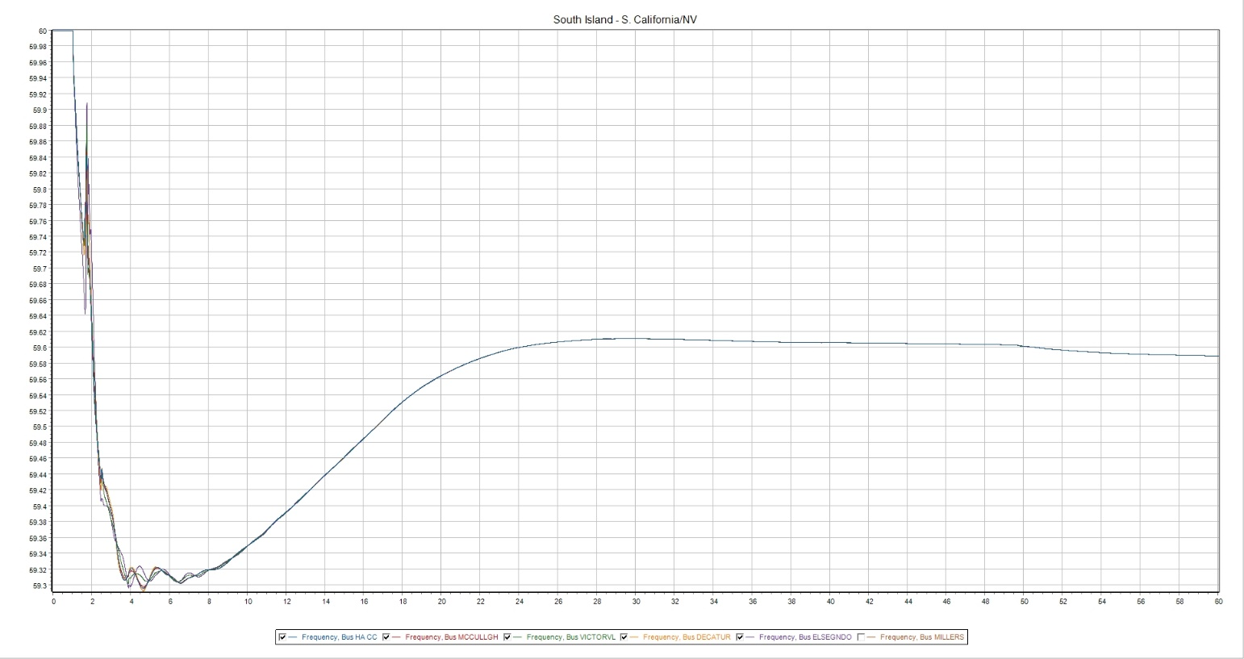

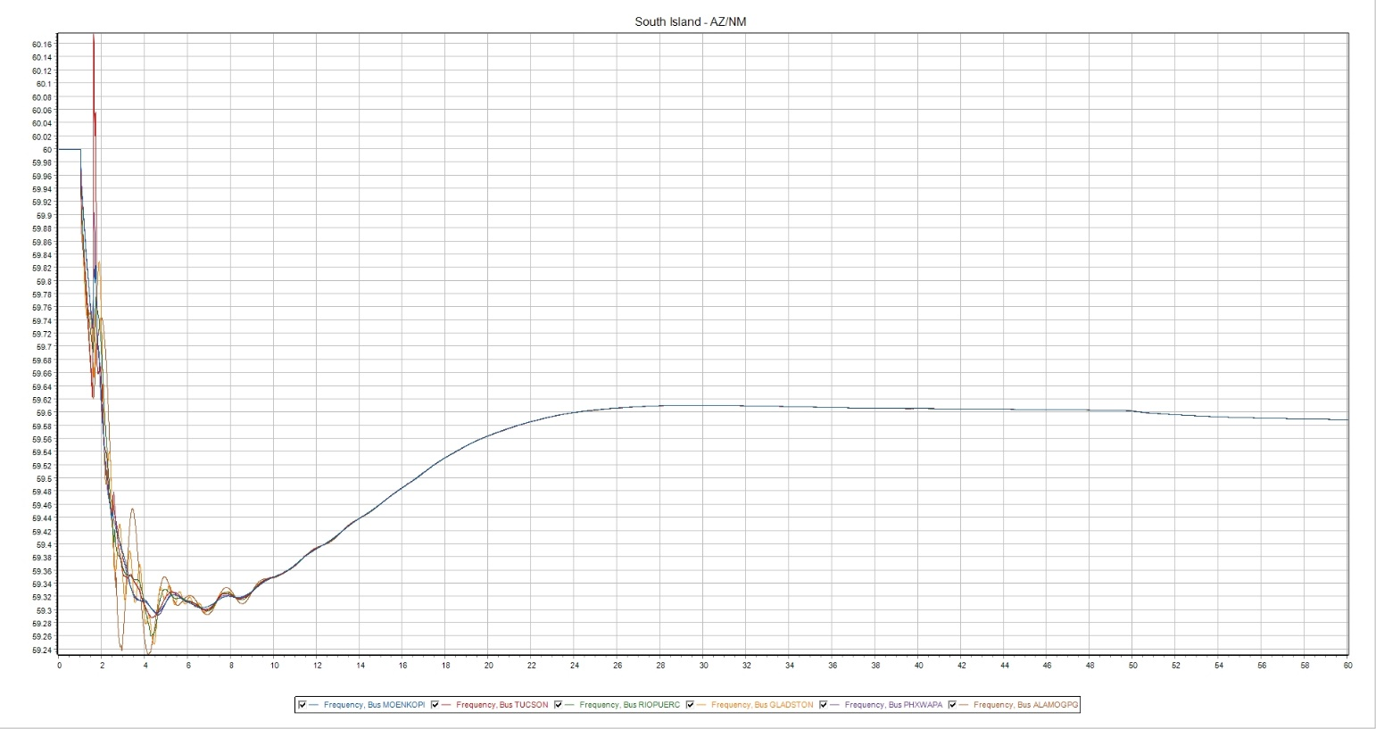

21HS—20%
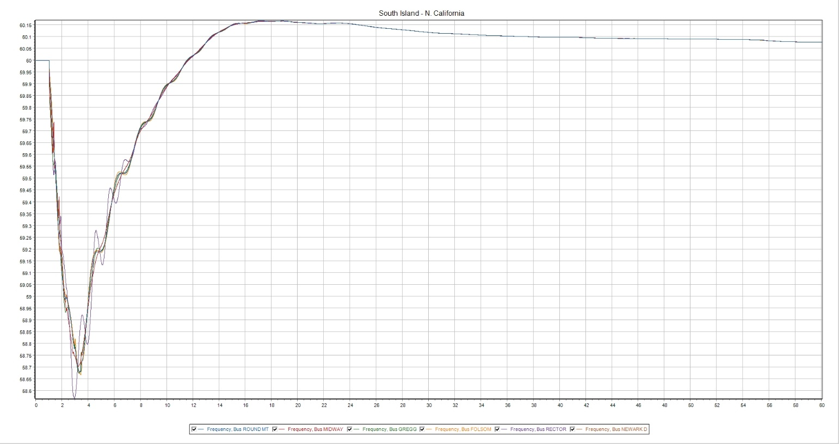

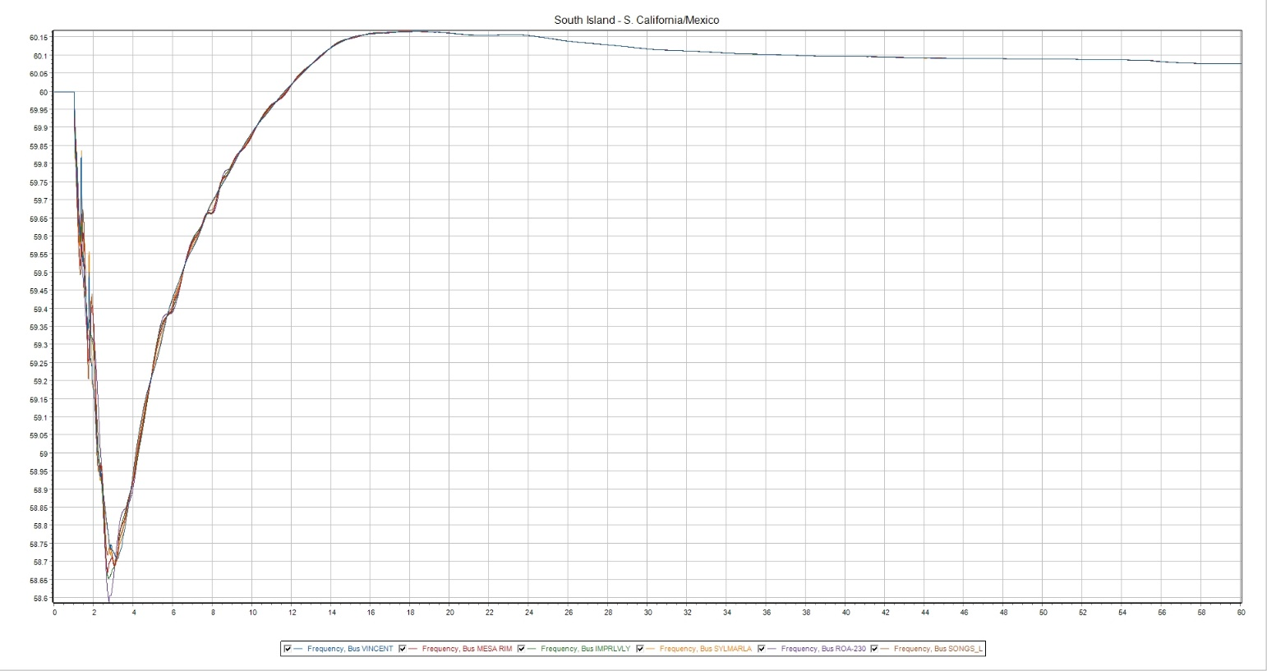

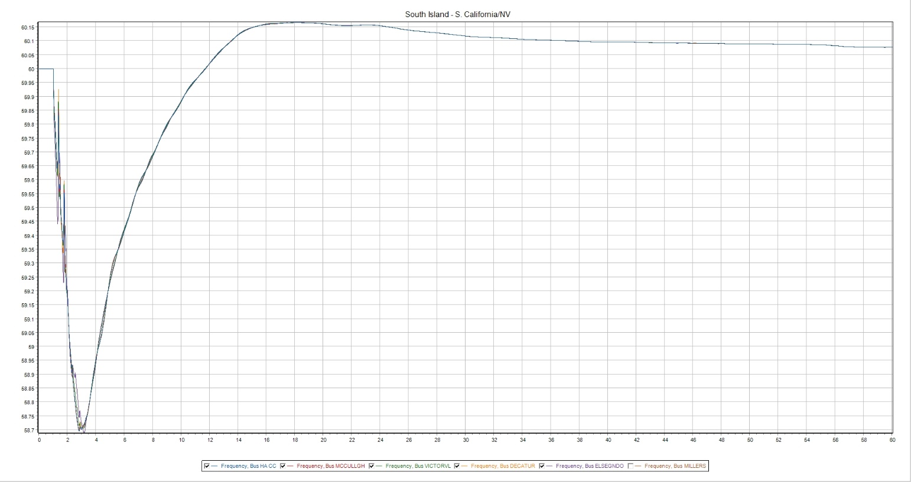

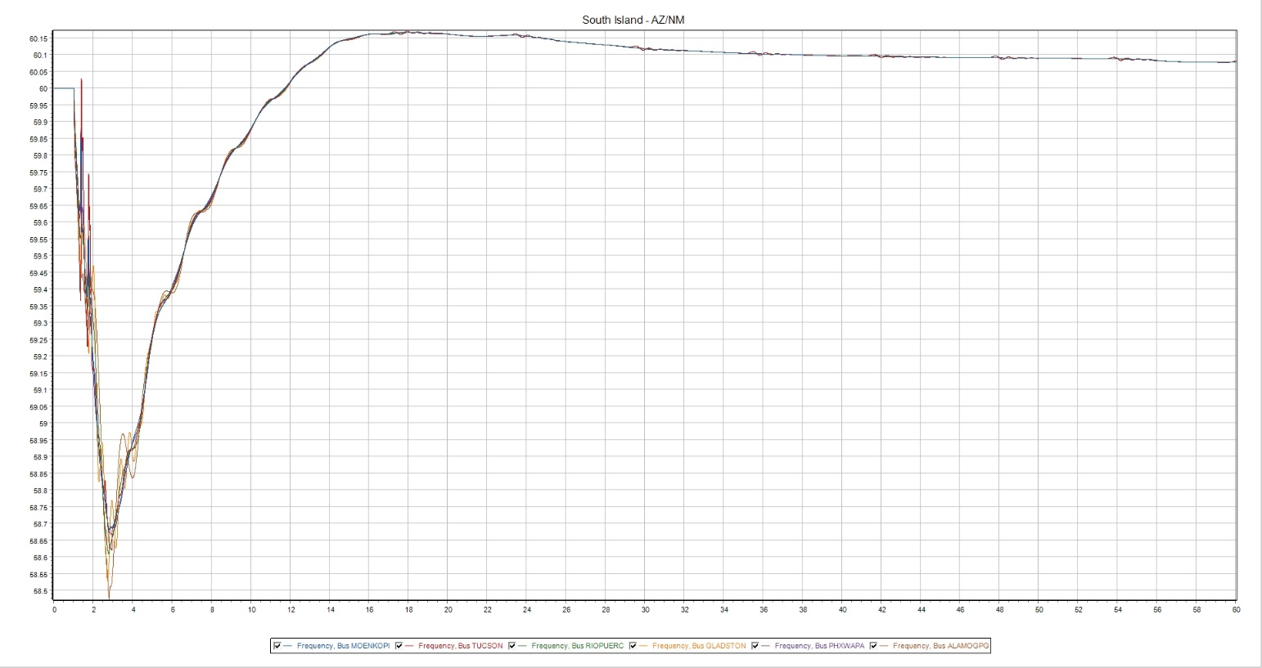

21HS—25%
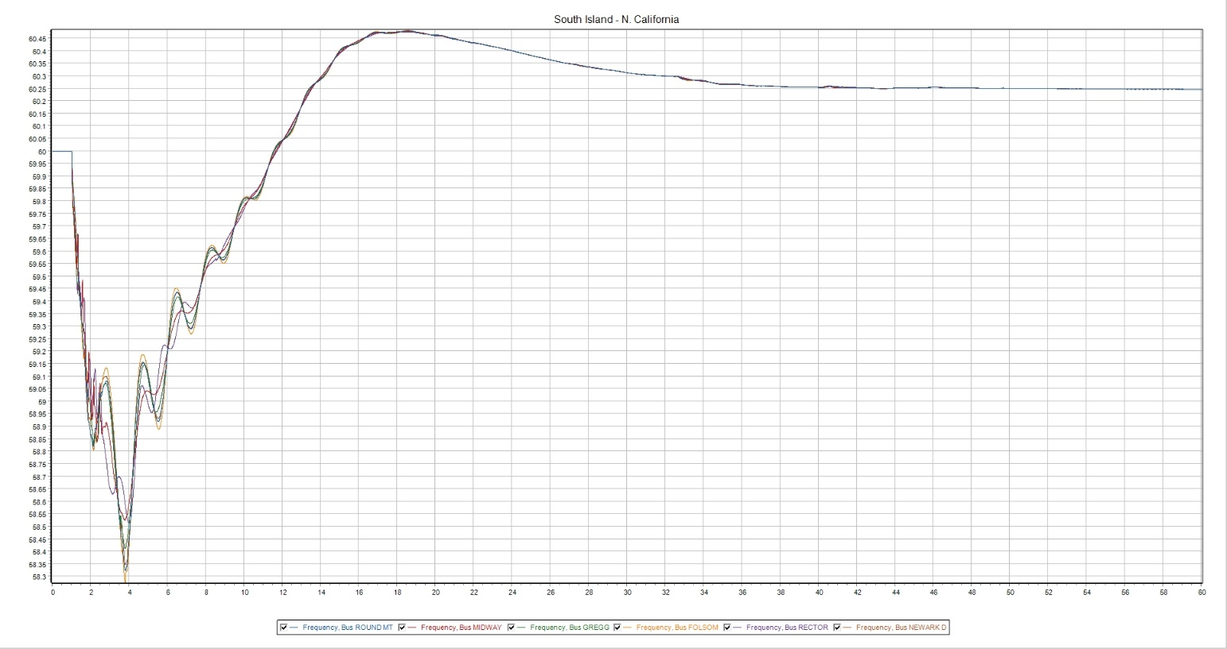

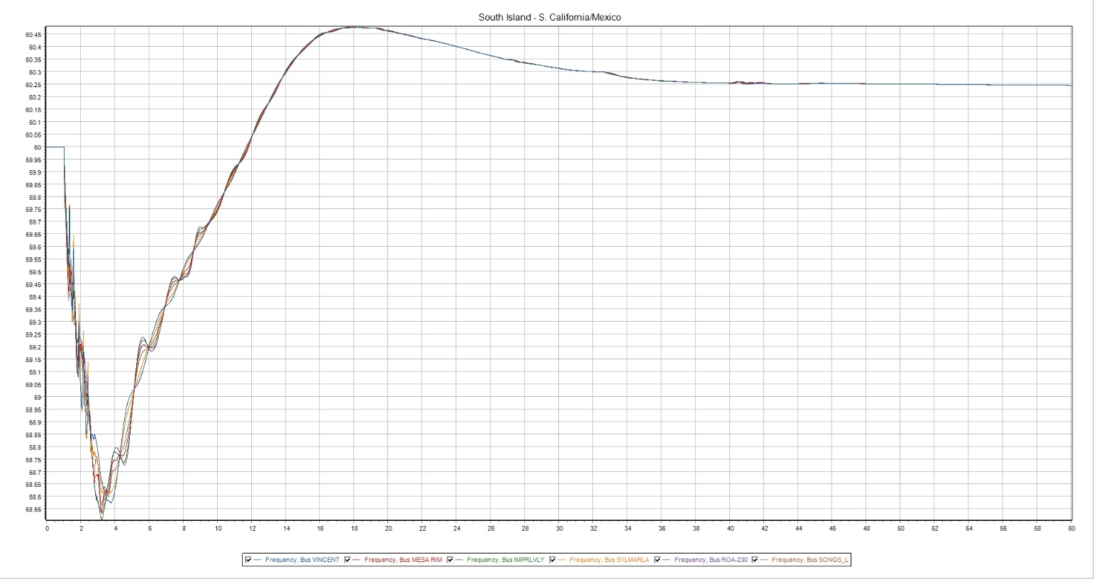

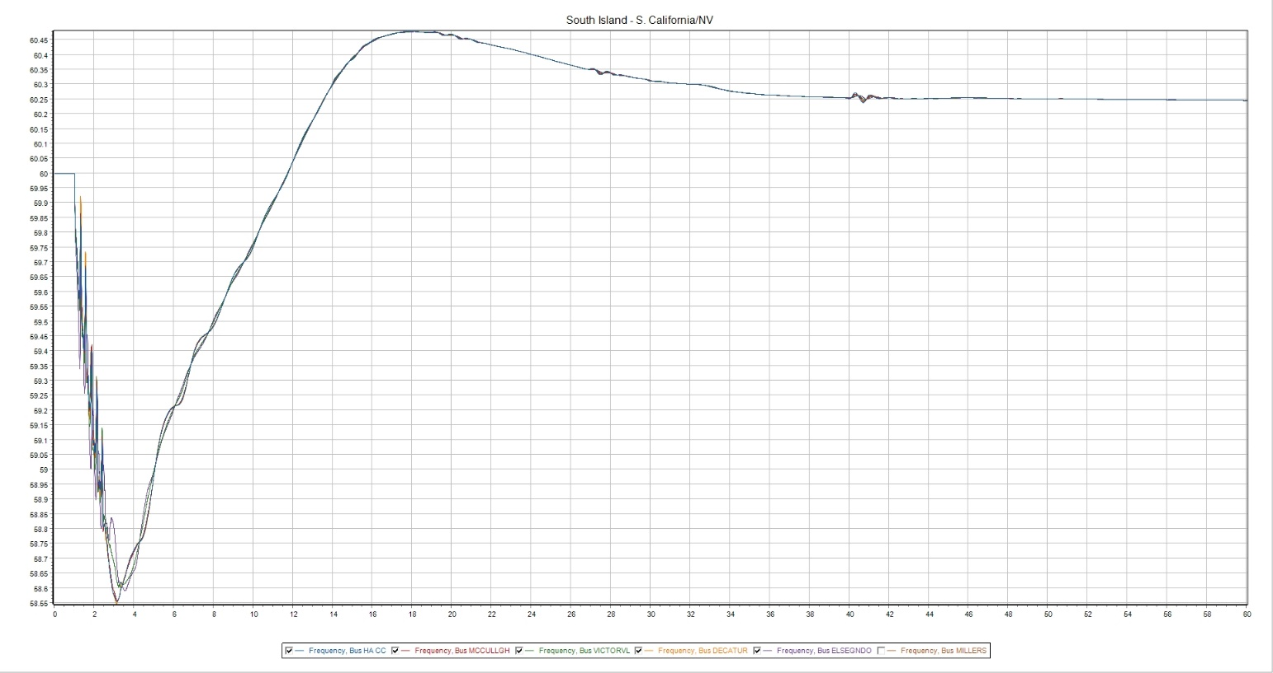

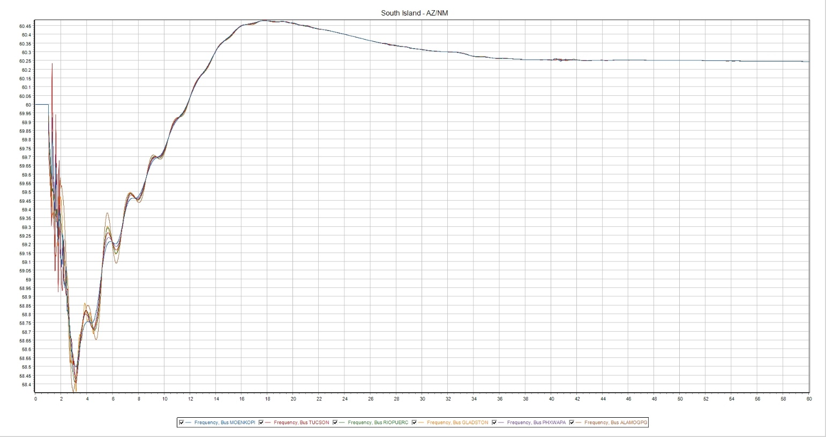

24LSP—10%
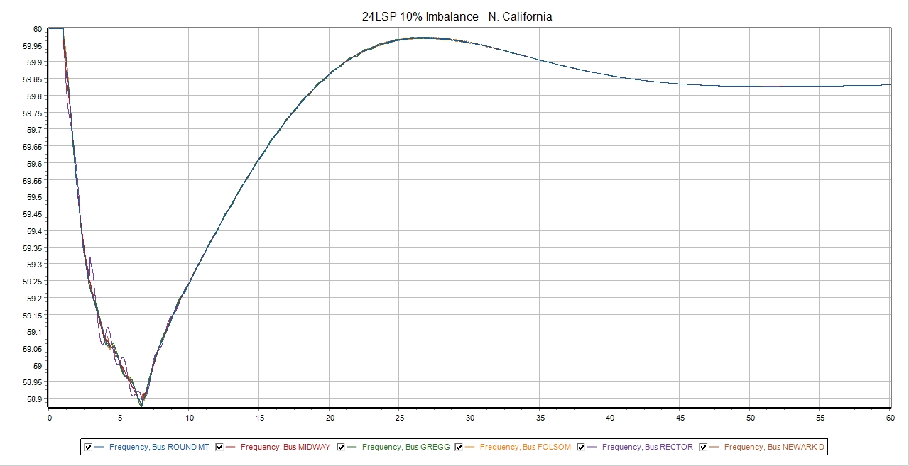

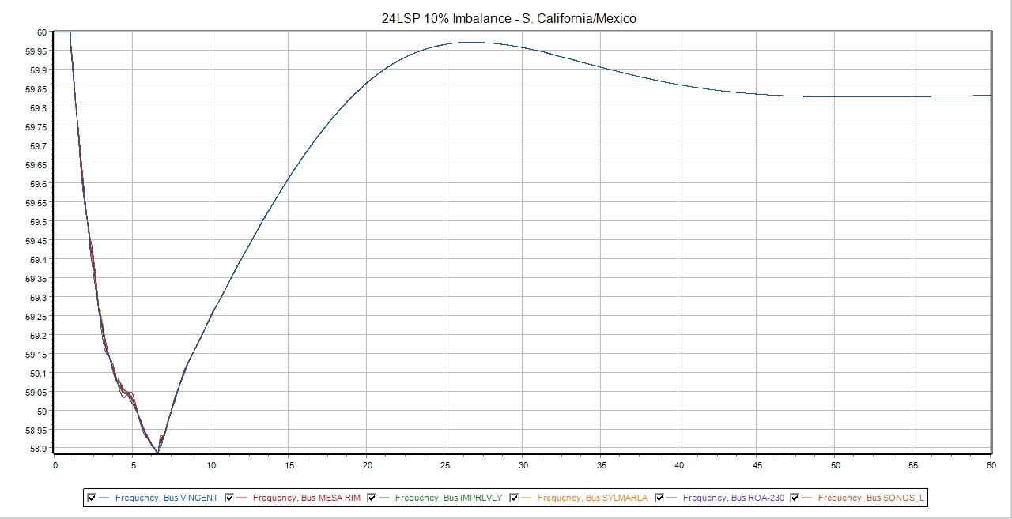

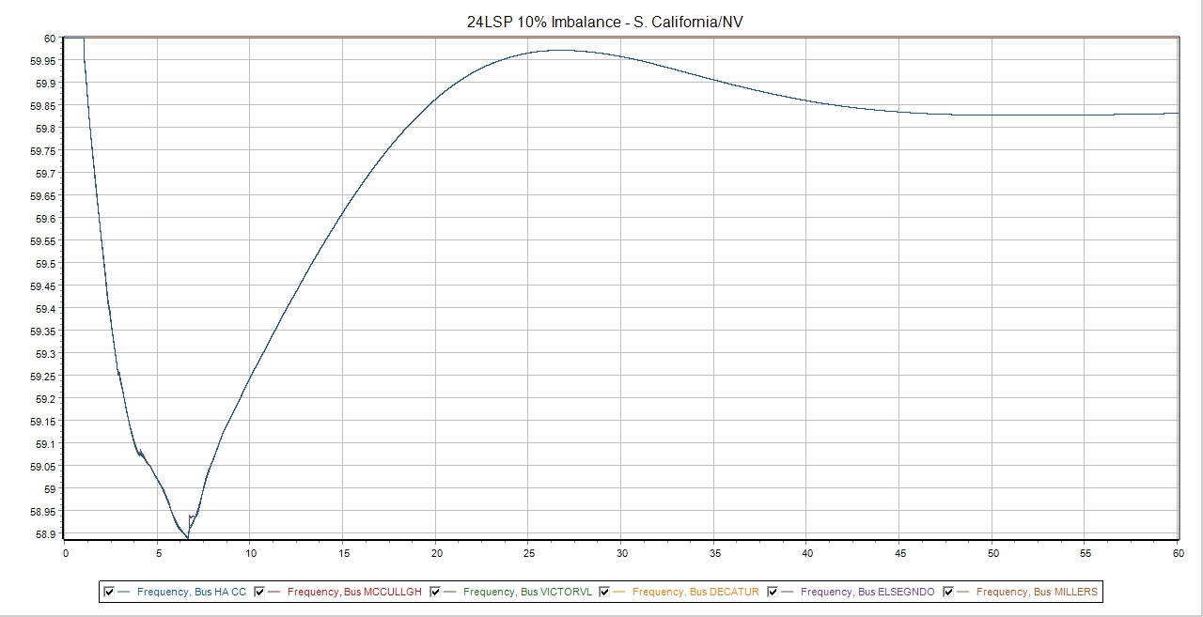

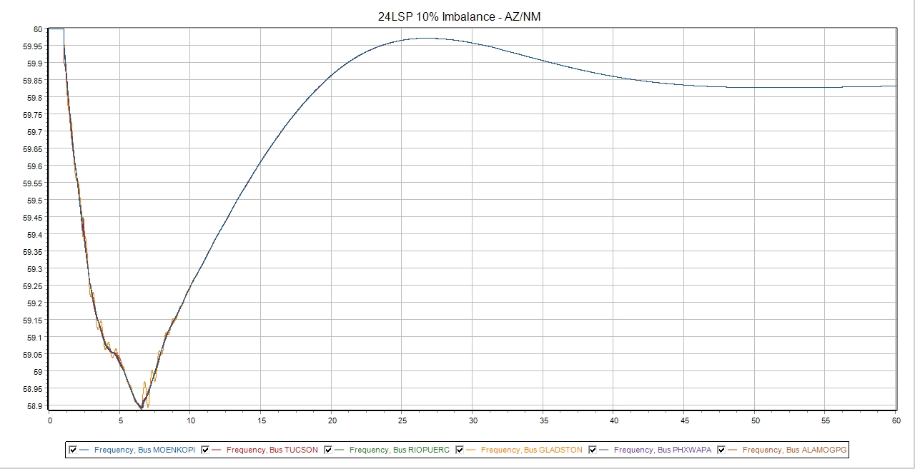

24LSP—20%
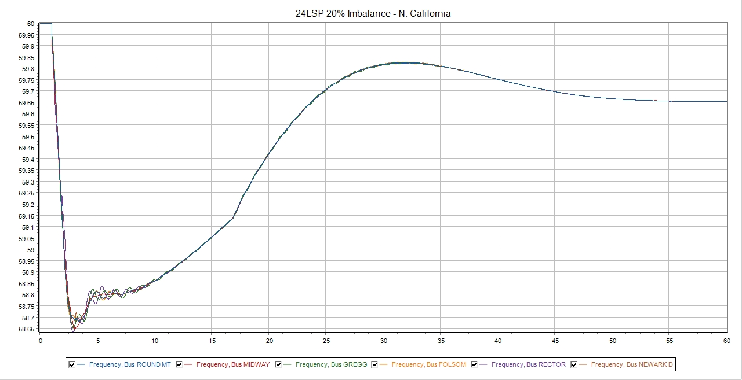

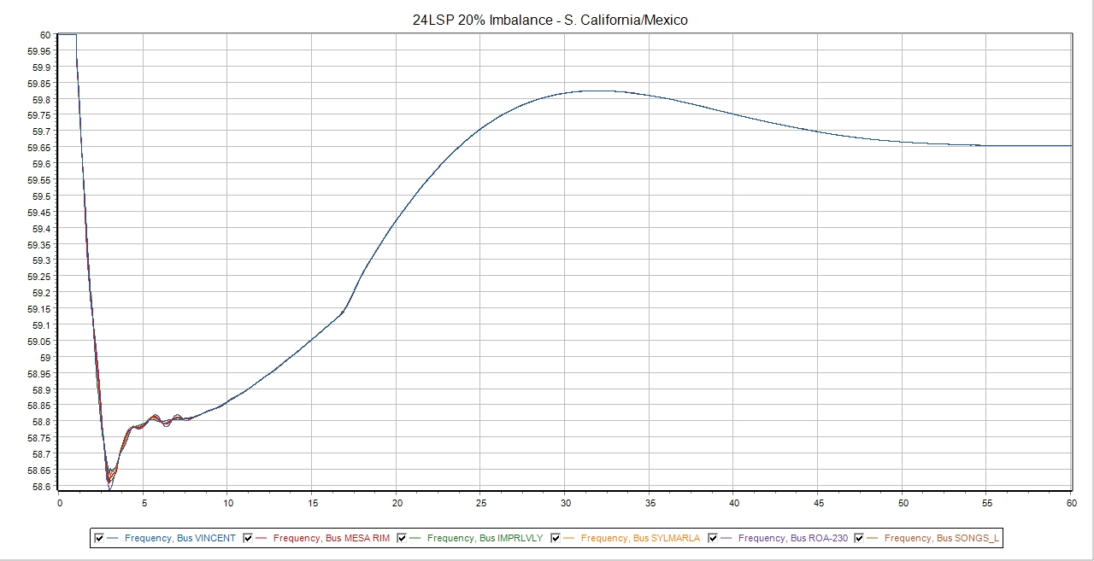

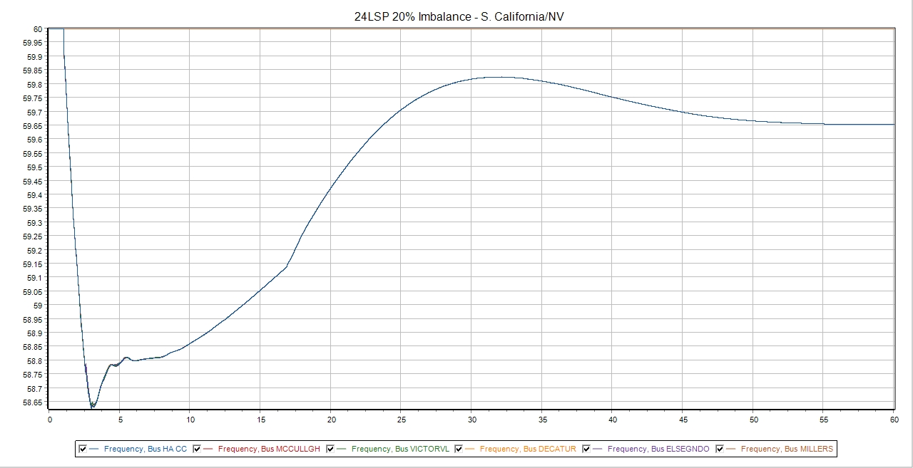

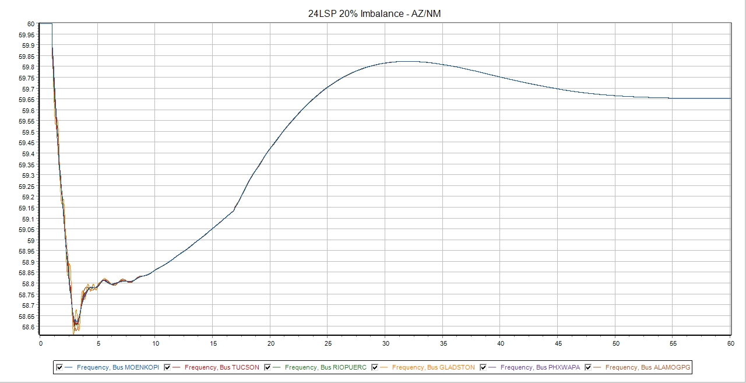

24LSP—25%
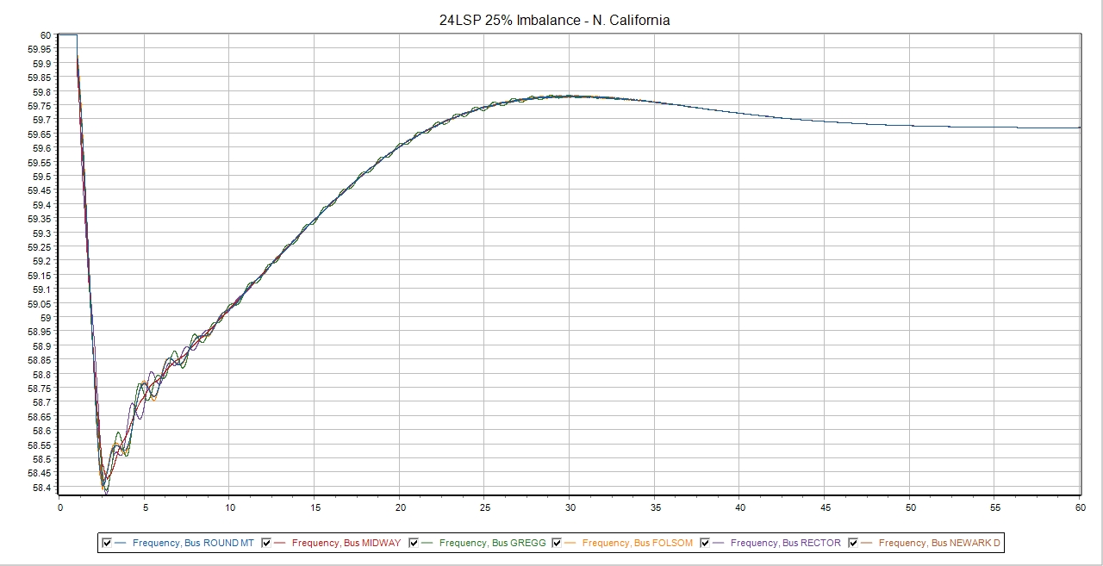

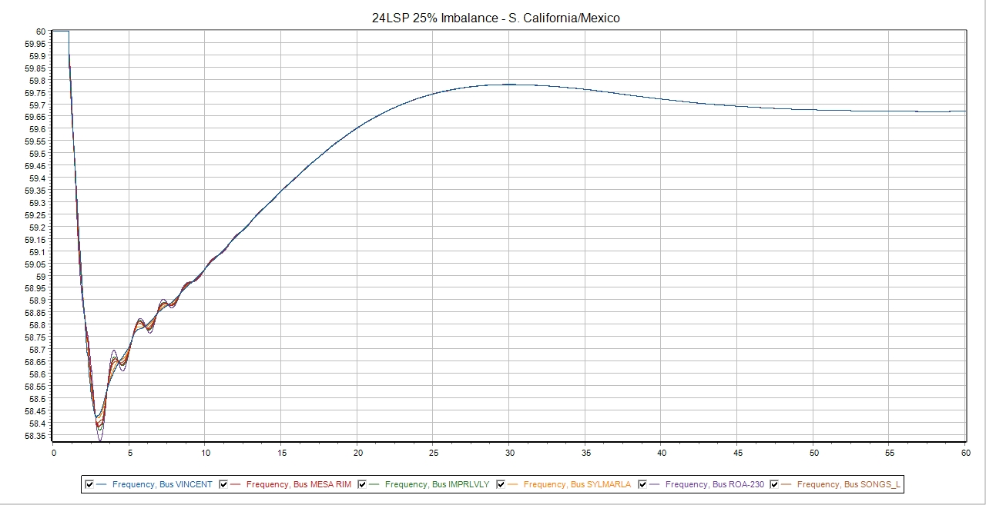

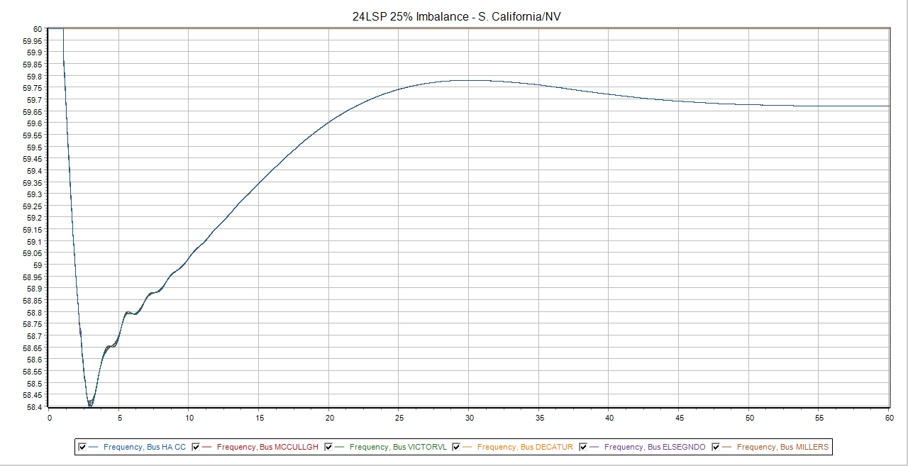

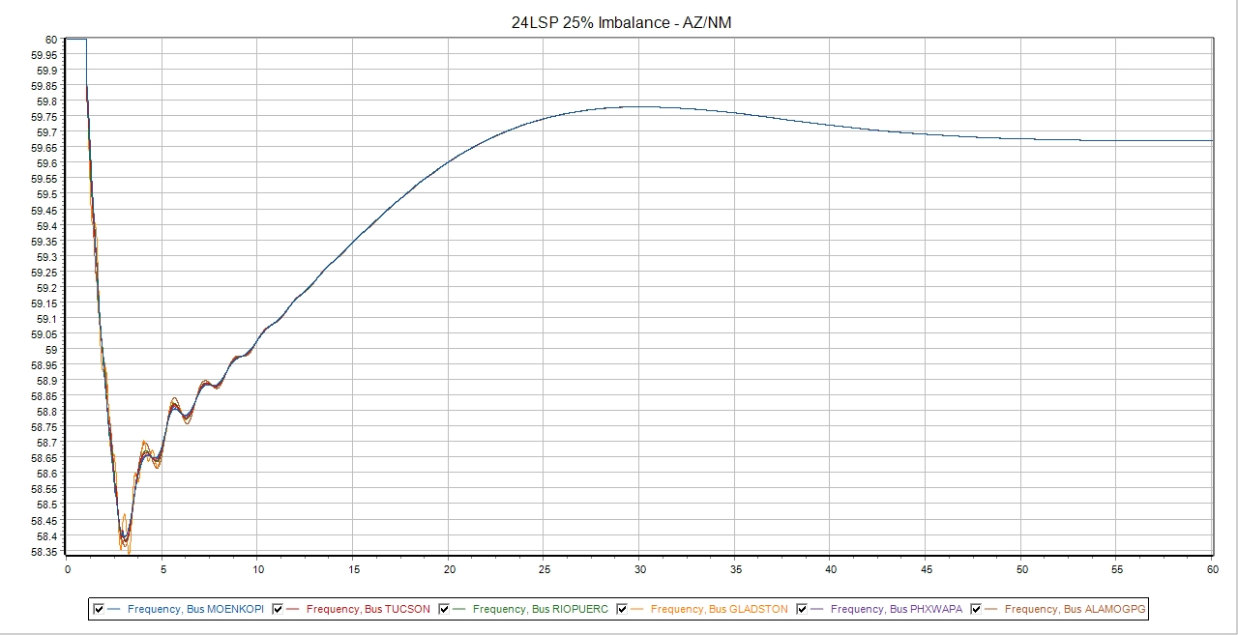

Appendix D—WECC Power Flow Areas
Area # | Area Name
South Island
10 | New Mexico
11 | El Paso
14 | APS
15 | SRP
16 | TEP
17 | AEPCO
18 | Nevada
19 | WAPA L.C.
20 | Mexico-CFE
21 | IID
22 | SDGE
24 | So. Ca. Edison
26 | LADWP
30 | PG&E
North Island
40 | Northwest
50 | B.C. Hydro
52 | Fortis BC
54 | Alberta
60 | Idaho
62 | Montana
63 | WAPA U.W.
64 | Sierra
65 | PACE
70 | PSCO
73 | WAPA R.M.

Appendix E—WECC NE/SE Separation Scheme
The Western Interconnection is designed to detach into North and South islands as a result of the WECC-1 Remedial Action Scheme (RAS). Depending on the region and the company referring to it, this scheme has many names, including NE/SE separation scheme, the COI RAS, PACI RAS, AC RAS, Four Corners Scheme, and Pacific Intertie Transfer Trip Scheme. WECC-1 is installed to prevent overload, low voltage, and instability in the connected system should one or more lines between John Day, Buckley, Marion in the north, and Vincent in the south trip for whatever reason. In addition, selected 500-kV lines north of John Day, Buckley, and Marion have line loss logic to initiate WECC-1 for specific operating conditions. The separation cut-plane is shown in Figure 5.
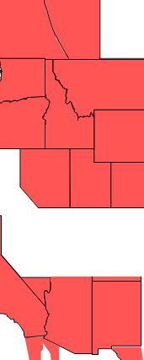
Figure 5: Separation Cut-plane
The separation occurs between the following entities:
- BPA and PG&E on the COI at Malin and Round Mountain Substations;
- BPA and WASN at Captain Jack and Olinda Substations;
- PG&E and PACW at Cascade Substation;
- PG&E and NVEN (SPP) at NVE’s California, Truckee, and North Truckee Substations;
- NVEN (SPP) and SCE at NVE’s Silver Peak Substation;
- NVEN (SPP) and NVES (NEVP) at NVE’s Robinson Summit Substation;
- PACE and APS at Four Corners and between PACE and NVES (NEVP) at Red Butte and Harry Allen; and
- Tri-State and PNM at the Gladstone Substation.
To complete the separation between the North and South islands, WACRSP and WARM trips the following:
- Glen Canyon-Sigurd 230-kV line;
- Shiprock-Lost Canyon 230-kV line;
- Glade- Hesperus 115-kV line; and
- San Juan-Hesperus 345-kV line.

WECC receives data used in its analyses from a wide variety of sources. WECC strives to source its data from reliable entities and undertakes reasonable efforts to validate the accuracy of the data used. WECC believes the data contained herein and used in its analyses is accurate and reliable. However, WECC disclaims any and all representations, guarantees, warranties, and liability for the information contained herein and any use thereof. Persons who use and rely on the information contained herein do so at their own risk.

Compliance with NERC Reliability Standard PRC‐006 and WECC Regional Criteria PRC‐006‐WECC‐CRT requirements is the responsibility of NERC Registered Entities. WECC does not guarantee that this report or any analysis or information contained in it is sufficient for compliance with these or any other requirements. It is the responsibility of each NERC Registered Entity to ensure that it meets its compliance responsibilities as applicable.
The area 50 (BC Hydro) representative indicated that a RAS is in place to trip 500 kV lines on over-voltage control, and this would remedy any V/Hz exceedances in the BC Hydro area.
Direct Load Tripping. Refers to approximately 709 MW of load in the PG&E control area that is armed to be directly tripped if all three 500 kV COI lines are lost and the NE/SE Separation Scheme is initiated. This load comprises CDWR pumps, Helms pumps, or PG&E load. The logic for this is built into the PG&E RAS controller.
Both the WECC and North island 25% imbalance simulations in the 2021 HS failed to complete, so these numbers are not meaningful. For the sake of completeness, they are presented here: Island Shed (MW) Shed (% of Armed) WECC 62,943 79.8 North 23,614 92.1
In the 25% WECC and North island imbalance cases in heavy summer conditions, several additional islands were formed within the North Island area. Plot information suggests that the following three sub-islands were formed: BC Hydro, Idaho/Utah/Colorado, NW/WAPA UM.

